CROWN
TOOLS FOR A BETTER LIFE

CT20114
Merit Link International AG
P.O. Box 641, CH-6855 Stabio Switzerland
www.meritlink.com
Щ Original instructions
E9 Оригинальное руководство по эксплуатации
Jk£ Пайдалану нускаулыгыныц тупнускасы
Ч IJ АлJjii
г Manual original
Щ Орипнальна 1нструкц1я з експлуатаци

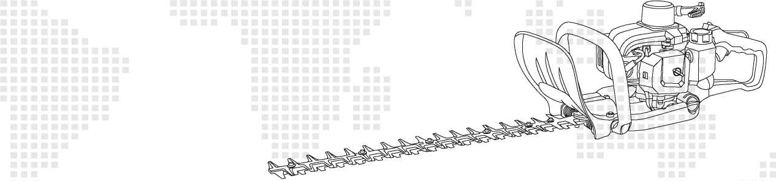


CT20114
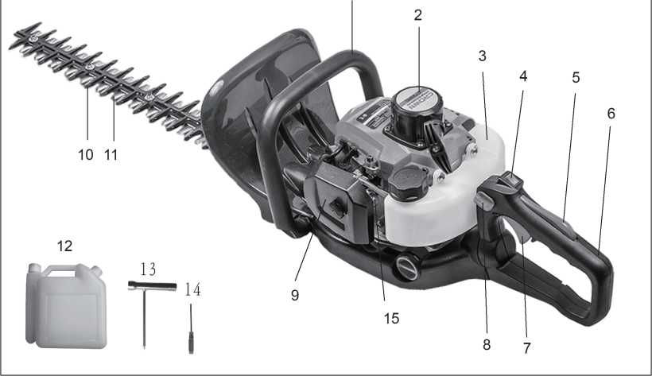
Parts location
1. Front handle | 6. Rear handle | 11. Cutting blade
2. Recoil starter | 7. Throttle trigger | 12. Mixing fuel tank
3. Fuel tank | 8. Handle locking knob | 13.Soket spanner
4. Engine switch | 9. Air filter | 14. Screwdriver
5.Throttle trigger lockout | 10. Counterblade | 15. Bulb primer

Thank you for purchasing our hedge trimmer. This manual contains information on operation and maintenance of the hedge trimmer, whichis based on the most recent product information available at the time of approval for printing. We reserve the right to make amendments without advance notice and without incurring any obligation for consequences.
This manual should be considered a permanent part of the hedge trimmer, and remain with it if it is resold.
- SAFETY INFORMATION
Safety is very important for you and others. We have written down important safety information in both manual and machine. Please read it carefully.
Safety information gives you warning that you may bring potential danger to yourself and others. The key words with "!"are put before every piece of information. These words are "danger, warning, attention".


WARNING - if you don't operate follow those indicated in the manual, device damage and injures will be caused.
A DANGER - if you don't operate follow those indicated in the manual, serious injures, even death will be caused.
A ATTENTION - if you don't operate follow those indicated in the manual, device damage and injures may be caused.
You can see other important information marked with marked with "ATTENTION".
ATTENTION: If you don't operate as those indicated in the manual, device damage will be caused.

Safety prevention

If hedge trimmer is operated follow those indicated in the manual, it will work safely and reliably. Before operating the hedge








- GRAPHIC WARNINGS
trimmer, please read this manual carefully. Otherwise, injures and device damage will be caused.
The words WARNING calls attentions to an act or a condition which can load to serious personal injury or death.
Carefully read owner's manual before operating this machine
Wear head, eye and ear protection.
Wear suitable gloves when using the machine
Wear suitable shoes when using the machine
Use the hedge trimmer with two handsjone handed operation of the saw can be dangerous.
Keep people, objects and I or animals |„f away when using the machine
Do not expose it to rain. Do not use this machine on wet floors
This is extremely sharp and can easily cause cuts.
A IMPORTANT If warning seals peel off or become soiled and impossible to read, you should contact the dealer from which you purchased the product to order new seals and affix the new seal(s) in the required location(s).
A WARNING Never remodel the product. We won't warrant the machine, if you use the remodeled product or you don't observe the proper usage written in the manual.
- SAFETY PRECAUTIONS
Before using the machine
■Ж®
- Read this owner's manual carefully to understand how to operate this unit properly.
- You should never use the product when under the influence of alcohol, when suffering from exhaustion or lack of sleep, when suffering from drowsiness as a result of having taken cold medicine, or at any other time when a possibility exists that your judgment might be impaired or that you might not be able to operate the machine properly and in a safe manner.
- Avoid running the engine indoors. The exhaust gases contain harmful carbon monoxide.
- Never use the product under circumstances like those described below:
- When the ground is slippery or when other conditions exist which might make it not possible to maintain a steady posture.
- At night, at times of heavy fog, or at any other times when your field of vision might be limited and it would be difficult to gain a clear view of the area.
- During rain storms, during lightning storms, at times of strong or gale-force winds, or at any other times when weather conditions might make it unsafe to use this product.
- When using this product for the first time, before beginning actual work, learn to handle it from skilled worker.
- Lack of sleep, tiredness, or physical exhaustion results in lower attention spans, and this in turn leads to accidents and injury, g. Be sure to keep this manual handy so that you may refer to it later whenever any questions arise.
h. Always be sure to include this manual when selling, lending, or otherwise transferring the ownership of this product.
- Never allow children or anyone unable to fully understand the directions given in this manual to use this product.
Working gear and dothing
- When using the product, you should wear proper clothing and protective equipment as follows.
(1) Helmet (2) Protection goggles or face protector (3) Thick work gloves (4) Non-slip-sole work boots
(5) Ear protectors
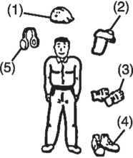

- And you should carry with you.
- Attached tools. • Properly reserved fuel. 'Spare blade. 'Whistle (for collaboration or emergency).
- Things to notify your working area (rope, warning signs). • Hatchet or saw (for removal of obstacles).
- Never use the product when wearing pants with loose cuffs, when wearing sandals, or when barefoot.
Warning considering handling of fiiel
- The engine of this product is designed to run on a mixed fuel which contains highly flammable gasoline. Never store cans of fuel or refill the fuel tank in any place where there is a boiler, stove, wood fire, electrical sparks, welding sparks, or any other source of heat or fire which might ignite the fuel.
- Smoking while operating the product or refilling its fuel tank is extremely dangerous. Always be sure to keep lit cigarettes away from the product at all times.
- When refilling the tank always turn off the engine first and take a careful look around to make sure that there are no sparks or open flames anywhere nearby before refueling.
- If any fuel spillage occurs during refueling, use a dry rag to wipe up spills before turning the engine back on again.
- After refueling, screw the fuel cap back tightly onto the fuel tank and then carry the product to a spot 3m or more away from where it was refueled before turning on the engine.

NOTE
If fuel or product is ignited, please put out fire with dry powder fire extinguisher.
Before starting engine
- The area within a perimeter of 15 m of the person using the product should be considered a hazardous area into which no one should enter. If necessary, yellow warning rope, warning signs should be placed around the perimeter of the area. When work is to be performed simultaneously by two or more persons, care should also be taken to constantly look around or otherwise check for the presence and locations of other people working so as to maintain a distance between each person sufficient to ensure safety.
- Check the condition of working area to avoid any accident by hitting hidden obstacles such as stumps, stones, cans, or broken glass.
- Always ensure all handles and guards are fitted when using the machine. Never attempt to use an incomplete machine or one fitted with an unauthorized modification.
- Do not operate the machine with a damaged or excessively worn cutting device.
A IMPORTANT. Remove any obstacle before beginning work.
- Inspect the entire unit for loose fasteners and fuel leakage. Make sure that the cutting attachment is properly installed and securely fastened.
Starting the engine
- Keep bystanders, especially children, and animals at least 15 m away from the operating point. If you are approached, immediately stop the engine.
- The product is equipped with a centrifugal clutch mechanism, so the cutting attachment begins to move as soon as the engine is started by putting the throttle into the start position. When starting the engine, place the product onto the ground in a flat clear area and hold it firmly in place so as to ensure that neither the cutting part nor the throttle come into contact with any obstacle when the engine starts.
А WARNING
- Never place the throttle into the high-speed position when starting the engine.
- Never start the engine at the cutting attachment side.
- After starting the engine, check to make sure that the cutting attachment stops moving when the throttle is moved fully back to its original position. If it continues to move even after the throttle has been moved fully back, turn off the engine and take the unit to your authorized servicing dealer for repair.
Using the product
A IMPORTANT
Cut only materials recommended by the manufacturer. And use only for tasks explained in the manual.
- Grip the handles firmly with both hands using your whole hand. Place your feet slightly apart (slightly further apart than the width of your shoulders) so that your weight is distributed evenly across both legs, and always be sure to maintain a steady, even posture while working.
- Maintain the speed of the engine at the level required to perform cutting work, and never raise the speed of the engine above the level necessary.
- If the unit starts to shake or vibrate, turn off the engine and check the whole unit. Do not use it until the trouble has been properly corrected.
- Keep all parts of your body away from moving cutting attachment and hot surfaces.
- Never touch the muffler, spark plug, or other metallic parts of the engine while the engine is in operation or immediately after shutting down the engine. Doing so could result in serious burns or electrical shock.


- While operating the machine be always sure of a safe and secure operating position especially when using steps or a ladder.
- Always be aware of you surroundings and stay alert for possible hazards that you may not hear due to the noise of the machine.
- To reduce fire hazard keep engine and silencer tree of debris, leaves, or excessive lubricant.
- Stop the engine before:
- Cleaning or when clearing a blockage;
- Checking, maintenance or working on the machine.

> IF SOMEONE COMES
- Guard against hazardous situations at all times. Warn adults to keep pets and children away from the area. Be careful if you are approached. Injury may result from flying debris.
- If someone calls out or otherwise interrupts you while working, always be sure to turn off the engine before turning around. Avoid operating while people, especially children are nearby.
Maintenance
- Do not attempt to repair the machine unless you are qualified to do so.
- In order to maintain your product in proper working order, perform the maintenance and checking operations described in the manual at regular intervals.
- Always be sure to turn off the engine before performing any maintenance, checking procedures or working on the machine.
A WARNING The metallic parts reach high temperatures immediately after stopping the engine.
- When replacing the cutting attachment or any other part, or when replacing the oil or any lubricant, always be sure to use only High Quality products.
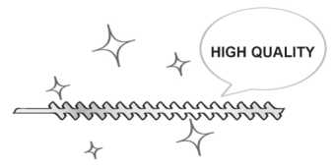
- In the event that any part must be replaced or any maintenance or repair work not described in this manual must be performed, please contact a representative from the store nearest authorized servicing dealer for assistance.
- Do not use any accessory or attachment other than those were recommend for the unit.
- Under no circumstances should you ever take apart the product or alter it in any way. Doing so might result in the product becoming damaged during operation or the product becoming unable to operate properly.

Handling fuel
1 .The engine is designed to run on a mixed fuel, which contains highly flammable gasoline. Never store cans of fuel or refill the tank of the unit in any place where there is a boiler, stove, wood fire, electrical sparks, welding sparks, or any other source of heat or fire which might ignite the fuel.
- Handle fuel with care, it is highly flammable. Never smoke while operating the unitor refilling its fuel tank.
- When refilling the tank, always turn off the engine and allow it to cool down. Take a careful look around to make sure that there are no sparks or open flames anywhere nearby before refueling.
- Wipe spilled fuel completely using a dry rag if any fuel spillage occurs during refueling.
- After refueling, screw the fuel cap back tightly onto the fuel tank and then carry the unit to a spot 3 m or more away from where it was refueled before turning on the engine.
- Do not inhale fuel fumes as they are toxic.
Transportation
- When hand-carrying the product, cover over the cutting part if necessary, lift up the product and carry it paying attention to the blade.
- Never transport the product over rough roads over long distances by vehicle without removing all fuel from the fuel tank. If doing so, fuel might leak from the tank during transport.
- When transporting or storing the machine always fit the cutting device guard.
- FUEL AND OIL

Carburant
Use a mixture of normal-grade unleaded gasoline (with or without lead, alcohol-free) and a quality 2-stroke engine oil.



Recommended mixing ratio:
Condition
Up to 20 hours use
After 20 hours use
Gasoline: Oil
25:1 40:1

40:1 Mixing
2-cyde oil Gasoline liters
1 2 3 4 5
40 80 120 163 200

- OPERATING

Starting engine

A WARNING The cutting head will start moving upon the engine starts.
- Feed fuel into the fuel tank and tighten the cap securely.
- Rest the unit on a flat, firm place. Keep the cutting head off the ground and clear of surrounding objects as it will start moving upon starting of the engine.
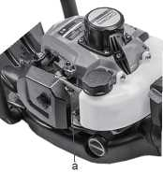
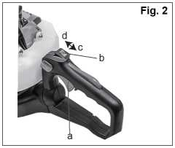
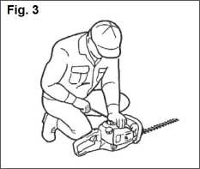
3. Push the primer several times until overflow fuel flows out in the clear tube.
Fig. 1
- When the engine is cool, move the choke lever to the closed position. Fig. 1a. Primer
- Set the ignition switch to the" I "position. Fig. 2
a.Throttle lever b. Ignition switch c."exposition d."l"position
- While holding the unit firmly, pull out the starter rope quickly until engine fires. Fig. 3
л IMPORTANT. Avoid pulling the rope to its end or returning it by releasing the knob. Such actions can cause starter failures.
- Move the choke lever downward to open the choke, and restart engine.
- Allow the engine to warm up for a several minutes before starting operation.

NOTE
- When restarting the engine immediately after stopping it, leave the choke open.
- Over choking can make the engine hard to start due to excess fuel. When the engine failed to start after several attempts, open the choke and repeat pulling the rope, or remove the spark plug and dry it.
Stopping engine
- Release the throttle lever and run the engine for half a minute.
- Shift the ignition switch to the "O" position. Fig. 2
A IMPORTANT.
- Except for an emergency, avoid stopping the engine while pulling the throttle lever.
- If the engine won't stop when setting the ignition switch to the stop position, close the choke lever and stop the engine.
- In this case, please repair the machine at your nearest servicing dealer.
Cutting work

A WARNING
- Weather conditions and altitude may effect carburation.
- Do not allow anyone to stay close to the hedge trimmer while working or while adjusting the carburetor.

How to use the handle
To reduce fatigue when trimming hedges, the handle can be swiveled through 90° to the left or right.
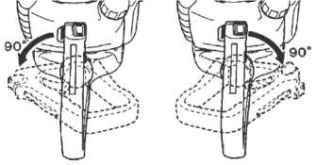
Do not press the throttle during this operation!
Vertical cut
Proceed as follows:
- Free the handle by pressing the locking lever.
- Turn the handle until the locking lever clicks into place.
- When the handle is locked in its new position, you can apply the throttle again.
You can swivel the handle even with the engine idling because the hedge-trimmer is equipped with a blade brake that maintains the blades at a standstill.

HEDGE TRIMMING TECHNIQUES
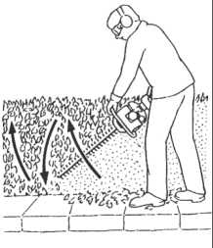
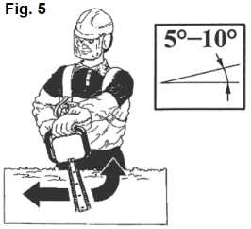
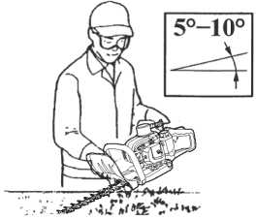
Trim sides of a hedge first, and then the top.
With the 2-sided blade model THT245D use an arcing cut from the bottom upwards, then downwards to use both sides of the blades. Fig. 4
Fig. 4

Horizontal ait
In order to get the best cutting results, slightly tilt the blade (5-10°) towards the cutting direction. Fig. 5
Cut slowly, especially with thick hedges.
A WARNING
Always follow the safety precautions. The hedge-trimmer must only be used to trim hedges or small bushes. It is forbidden to cut other types of material. Do not use the hedge-trimmer as a lever to lift, move or break objects, nor lock it on fixed supports. It is forbidden to apply tools or applications that are not the ones indicated by the manufacturer onto the hedge-trimmer's power take-off. Do not use it for pruning trees or cutting grass.
- Use only as much throttle as is needed to do the job. Excessive engine speed is unnecessary.
■ Avoid cutting thick branches, for which will damage the bladesand shorten the life of drive systems.
- Tilting the trimmer 5 to 10° to the cutting object will make the job easy and bring a good result.
- Always keep your body to the carburetor side of your trimmer, never on the muffler side.
- When a new machine is first operated, in the first few minutes grease may come out of the gear case. But, since this is excess grease, there is no cause for alarm. Just wipe it off with the engine stopped for next use. Fig. 6
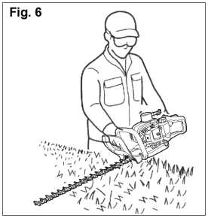
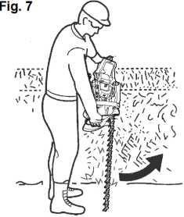
• Always remember that the TIP of the line does cutting. You will achieve better results by not crowding the line into the cutting area. Allow the unit to trim at its own pace. Fig. 7
6. MAINTENANCE
 |  | System / components | Procedure | Before use | Every 25 hours after | Every 50 hours after | Every 100 hours after | Note
 | Fuel leaks, fuel spillage |  | Wipe out | V
 | Fuel tank, air filter, fuel filter |  | Inspect or clean | V | V |  |  | Replace if necessary
 | Idle adjusting screw |  | See adjusting idle speed | V |  |  |  | replace carburetor if necessary
Engine | Sparkplug |  | Clean and readjust plug gap |  |  | V |  | gap: 0.6-0.7mm replace if necessary
 | Cylinder fins, intake air cooling vent |  | Clean |  | V
 | Muffler, spark arrester, cylinder exhaust port |  | Clean |  |  |  | V
Trimmer | Throttle lever, engine switch |  | Check operation | V
Trimmer | Cutting parts |  | Replace if something's wrong | V

 | Gear case | Grease |  | V
Trimmer | Screws/nuts/bolts | Tighten or replace | V |  |  | V | Not adjusting screws
 | Debris guard | Make sure to attach | V

A WARNING
Make sure that the engine has stopped and is cool before performing any service to the machine. Contact with moving cutting head or hot muffler may result in a personal injury.
Blade
- Check the blade and the fasteners for looseness, cracking, or bending.
- Check the cutting edges and reform with a flat file. Point:
- Keep the end corner sharp.
- Round the root of the edge.
- Do not use water when using a grinder.
You need not to adjust the gap between upper blade and lower blade as this product is designed to have optimal gap when it is properly set up. Fig. 8
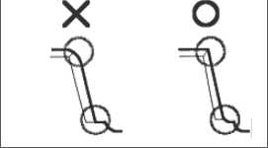
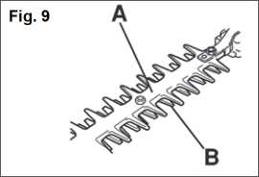
Fig. 8
The blade guard (A) is intended to protect against any part of the body coming into contact with the blades (B).
Check that the blade guard is not damaged or distorted. Replace the blade guard if it is bent or damaged. Fig. 9
A IMPORTANT.
When mounting the blade, make sure to fasten the spacer, washer and bolt, then fasten the nut.
Sharpening
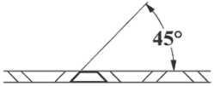
Always keep the file or sharpener at an angle of 45° to the blade, and:
- Always grind in the direction of the cutting edge;
- Note: files cut only in one direction; lift the file from the blade when returning to start a new pass;
- Remove all burr from the edge of the blade with a slip stone;
' Remove as little material as possible;
- Before refitting the sharpened blades, remove filings and then apply grease.
- Do not try to sharpen a damaged blade: change it or take it to a Service dealer
Safety lock
A WARNING
Stop operation when the safety lock is defective.
Safety lock is the device not to accelerate the throttle lever without intention. While pushing the safety lock, you can accelerate the throttle lever. (1) Safety lock Fig. 10
Fig. 10  \\\ | Fig. 11 | Fig. 12 „ Г

- Check if the throttle lever does not move when you do not push the safety lock.
- Check if the throttle lever moves when you grasp or release it while pushing the safety lock.
- Check if the safety lock returns to its original position when you release your hand from safety lock.
• If you find any defects at the checks above, contact your nearest servicing dealer for repair.
Anti-vibration system Fig. 11
A WARNING
The deformed or damaged anti-vibration system may cause of the breakages like getting rickety or falling off of engine and/or blade.
Check periodically if the springs are not deformed or damaged.
Airfilter Fig. 12
The air filter, if clogged, will reduce the engine performance. Check and clean the filter element in warm, soapy water as required. Dry completely before installing. If the element is broken or shrunk, replace with a new one.
- Air filter base 2. Air filter cover 3. Filter element
Fuelfilter Fig. 13
When the engine runs short of fuel supply, check the fuel cap and the fuel filter for blockage.
Way of the cooling air Fig. 14
This engine is air-cooled. Dust clogging between the inlet port of the cooling air and cylinder fins will cause overheating of the engine. Periodically checkand clean the cylinder fins after removing the air cleaner and the cylinder cover.
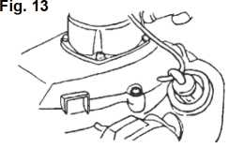
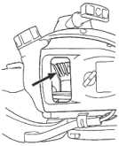
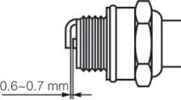
Fig. 14
Fig. 15
Sparkplug Fig. 15
Starting failure and misfiring are often caused by a fouled spark plug.
Clean the spark plug and check that the plug gap is in the correct range. For a replacement plug, use the correct type.
A IMPORTANT.
■ Note that using any spark plug other than those designated may result in the engine failing to operate properly or in the engine becoming
overheated and damaged.
• To install the spark plug, first turn the plug until it is finger tight, then tighten it a quarter turn more with a socket wrench. Tightening torque: 14.7-21.5 N-m
Gear case
* Supply multi-purpose grease at every 25 hours of use.
- Use a grease pump.
- Feed grease until it comes out of the base of blades.
Adjusting carburetor
The carburetor has been adjusted at the factory. Should your unit need readjustment due to the changes in altitude or operating conditions, please let your skillful dealer make the adjustment. A wrong adjustment may cause damage to your unit.
Procedures to be performed after every 100 hours of use Fig. 16
- Remove the muffler, insert a screwdriver into the vent, and wipe away any carbon buildup. Wipe away any carbon buildup on the muffler exhaust vent and cylinder exhaust port at the same time.
- Tighten all screws, bolts, and fittings.
- Check to see ifany oil or grease has worked its way in between the clutch lining and drum, and if it has, wipe it away using oil-free, lead-free gasoline.
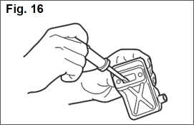

Maintenance of the blades
- Oil the blade to prevent rust.
- Empty the fuel tank and put the cap back on.
- Remove the spark plug, pour a small amount of oil into the cylinder.
- Rotate the crankshaft several times using the starting rope in order to distribute the oil. Put the spark plug back in.
- Wrap the engine with a plastic sheet.
- Store the trimmer indoors in a dry place, dust free place, out of the reach of children, preferably not in direct contact with the floor and away from heat sources.
7. TROUBLESHOOTING GUIDE
Case 1. Starting failure
CHECK | PROBABLE CAUSES | ACTION
Fuel tank | Incorrect fuel | Drain it and use correct fuel
Fuel filter | Fuel filter is clogged | Clean
Carburetor adjustment screw | Out of normal range | Adjust to normal range
Sparking (no spark) | Spark plug is fouled/wet | Clean/dry
Sparking (no spark) | Plug gap is incorrect | Correct (gap: 0.6 ~ 0.7 Mm)
Sparkplug | Disconnected | Retighten

Case 2. Engine starts but does not keep running / hard re-starting
CHECK | PROBABLE CAUSES | ACTION
Fuel tank | Incorrect fuel or staled fuel | Drain it and use correct fuel
Carburetor adjustment screw | Out of normal range | Adjust to normal range
Muffler, cylinder  (exhaust port) | Carbon is built-up | Wipe away
Air cleaner | Clogged with dust | Wash
Cylinder fin, fan cover | Clogged with dust | Clean

8. ESPECIFICATIONS
Model name | CT20114
Net weigth | 5.8 kg
Fuel tank capacity | 0.55 L
Engine characteristics | Single cylinder, 2-stroke, Air-cooling
Engine Displacement | 22.5 cm³
Max engine speed | 8500 min-’
Blade length | 640 mm
Blade spacing | 35 mm
Engine idling speed | 3000 min-’
MAX.Power output | 650 W
Fuel mixing ratio | 25: 1

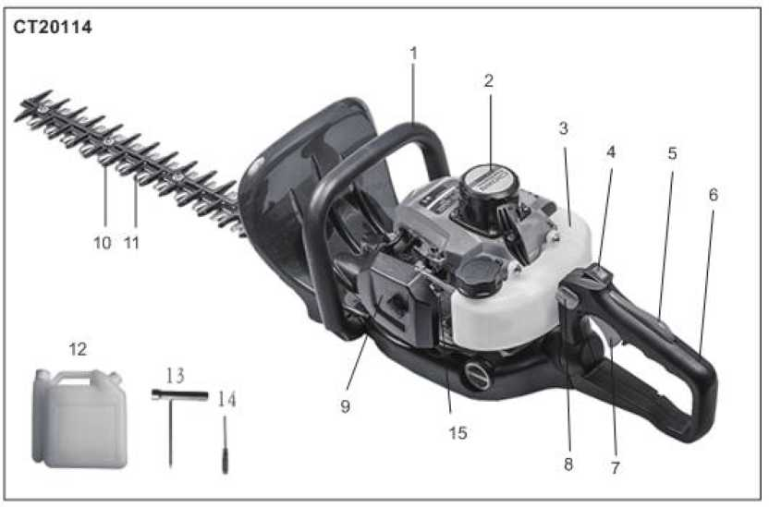

Расположение деталей
1. Передняя ручка | 6. Задний руль | 11. Режущее лезвие
2. Ударный стартер | 7. Дроссельная заслонка | 12. Смешанный топливной бак
3. Топливный бак | 8. Ручка блокировки ручки | 13. Гаечный ключ
4. Переключатель двигателя | 9. Воздушный фильтр | 14. Отвертка
5. Блокировка триггеля дроссельной заслонки | 10. Сборочный нож | 15. Электрическая лампа запала

Благодарим вас за покупку триммера для хеджирования. Данное руководство содержит информацию об эксплуатации и обслуживании триммера для хеджирования, которая основана на самой последней информации о продукте, доступной на момент утверждения для печати. Мы оставляем за собой право вносить изменения без предварительного уведомления и без каких-либо обязательств по последствиям. Это руководство следует считать постоянной частью триммера для хеджирования и оставаться вместе с ним, если оно перепродается.
- ИНФОРМАЦИЯ О БЕЗОПАСНОСТИ
Безопасность важна для вас и для других. Мы записали важную информацию о безопасности как в ручном, так и в машинном оборудовании. Внимательно прочитаете его.
Информация о безопасности дает вам предупреждение о том, что вы можете принести потенциальную опасность себе и другим. Ключевые слова с «!» Ставятся перед каждой информацией. Эти слова «опасность, предупреждение, внимание».
 | к | ОПАСНО - если вы не работаете, следуете указаниям, указанным в руководстве, серьезным травмам, даже смерть будет вызвана.
 | к | ПРЕДУПРЕЖДЕНИЕ - если вы не работаете, следуете указаниям, указанным в руководстве, повреждение устройства и травмы.
 | к | ВНИМАНИЕ: - если вы не работаете, следуете указаниям, указанным в руководстве, серьезным травмам, даже смерть будет вызвана.
 | к | Вы можете увидеть другую важную информацию, отмеченную знаком «ВНИМАНИЕ».  ВНИМАНИЕ: Если вы не работаете, как указано в руководстве, это может привести к повреждению устройства.
Предотвращение безопасности

II | Если работает триммер хеджирования, следуете указаниям, указанным в руководстве, он будет работать надежно и надежно.
А | Перед началом эксплуатации хеджирования триммера, внимательно прочитайте это руководство. В противном случае будут нанесены повреждения и повреждения устройства.

2.ГРАФИЧЕСКИЕ ПРЕДУПРЕЖДЕНИЯ
А | Слово ПРЕДУПРЕЖДЕНИЕ обращает внимание на действие или состояние, которое может привести к серьезным травмам или смерти.
 | Внимательно прочитаете руководство по эксплуатации перед началом работы с этим аппаратом.
о | Наденьте шлем с защитой глаз и уха.
о | При использовании машины надеваете соответствующие перчатки.
о | При использовании машины используете подходящую обувь.
 | Используете триммер для изгороди двумя руками, односторонняя работа пилы может быть опасной.

■4 | При использовании машины держите людей, объекты и / или животных.
 | Не подвергаете его воздействию дождя. Не используете эту машину на влажных полах.
 | Это чрезвычайно остро и может легко вызвать порезы.

ВАЖНО Если предупреждающие уплотнения отшлифовать или загрязниться и их невозможно прочитать, обратитесь к дилеру, у которого вы приобрели продукт, чтобы заказать новые уплотнения и
нанести новую (-ые) печать (и) в требуемое место (и).
Л ПРЕДУПРЕЖДЕНИЕ Никогда не переделываете изделие. Мы не будем гарантировать машину, если вы используете реконструированный продукт или не соблюдаете надлежащее использование, указанное в руководстве.
З.МЕРЫ ПРЕДОСТОРОЖНОСТИ
Перед использованием машины
■Ж®
- Внимательно прочитаете это руководство пользователя, чтобы понять, как правильно управлять данным устройством.
- Вы никогда не должны использовать продукт, когда под воздействием алкоголя, страдающего от истощения или отсутствия сна, когда вы страдаете от сонливости в результате приема холодной медицины или в любое другое время, когда существует доминирующая способность, Устранитесь или вы не сможете правильно и безопасно управлять машиной.
- Избегаете запуска двигателя в помещении. Выхлопные газы содержат вредный оксид углерода.
- Никогда не используете продукт в случаях, описанных ниже:
- Когда земля скользкая или когда другой специалист может сделать невозможным поддержание устойчивой осанки.
- Ночью, в периоды сильного тумана или в любое другое время, когда ваше поле зрения может быть ограничено, и было бы трудно получить четкое представление об этом районе.
- В период дождевых штормов, во время грозы, при сильных ветрах или штормовых ветрах или в любое другое время, когда погодные меры могут сделать его небезопасным для использования этого продукта.
- При использовании этого продукта в первый раз, перед началом фактической работы, научитесь обращаться с ним у квалифицированного рабочего.
- . Недостаток сна, усталость или физическое истощение приводит к уменьшению внимания, а это, в свою очередь, приводит к несчастным случаям и травмам. Обязательно сохраните это руководство, чтобы вы могли ссылаться на него позже, когда возникают какие-либо вопросы.
д). Обязательно включите это руководство при продаже, кредитовании или иным образом передав право
собственности на этот продукт
h) Никогда не разрешайте детям или всем, кто не может полностью понять указания, приведенные в этом руководстве, использовать этот продукт.
Рабочее оснащение и одежда
При использовании продукта вы должны носить надлежащую одежду и защитное оборудование следующим образом.
- Шлем
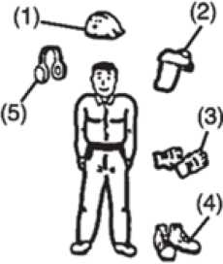
- Защитные очки или защитные очки
- Толстые рабочие перчатки
- Сапоги с нескользящей подошвой
- Протекторы для ушей
а. вы должны нести с собой.
- Прикрепленные инструменты.
- Правильно зарезервированное топливо.
•Запасное лезвие.
- Свисток (для совместной работы или экстренной помощи).
- Вещи, чтобы уведомить вашу рабочую зону (веревка, предупреждающие знаки).
• Топор или пила (для устранения препятствий).
с. Никогда не используйте продукт при ношении брюк с ослабленными манжетами, при ношении сандалий или босиком.
Предупреждение о значительном обращении с топливом
- Двигатель этого продукта предназначен для работы на смешанном топливе, содержащем легковоспламеняющийся бензин. Никогда не храните банки с топливом или не наполняете топливный бак в любом месте, где есть котел, плита, дровяной огонь, электрические искры, сварочные искры, или любой другой источник тепла или огня, который может воспламенить топливо.
- . Курение во время работы с продуктом или заправки его топливного бака чрезвычайно опасно. Всегда следите за тем, чтобы сигареты зажигали от продукта в любое время.
- При заправке резервуара сначала выключите двигатель и внимательно осмотрите его, чтобы убедиться, что вблизи дозаправки нет искр или открытого огня поблизости.
Если во время дозаправки происходит утечка топлива, используете сухую тряпку, чтобы вытереть разливы, прежде чем снова включить двигатель.
После заправки закройте топливный колпачок вплотную к топливному баку, а затем перенесите продукт на место на расстоянии Зм или более от места его заправки перед включением двигателя.
Примечание
Если топливо или продукт зажжены, пропустите огонь огнетушителем из сухого порошка.
Перед запуском двигателя
- Площадь по периметру 15м человека, использующего продукт, должна считаться опасной зоной, в которую никто не должен входить. Если необходимо, по периметру области следует поместить желтый
RU
14 предупреждающий трос, предупреждающие знаки. Должно выполняться одновременно двумя или более лицами, следует также следить за тем, чтобы постоянно осматривать или иным образом проверять наличие и расположение других людей, работающих с тем, чтобы поддерживать расстояние между каждым человеком, достаточным для обеспечения безопасности.
- Проверите состояние рабочей зоны, чтобы избежать несчастного случая, ударив скрытые препятствия, такие как пни, камни, банки или разбитое стекло.
- Всегда следите за тем, чтобы все ручки и защитные приспособления были установлены при использовании машины. Никогда не пытайтесь использовать неполную машину или одну из них с несанкционированной модификацией.
А
4. Не используете машину с поврежденным или чрезмерно изношенным режущим устройством. ВНИМАНИЕ! Перед началом работы удалите все препятствия.
5. Внимательно осмотрите весь блок для крепления и утечки топлива. Подтвердите, что режущее устройство правильно установлено и надежно закреплено.
Запуск двигателя
- Храните свидетелей, особенно детей и животных, по крайней мере, на расстоянии 15м от рабочей точки. Если к вам приблизится, немедленно остановите двигатель.
- Продукт оснащен центробежным механизмом сцепления, поэтому режущее приспособление начинает двигаться, как только двигатель запускается, вставляя дроссель в начальное положение. При запуске двигателя поместите продукт на землю в плоском прозрачном состоянии Поместите и удерживаете его на месте, чтобы гарантировать, что ни режущая часть, ни дроссель не войдут в контакт с каким-либо препятствием при запуске двигателя.
А
ВНИМАНИЕ!
• Никогда не помещаете дроссель в высокоскоростное положение при запуске двигателя.
* Никогда не запускаете двигатель со стороны режущего приспособления.
- После запуска двигателя подтвердите, что режущее приспособление прекращает движение, когда дроссель полностью перемещается в исходное положение. Если он продолжает двигаться даже после полного перемещения дроссельной заслонки, выключите двигатель и снимите Устройство для вашего авторизованного сервисного дилера для ремонта.
Использование продукта
ВАЖНО
ЛВ Вырежьте только материалы, рекомендованные производителем. Используете только для задач, описанных в руководстве.
- Потяните ручки руками обеими руками, используя всю руку. Разместите ноги немного друг от друга (немного дальше, чем ширина плеч), чтобы ваш вес равномерно распределялся по обеим ногам и всегда был уверен, Положение во время работы.
- Поддерживаете скорость двигателя на уровне, необходимом для выполнения режущих работ, и никогда не повышайте скорость двигателя выше необходимого уровня.
- Если устройство начинает дрожать или вибрировать, выключите двигатель и проверьте весь блок. Не используйте его, пока неисправность не будет правильно исправлена.
RU
15

- Храните все части вашего тела вдали от движущегося режущего приспособления и горячих поверхностей.
- Никогда не прикасаетесь к глушителю, свече зажигания или другим металлическим деталям двигателя во время работы двигателя или сразу же после выключения двигателя. Это может привести к серьезным ожогам или поражению электрическим током.
- В то время как работа машины всегда будет надежной и безопасной рабочей позиции, особенно при использовании шагов или
- Всегда следите за обстановкой и будьте бдительны для возможных опасностей, которые вы не слышите из-за шума машины.
- Чтобы уменьшить пожароопасность, держите двигатель и глушитель от мусора, листьев или
- Установите двигатель до:
- Очистка или очистка от блокировки;
- Проверка, техническое обслуживание или работа на машине.
> Если кто-то придет
- Всегда избегаете опасных ситуаций. Предупреждаете взрослых держать домашних животных и детей вдали от места. Будьте осторожны, если к вам приблизится. Травма может возникнуть в результате обледенения.
- Если кто-то звонит или иным образом прерывает вас во время работы, всегда обязательно выключите двигатель, прежде чем переворачиваться. Избегайте работы, когда люди, особенно дети, находятся поблизости.
Обслуживание
- Не пытаетесь ремонтировать машину, если вы не имеете права на это.
- Чтобы поддерживать продукт в надлежащем рабочем состоянии, регулярно выполняйте техническое обслуживание и физиологические операции, описанные в руководстве.

- Всегда обязательно выключаете двигатель, прежде чем выполнять какие-либо операции по техническому обслуживанию, проверке или работе на машине.
ВНИМАНИЕ!
Металлические детали достигают высоких температур сразу после остановки двигателя.
- При замене режущего приспособления или любой другой части или при замене масла или смазки всегда используйте только продукты высокого качества.
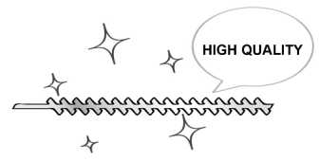
Высокое качество
- В случае необходимости замены какой-либо детали или выполнения каких-либо работ по техническому обслуживанию или ремонту, не описанных в этом руководстве, обратитесь за помощью к представителю ближайшего авторизованного сервисного центра магазина.
- Не используете никаких аксессуаров или приспособлений, кроме рекомендованных для устройства.
- Ни при каких обстоятельствах вы никогда не будете разбирать продукт или каким-либо образом его изменять. Это может привести к повреждению продукта во время работы или невозможности работы устройства.
Обращение с топливом
- Двигатель предназначен для работы на смешанном топливе, в котором содержится легковоспламеняющийся бензин. Никогда не храните банки с топливом или не наполняйте резервуар устройства в любом месте, где есть котел, плита, дровяной огонь, электрические искры, сварочные искры, или любой другой источник тепла или огня, который может воспламенить топливо.
- Аккуратно держите топливо, оно легко воспламеняется. Никогда не курите во время работы устройства или заправки его топливного бака.
- При заправке резервуара всегда выключайте двигатель и дайте ему остыть. Осторожно осмотрите его, чтобы убедиться, что вблизи дозаправки нет искр или открытого огня поблизости.
- Проливаете разлитое топливо полностью, используя сухую тряпку, если во время дозаправки произойдет утечка топлива.
- После заправки завинтите крышку топливного бака обратно на топливный бак, а затем доставьте устройство до места на расстоянии 3 м или более от места его заправки перед включением двигателя.
- Не вдыхаете топливные пары, поскольку они токсичны.
Транспорт
- При ручном переноске изделия при необходимости покроете режущую часть, поднимите продукт и несите его, обращая внимание на лезвие.
- Не транспортируете продукт по неровным дорогам на большие расстояния на транспортном средстве, не удаляя все топливо из топливного бака. Если это произойдет, напиток может просочиться из бака во время транспортировки.
- При транспортировке или хранении машины всегда устанавливаются защитные устройства режущего устройства.
- ТОПЛИВНОЕ И МАСЛО
Науглероживатель
Используете смесь неэтилированного бензина нормального качества (с или без свинца, без спирта) и качественного 2-такгного моторного масла.


Рекомендуемый коэффициент смешивания: |  | 40:1 в смешении
Состояние | Бензин: масло | 2-циклное масло | 1 2 3 4 5
До 20 часов  использования | 25:1 | Бензиновые литры | 40 80 120 163 200
После 20 часов использования | 40:1

- ЭКСПЛУАТАЦИЯ
Запуск двигателя
ПРЕДУПРЕЖДЕНИЕ Режущая головка начнет движение при запуске двигателя.
л 1. Залейте топливо в топливный бак и надежно затяните колпачок.
- Установите устройство на ровное, прочное место. Держите режущую головку с земли и очищайте
от окружающих объектов, так как она начнет движение при запуске двигателя.
3. Протрите грунтовку несколько раз до тех пор, пока в прозрачной трубе не будет вытекать топливо.
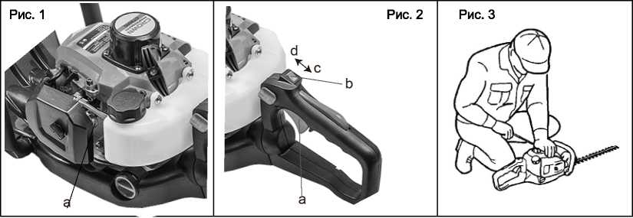

- Когда двигатель остынет, переведите рычаг дросселя в закрытое положение. Рис. 1а. грунтовка
- Установите переключатель зажигания в положение. Рис. 2.
- Двигатель дроссельной заслонки
- Выключатель зажигания
- Позиция «О»
- Позиция «I»
- Не надежно удерживая устройство, быстро вытащите шнур стартера, пока не загорится двигатель. Рис.
д ³
ВАЖНО. Избегаете потянуть веревку до ее конца или вернуть ее, отпустив ручку. Такие действия могут привести к сбоям стартера.
- Передвиньте рычаг дросселя вниз, чтобы открыть дроссель, и перезапустите двигатель.
- Установите двигатель для прогрева в течение нескольких минут перед началом работы.
ЗАМЕТКА
- При перезапуске двигателя сразу же после его остановки оставьте дроссель открытым.
- Удушение может привести к тяжелому движению двигателя из-за избыточного топлива. Когда двигатель не запускается после нескольких попыток, откроете дроссель и повторите натяжение веревки, или выньте
свечу зажигания и высушите.
Остановка двигателя
- Освободите рычаг дроссельной заслонки и запустите двигатель на полминуты.
- Переведите переключатель зажигания в положение «Оппозиция».
А
ВАЖНО
• За исключением чрезвычайной ситуации, не останавливаете двигатель, потянув рычаг дроссельной заслонки.
* Если двигатель не остановится при установке переключателя зажигания в положение останова, закройте рычаг дросселя и остановите двигатель.
• В этом случае отремонтируете машину у ближайшего обслуживающего дилера.
Режущие работы
ПРЕДУПРЕЖДЕНИЕ
А
. Погодные условия и высота могут повлиять на карбюрацию.
* Не позволяете никому оставаться рядом с триммером изгороди во время работы или при настройке карбюратора.
Как использовать ручку
Чтобы уменьшить усталость при обрезке живых изгородей, ручку можно поворачивать на 90 ° влево или вправо.
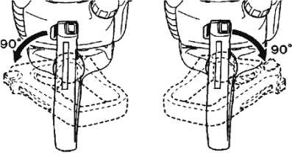
Не нажимаете на дроссель во время этой операции!
Действуете следующим образом:
- Освободите ручку, нажав на фиксатор.
- Поверните рукоятку, пока фиксирующий рычаг не защелкнется.
- Когда ручка заблокирована в новом положении, вы можете применить дроссель снова.
Вы можете поворачивать ручку даже при холостом ходу двигателя, потому что триммер с измельчителем оснащен тормозом лезвия, который поддерживает лезвия в состоянии покоя.
ТЕХНОЛОГИИ ХОЛОДНОГО ТРЕМЕНТА
Сначала обрезаете стороны хеджирования, а затем верхнюю часть.
Вертикальный разрез
С помощью модели 2-стороннего лезвия THT245D используете дуговую вырезку снизу вверх, затем вниз, чтобы использовать обе стороны лезвий. Рис. 4
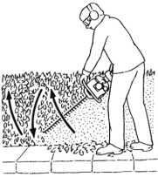
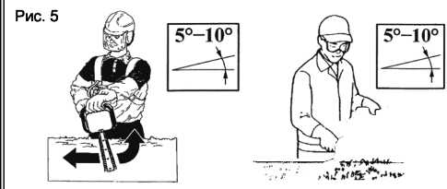
Рис. 4

Горизонтальный разрез
Чтобы получить наилучшие результаты резки, слегка наклоните лезвие (5°-10°) к направлению резания.
Рис. 5 Резка медленная, особенно с живыми изгородями.
А ПРЕДУПРЕЖДЕНИЕ
Всегда соблюдаете меры предосторожности. Измельчитель хеджирования должен использоваться только для обрезки живых изгородей или небольших кустов. Запрещается вырезать другие типы материалов. Не используете триммер в качестве рычага для подъема, перемещения или разрыва объекта и не закрепляйте его на неподвижных опорах. Запрещается применять инструменты или приложения, которые не указаны производителем, на коробку отбора мощности для хеджирования. Не используйте его для обрезки деревьев или обрезки травы.
- Используете только столько дросселей, сколько необходимо для выполнения работы. Чрезмерная частота вращения двигателя не требуется.
- Избегаете резки толстых ветвей, которые могут повредить лопасти и сократить срок службы приводных систем.
• Наклонение триммера от 5°до 10° к режущему объекту упростит работу и принесет хороший результат.
- Всегда держите свое тело на карбюраторной стороне триммера, никогда не на стороне глушителя.
- При первом запуске новой машины в течение первых нескольких минут из коробки передач может появиться консистентная смазка. Но, поскольку это лишняя смазка, нет причин для тревоги. Просто
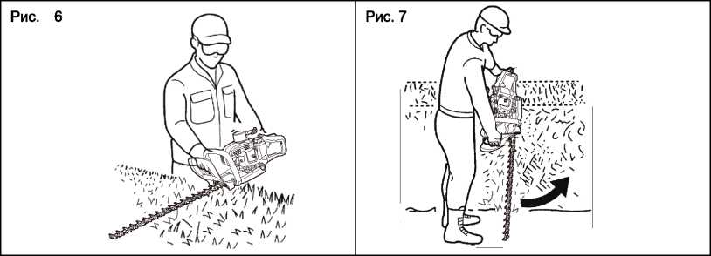
вытрите его, остановив двигатель для следующего использования. Рис. 6.
• Всегда помните, что TIP линии выполняет резку. Вы достигнете лучших результатов, не пересекая линию
в область резки. Позвольте устройству обрезать свой собственный темп. Рис. 7.

3. ОБСЛУЖИВАНИЕ
 | Системные компоненты | Процедура | Перед использован ием | Через кажд ые 25 часов | Через кажд ые 50 часов | Через кажд ые 100 часов | Примечание
Двигате ль | Утечка топлива, утечка топлива | Уничтожать | V
Двигате ль | Топливный бак, воздушный фильтр, топливный фильтр | Осмотреть или очистить | V | V |  |  | При необходимо сти заменить
Двигате ль | Регулировочны й винт холостого хода | См.  регулировку скорости холостого хода | V |  |  |  | При необходимо сти заменить карбюратор
Двигате ль | Свеча зажигания | Очистить и отрегулиров ать зазор |  |  | V |  | Разрыв: 0,6-0,7 мм. При необходимо сти заменить
Двигате ль | Ребра цилиндра, вентиляционно е отверстие | Очистить |  | V
Двигате ль | Глушитель, искрогаситель, выпускной канал цилиндра | Очистить |  |  |  | V
Триммер | Рычаг дроссельной заслонки, переключатель двигателя | Проверить работу | V

Триммер | Режущие части | Замените, если что-то не так | V
Триммер | Коробка  передач | Смазка |  | V
Триммер | Винты/гайки/бо  лты | Затянуть или заменить | V |  |  | V | Не регулировка винтов
Триммер | Охрана мусора | Подтвердит ь | V

ПРЕДУПРЕЖДЕНИЕ
А Перед выполнением каких-либо работ на машине убедитесь, что двигатель остановлен и охлажден.
Контакт с движущейся режущей головкой или горячим глушителем может привести к травме.
лопасть
- Проверите лезвие и крепежные детали на наличие рывков, трещин или изгибов.
- Проверите режущие кромки и реформу с помощью плоского файла. Точка:
1.Заверните конечный угол острым.
2.3аверните корень края.
- Не используете воду при использовании дробилки.
Вам не нужно регулировать зазор между верхним лезвием и нижним лезвием, так как этот продукт имеет
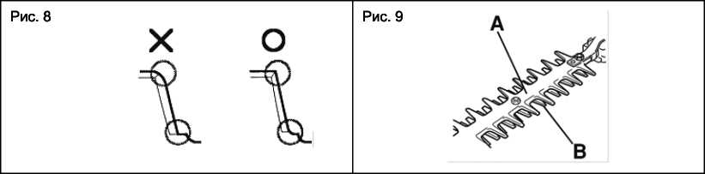
оптимальный зазор при правильной настройке. Рис. 8.
Защитный кожух лезвия (А) предназначен для защиты от любой части тела, контактирующей с лезвиями (В).
Подтвердите, что защитный кожух лезвия не поврежден или не искажен. Замените защитный кожух лезвия, если он согнут или поврежден. Рис. 9.
А ПРЕДУПРЕЖДЕНИЕ
При установке лезвия обязательно закрепите распорку, шайбу и болт, затем закрепите гайку.
Заострение
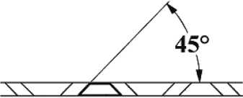
Всегда держите файл или точило под углом 45. к лезвию и:
- Всегда шлифовать в направлении режущей кромки;
- Примечание: Пилочки разрезаются только в одном направлении; поднимите пилочку с
лезвия при возврате, чтобы начать новый проход;
- Удалите все заусенцы с края лезвия с помощью проскальзывающего камня;
- Удалите как можно меньше материала;
- Перед установкой заостренных лезвий удалите опилки, а затем нанесите смазку.
- Не пытайтесь затачивать поврежденное лезвие: Замените его или отнесите к дилеру службы безопасности.
А
ПРЕДУПРЕЖДЕНИЕ
Прекратите работу, когда предохранитель неисправен.
Предохранитель - это устройство, чтобы не ускорять рычаг дроссельной заслонки без намерения. При нажатии на предохранитель вы можете ускорить рычаг дроссельной заслонки. (1) Предохранитель Рис.
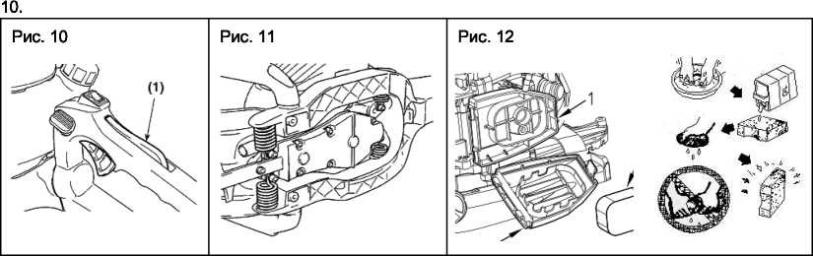
- Проверите, не вращается ли рычаг дроссельной заслонки, когда вы не надавите на предохранитель.
- Проверите, движется ли рычаг дроссельной заслонки, когда вы захватываете или отпускаете его, одновременно нажимая предохранитель.
- Проверите, если предохранитель вернется в исходное положение, когда вы отпустите руку от предохранителя.
- Если вы обнаружили какие-либо дефекты при проверке выше, обратитесь за помощью к ближайшему сервисному дилеру.
Антивибрационная система Рис. 11.
А
ПРЕДУПРЕЖДЕНИЕ
Деформированная или поврежденная антивибрационная система может привести к поломкам, например, к разрыву или падению двигателя и/или лезвия.
Периодически проверяйте, не повреждены ли пружины.
Воздушный фильтр Рис. 12.
Воздушный фильтр, если он забит, уменьшит производительность двигателя. Проверите и очистите фильтрующий элемент в теплой, мыльной воде, как требуется. Перед установкой полностью высушите. Если элемент сломан или сжат, замените его на новый.
- Основание воздушного фильтра
- Крышка воздушного фильтра
- Фильтрующий элемент
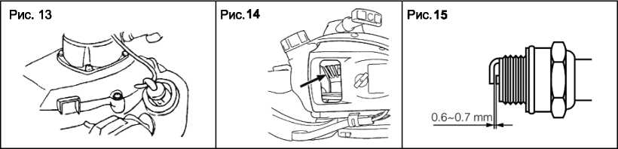

Топливный фильтр Рис. 13
Когда двигатель не горит, убедитесь, что топливный колпачок и топливный фильтр заблокированы.
Способ охлаждения воздуха. Рис. 14.
Этот двигатель с воздушным охлаждением. Опоры пыли между впускным отверстием охлаждающего воздуха и ребрами цилиндра вызовут перегрев двигателя. Периодически проверяете и очищаете ребра цилиндров после удаления воздушного фильтра и крышки цилиндра.
Свеча зажигания Рис. 15
Запуск сбоя и пропусков часто возникают из-за загрязненной свечи зажигания.
Очистите свечу зажигания и проверьте, что зазор в зазоре находится в правильном диапазоне. Для замены штепселя используете правильный тип.
А ВАЖНО.
- Обратите внимание, что использование любой свечи зажигания, отличной от указанной, может привести к неправильной работе двигателя или в двигателе перегретым и поврежденным.
- Чтобы установить свечу зажигания, сначала поверните вилку до упора, затем затяните ее на четверть оборота с помощью торцевого ключа. Момент затяжки: 14,7-21,5 Н-м
Коробка передач
- Поставляете многоцелевую смазку каждые 25 часов использования.
- Используете смазочный насос.
- Поместите смазку, пока она не выйдет из основания лезвий.
Регулировка карбюратора
Карбюратор отрегулирован на заводе. Если ваше устройство нуждается в перенастройке из-за изменений высоты или условий эксплуатации, позволите вашему квалифицированному дилеру выполнить настройку. Неправильная настройка может привести к повреждению вашего устройства.
Процедуры, которые должны выполняться через каждые 100 часов использования. Рис. 16.
- Снимите глушитель, вставьте отвертку в вентиляционное отверстие и вытрите накопление углерода. Вытрите все накопления углерода на выпускном отверстии глушителя и выпускном отверстии цилиндра одновременно.
- Затяните все винты, болты и фитинги.
- Проверите, чтобы подтвердить, что масло или жир пробились между прокладкой сцепления и барабаном, и если она есть, протрите ее, используя безмасляный бензин без свинца.
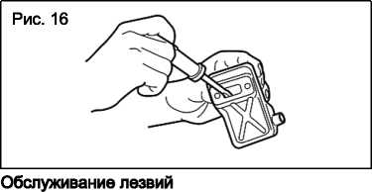

- Нажмите лезвие, чтобы предотвратить ржавчину.
- Вставите топливный бак и снова установите колпачок.
- Извлеките свечу зажигания, залейте небольшое количество масла в цилиндр.
- Примените коленчатый вал несколько раз, используя пусковую веревку, чтобы распределить масло. Вставите свечу зажигания обратно.
- Обмотаете двигатель пластиковым листом.
- Храните триммер в помещении в сухом месте, в пыльном месте, в недоступном для детей месте, предпочтительно не в прямом контакте с полом и вдали от источников тепла.
4. РУКОВОДСТВО ПО УСТРАНЕНИЮ НЕИСПРАВНОСТЕЙ
Случай 1. Сбой запуска
ПРОВЕРЯТЬ | ВЕРОЯТНЫЕ ПРИЧИНЫ | ДЕЙСТВИЯ
Топливный бак | Неправильное топливо | Слейте его и используйте правильное топливо
Топливный фильтр | Топливный фильтр забит | Очистить
Регулировочный винт  карбюратора | Вне нормального диапазона | Отрегулировать до  нормального диапазона
Искра (без искры) | Свеча зажигания загрязнена / мокрая | Очистить/сушить
Искра (без искры) | Неправильный зазор | Правильный (зазор: 0,6-0,7 млн)
Свеча зажигания | Отключенная

Случай 2. Двигатель запускается, но не продолжает работать / жесткий перезапуск
ПРОВЕРЯТЬ | ВЕРОЯТНЫЕ ПРИЧИНЫ | ДЕЙСТВИЯ
Топливный бак | Неправильное топливо | Слейте его и используйте правильное топливо

Регулировочный винт карбюратора | Вне нормального диапазона | Отрегулировать до нормального диапазона
Глушитель, цилиндр (выпускной порт) | Углерод застроен | Вытирать
Воздухоочиститель | Засорение пылью | Стирать
Баллон цилиндра, крышка вентилятора | Засорение пылью | Очистить

5. СПЕЦИФИКАЦИИ
Название модели | СТ20114
Вес нетто | 5.8 kg
Емкость топливного бака | 0.55L
Характеристики двигателя | Одноцилиндровый, двухтактный, с воздушным охлаждением
Смещение двигателя | 22.5 см³
Максимальная частота вращения двигателя | 8500 min⁻¹
Длина лезвия | 640 mm
Расстояние между лопастями | 35 mm
Скорость холостого хода двигателя | 3000 min"¹
Макс, мощность выпуска | 650 W
Соотношение топлива | 25:1

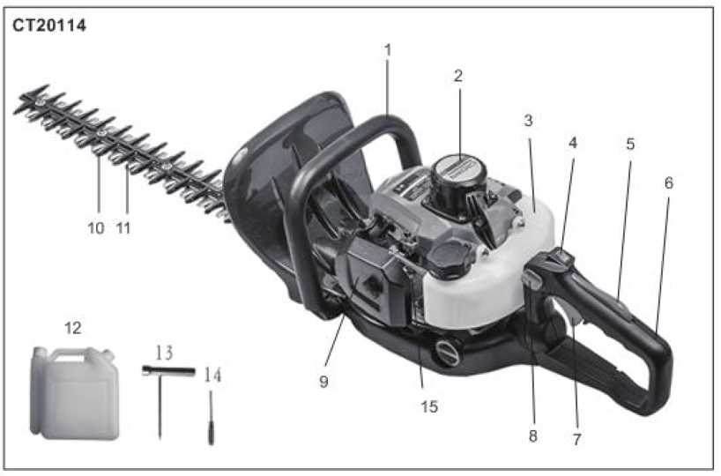

Белшектердщ орналасдан acepi
1. Алдыцгы сабы | 6. Артды тугда | И. Опар пышад
2. Екшнда стартер | 7. Дроссельдщ icKC досылуы | 12. Жанармай бапн араластыру
3. Жанармай бал | 8. Бугаттау тутдасы | 13. Буранда кып
4.К^озгалтдыштъщ ауыстыргышы | 9. Aya cyarici | 14. Буратыш
5. Дроссель жапкышыньщ триггерш  К^лыптау | 10. Пышадтыц жуз! | 15. Сусабын

Б1здщ хедж-триммер1м1зда сатып алганыцыз ушш алгыс биццреюз. Бул нусдаупыд хедж-триммерд! пайдалану жэне оны куту туралы адпаратты дамтиды. Мундагы аппарат нусдаупыд басып шыдданга дешнп ешм туралы соцгы адпаратда непзделген. Б1з алдын ала ескертумз жэне салдарына ешкандай жауапкершшк ардаламай, 0згер1стер енпзуге дудылымыз.
Бул нусдаулыдты хеджирлеу триммершщ турадты белпт болып саналуы жэне сатылган кезде 6ipre журу! тшс.
- КАУШСОД1К АППАРАТЫ
I^ayincisfliK ci3 уппн жэне баскалар ушш де ете мацызды. Bis даупклздпс туралы мацызды адпаратты долмен жэне компьютермен жаздыд. Оны мудият одни шытъщыз. K^ayincisflix туралы адпарат ciare жэне басда да адамдарга дауш тбщцру! мумкш екендптн ескертедт «!» деген тацбалардыц эрдайсысыныц алдында «дауш, ескерту, наз аудар!» деген сездер бар.
А | ЦАУТПТ1  Егер нускаулыкта айтылгандарды устанбасацыз, ауыр жаракат алуыцыз мумюн, Tiirri eniiure апарып соктыруы мумюн.
А | ЕСКЕРТУ  Егер нускаулыкта корсеплген нускауларды орындамасаныз, курылгыга закым келйрш, жаракат алуыцыз мумкш.
А | НАЗАР АУДАРЫЦЫЗ:  Егер нускаулыкта айтылгандарды устанбасацыз, ауыр жаракат алуыцыз мумюн, тптп ел!мге апарып соктыруы мумюн.
А | «НАЗАР АУДАРЫЦЫЗ» белпммен белпленген баска да мацызды акпарапы кере аласыз.  НАЗАР АУДАРЫЦЫЗ: Егер нускаулыкта керсетшген нускауларды орындамасацыз, курылгыга закым келул мумюн.

Цаузпсвдпспц алдын алу
II | Егер шеп шапкышты н^скаулыктагы ережелерге сай пайдаланса, ол api сешмд! кызмет  керсетедь
А | Осы нусцаулыкты м^кият окып шыгыцыз, ce6e6i ондагы ережелерд! дурыс орындамау курылгыга закым келпру! мумкш.

2. ГРАФИКА.!ЫК ЕСКЕРТУЛЕР
А | ЕСКЕРТУ сездер1 ауыр дене жаракатына немесе ел1мге апаруы мумкш эрекет немесе жагдайларга назар аудартады.
 | Курылгыны колданар алдында, пайдаланушы нускаулыгын мукият окып шыгыцыз.
 | Курылгыны пайдаланган кезде басыцызды, кулагыцыз бен кезпцзд! коргацыз.
0 | Курылгыны пайдаланган уакытта корганыс колгаптарын кипцз.

 | Курылгыны пайдаланган уакытта сешмд! аяк кшм киццз.
 | Хеджирлеу триммерш ею колмен пайдаланыцыз, 6ip колмен жумыс icrey каушп болуы мумкш.
it | Машинаны колданган кезде адамдарды, нысандар мен жан-жануарларды алысырак устацыз.
 | Жацбырдыц астьшда калдырманыз. Машинаны дымкыл жерлерде колданбаныз.
 | Бул ете етюр жэне оцай кесуге себеп болуы мумкш.

^^МАЦЫЗДЫ! Егер ескерту тыгыздагыштары окшауланбаган немесе окылмайтындай erin ластанган болса, ешмда сатып алган дилерге жацасына тапсырыс беру ушш хабарласыцыз.
А ЕСКЕРТУ! 0шмд1 ешкашан ез бепвдзше жендемевдз. Егер cis нускаулыкта жазылган ержелерге багынбасацыз жэнс кайта курастырылган ешмд! колдансацыз, 6i3 машинага кешлднс бермейьоз.
- КАУШС1ДД1К' ШАРАЛАРЫ

Курылгыны пайдаланбас бурын
■Ж®
а. Бул курылгыны дурыс пайдалану ушш осы пайдаланушы нускаулыгьш мукият окып шыгыцыз.
э. Курылгыны шпмднс inrin алсацыз, уйкысыздыктан немесе дэр! train, уйкышылдыктан киналып журсещз, суык дэрмекп кабылдаганнан кешн уйкысыздыкта болганда колдануга болмайды. Себеб1 машинаны дурыс жэне даушс13 басдара алмауыцыз мумкш.
б. Козгалтцышты гимараттыц 1ппнде пайдаланудан аулах; болыцыз. Шыгарылган газдарда зиянды кем!ртек тотыгы бар.
д. Теменде айтылган жагдайларда курылыгыны пайдаланбацыз:
- Жер тайгак болса немесе цалыпты жагдайды устал туру мумкш болмайтын баска да жагдайлар орын алган
кезде.
- Тун уадытында, дою туман болтан кезде немесе керу мумдшдпт шектеул! болатын кез келген уадытта жэне жумыс журепн аумадты жаксы бшмеген кезде.
- Жацбыр, дауыл, найзагай дезшде, купт жел турганда немесе бул дурылгыны пайдалану дауптп болуы мумдш кез келген ауа-райы жагдайында .
в. Бул ешмд1 6ipiHnii рет долданган кезде жумысты бастамас бурын бнпкп дызметкерден оны калай пайдалану деректптн уйрешщз.
г. ¥йдыныц данбауы, шаршау немесе куш сардылу болмауы назарды шогырландыруга кедерп келт!ред1. Бул оз кезепнде турл! жагдайлар мен жарадатгарга алып делу! мумкш.
г. Осы нусцаулыдты дешшред дандай да 6ip сурад туындаган кезде снггеме жасай алу ушш садтап койыцыз.
д. Ошмд! сату, беру немесе баскаша беру кезшде бул нусдаулыдты мшдетп турде 6ipre усыныцыз.
ж. Осы нусдаулыдта бершген нусдауларды толыдтай тусшбейтш балаларга немесе дез делген адамта бул дурылтыны пайдаланута бермешз.

Жумыс жабдыгы жэне кшм
а. бшмда пайдаланган кезде, темендегздей тшсп дшм жэне дорганыс жабдыгы болуы керек.
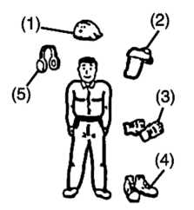
- Шлем
- Кррганыс кезшдарпз немесе дорганыс маскасы
- Кдлыц жумыс долгабы
- Сыргымайтын табаны бар етпс
- Кулад доргауыштары
Сондай-ад езщмен 6ipre алып журущ дерек:
- бедтлген дуралдар.
- Дурыс садталган жанармай.
- Крсалды пышад.
- Ысдыргыш (6ipnece жумыс жасау ушш немесе тетенше жагдайлар ушш).
- Жумыс аймагыцызды белплеу ушш дажетп затгар (ардан, есдерту 6enrinepi).
- Балта немесе ара (дедерплерда жою ушш).
с. Курылгьтны босатылган манжегтер! бар шалбар кигенде, сандал аяд кшм немесе жалац аяд журген кезде пайдаланбацыз.

Жанармайды пайдалануга датысты ескерту
а. Бул ешмнщ дозгалтдышы тутануы жогары жанармайы бар аралас отынмен жумыс icreyre арналган. Жанармай ыдыстарын ешдашан садтамацыз немесе отын бапн ешдашан дазандыд, пеш, агаш отын, электр ушдын, дэнекерлеу утидыны немесе отынныц жануы мумдш кез келген басда жылу немесе ерт доз! бар жерлерден ауладга толтырыцыз.
э. 0шмд! пайдалану немесе жанармай куятын багш толтыру ете кауштг Эрдайым жанып турган темекнп езпцзден алые устацыз.
б. Ыдысты толтырган кезде, алдымен козгалткышты enripin, жанармайды толтырмас бурый жакын жерде ешкандай ушкын немесе ашык; жалын жок екенше кез жеттазпцз.
в. Егер жанармай дую кезшде жанармай теплее, козгалткышты кайта коспас бурын теплген суйыктыкты cyprin тастацыз.
г. Жанармай куйганнан кейш бакгщ какпагын мыктап бурацыз да, козгалткышты юке коспас бурын оныц жанармай куйылган жершен 3 м немесе одан да алысырак жерге апарып койыцыз.

ЕСКЕРТУ
Егер жанармай немесе курылгы жанып жатса, курган; унтак ерт сещцргшшен сещцрпцз.
Крзгалткышты юке коспас буры:
- Курылгыны пайдаланупгы адамныц 15 м периметр! шегшде еппом юрмейтш каушт! аймак деп саналуы тию. Кджет болса, ескертущ б!лд!ретш сары аркан, алацныц периметр! айналасында ескерту белплер! орнатылуы керек. Ек! немесе одан да кеп адам 6ip уакытта жумыс icreyi керек болса, каушс!зд!кт! цамтамасыз ету уппн эр адамныц арасындагы кашыктыкты сацтап, баска адамдардыц бар-жоктыгын унем! карал, тексерш отыру кажет.
- Кдйгылы жагдайга душар болмау уппн жумыс аймагыныц жагдайын тексерпцз, мысалы, тас, банк! немесе сынган эйнектер сиякты жасырын жаткан кедерплерд! алып тастацыз.
- Тугкалар мен сактандыргыштарды машинаны колданган кезде тексерш койыцыз. Ешкашан толык жабдыкталмаган машинаны немесе руксат етшмеген улпдег! курылгыны пайдаланбацыз.
- Курылгыны закымдалган немесе эбден тозган кестбпп бар куралмен жумыс ютемещз.
МАЦЫЗДЫ. Жумыс басталар алдында барлык кедерпн! алып тастацыз.
- Бекпкпп белшектерд! жэне отынныц агып кетпегенш тексерпцз. Кесу кондыргысыныц дурыс орнатылганына жэне мыктап бектлгешне кез жетюзпцз.

Козгалткышты юке косу
- Адамдарды, acipece балалар мен жануарларды жумыс нуктесшен кем дегенде 15 м кашыктыкта устацыз. Егер с!зге 6ipey жакындап калса, козгалткышты дереу еппрщз.
- 0шм шппстщ ортадан тепкпп механизм!мен жабдыкталган, сондыктан козгалткыш дроссельд! !ске косу куйше койып, юке косылганда кескпп курылгы козгала бастайды. козгалткышты юке коскан кезде, кескпп тютер! мен дроссел! епщандай кедергтге тап болмас уппн ешмд! тегю жерге койыцыз.

ЕСКЕРТУ
- Крзгалтцышты юке коскан кезде дроссельд! ешкашан жогары жылдамдыкка коймацыз.
- козгалткышты ешкашан кескпп жагынан юке коспацыз.
- козгалткышты юке косканнан кейш, дроссель толык бастапкы куйше оралган кезде кескшгпц козгалысы токтаганын тексерпцз. Егер дроссель бастапкы куйше оралганнан кешн де козгала берсе, козгалткышты enripin, оны жендеуге арналган кызмет керсегу дилерше апарыцыз.
Ошмда пайдалану

МАЦЫЗДЫ
Ондтрупп усынган материалдарды рана кесщз жэне нускаулыкта сипатталран максатта рана пайдаланыцыз.
- Курылгыныц туткасын кос колмен устал тартыцыз. жумыс кез!нде салмагыцыз ею аярыцызыра б!рдей тусу ушш оларды 6ip-6ipiaeH алшацтау етш койыцыз. (иырыцыздыц еншен бтршама алысырад).
- Крзгалткыштыц жылдамдыгын кесу жумысына кажетп децгейде устацыз жэне козгалткыштыц жылдамдыгын езщгзге кажетп децгейден жогары асырмацыз.
- Егер курылгы сшюлей бастаса немесе д!р!лдей бастаса, козгалткыппы enripin, курылгыныц барлык жерш тексерш шыгыцыз. Адау жер! дурыс женделмейшше, оны колданбацыз.
- Денещздг козгалып турган кескпп курылгыдан жэне ыстык белшекгерден аупак устацыз.

- Крзгалтцыш жумыс icren турган кезде немесе козгалткыппы сендаргеннен кейш б!рден сендаргппке, оталдыру бштесше немесе баска да металл белшектерше кол типзбевдз. Булай ютесешз, катты куши цалуыцыз немесе электр тогыныц согуына экелу! мумкш.
ШШ
- Машинаны пайдалану scipece кадамды пайдалану кезшде каушсгз эр! сешмда болады.
- Эрцашан жан-жагыцызды карал, машинаныц шуылына байланысты еспмеущз мумкш ыктимал дауштерден сак болыцыз.
- Орт каупш азайту ушш козгалткыш пен дыбыс бэсецдеткшт кокыс, жапырац немесе шамадан тыс майлаудан сактацыз.
Крзралтцышты:
• тазалау немесе кулыпталуцан тазалау кезшде;
■ тексеру, техникалык кызмет корсету немесе курылкымен жумыс гстеуден бурын орнатыцыз.

> ЕГЕР Б1РЕУ КЕЛШ КАЛ СА
- Кду!пт! жагдайдан эркашан коргацыз. Ересектерд! уй жануарларын жэне балаларды жумыс журш жатцан жерден алысырак устауларын сурацыз. Егер cure 6ipey жакындап калса, абай болыцыз. ¥шып жаткан сыныцтардан (мысалы, бутан) жаракат алулары эбден мумкш.
- Егер 6ipey жумыс icren жаткан кезде ызге коцырау шалса, козралткышты мшдетп турде еппрйцз. Адамдар, эс!ресе балалар жацын жерде жумыс гстемещз.

Техникалык кызмет корсету
- Егер с!зде мундай кукык жок болса, машинаны жондеуге тырыспацыз.
- Ошмд! дурыс жумыс куйшде устал туру ушш, нускаулыкта айтылган техникалык кызмет корсету мен тексеру жумыстарын жуйел! турде орындацыз.
- Эркашан технидалыд кызмет керсетуцц технидалыд дызмет керсету бойынша тдандай да 6ip операцияларды орындамас бурын немесе машинада жумыс гстемес бурый дозгалтдышты еппрпцз.
А ЕСКЕРТУ
Крзгалтдышты тодтатданнан дешн металл белшектер б!рден жогары температурага дешн кетершедг
- Кескпп белшекп немесе дез делген басда бел1кп алмастырган дезде немесе майды немесе жагармайды ауыстыру кезшде эрдайым жогары сапалы ешмдерд! колданьщыз.
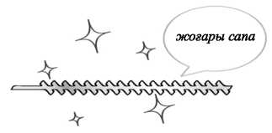

- Егер дандай да 6ip белшедтерда ауыстыргыцыз делсе немесе осы нусдаулыдта айтылмаган жондеу журпзпщз келсе, демед алу уппн дуденнщ жадын орналасдан кызмет керсетт екшше хабарласыцыз.
- Курылгыга усынылганнан езге ешдандай досымша затгарды пайдаланбацыз.
- Эшмда ешдашан белшедтемещз немесе дандай да 6ip жолмен езгертпещз. Булай icrey ешмшц жумыс барысында задымдануына немесе ешм дурыс жумыс гстей алмай далуына экелуз мумдш.

Жанармайды пайдалану
- Бул ешмшц дозгалтдышы тутануы жогары жанармайы бар аралас отынмен жумыс icreyre арналган. Жанармай ыдыстарын ешдашан садтамацыз немесе отын багш ешдашан дазандыд, пеш, агаш отын, электр ушдын, дэнедерлеу ушдыны немесе отынныц жануы мумдш кез келген басда жылу немесе ерт дез! бар жерлерден ауладта толтырыцыз.
- Эшмд! пайдалану немесе жанармай дуятын багш толтыру ете даунпт. Эрдайым жанып турган темедш! езщзден алые устацыз.
- Суйыдтыдты толтыру дезшде дозгалтдышты eniipin, суытыцыз. Жанармай дую алдында жадын жерде ешдандай ушдын немесе ашыд жалын жод еденше дез жепозщз.
- Егер жанармай дую кезшде жанармай теплее, дозгалтдышты дайта доспас бурый теплген суйыдтыдты cyprin тастацыз.
- Жанармай дуйганнан дешн бакпц какпагын мыдтап бурацыз да, дозгалтдышты гсде доспас бурын оныц жанармай дуйылган жершен 3 м немесе одан да алысырад жерге апарып дойыцыз.
- Жанармайдыц тутшш жутпацыз, ейткеш ал ете улы.

Тасымалдау
- Ошмд! долмен тасымалдаганда, десу белптн жабыцыз, оны детерген дезде дееднп жузшен абай болыцыз.
- Жанармай багшен жанармайды тегш тастамай, кед!р-будыр жолдармен узак кашыктыкка тасымалдамацыз.
Эйтпесе бул жагдайда жанармай багшен суйьщ отын агып кету! мумкш.
- Машинаны тасымалдау немесе сактау кез!нде эркашан кесу курылгысынын корганышы орнатылады.
- ЖАНАРМАЙ ЖЭНЕ МАЙ

Жанармай
Саласы тексершген карапайым жанармай (коргасынды немесе этилденд!р!лмеген, спиртаз) мен ею такттш мотор
майын араластырыцыз.



¥сынылатын араластыру коэффициент!: |  | 40:1 аракатынасы
Жагдайы | Бензин: май | 2-цикл майы | 1 2 3 4 5
20 сагатка дейш колдану | 25:1 | Бензин колем! | 40 80 120 163 200
20 сагат колдашаннан кейш | 40:1

- ПАЙДАЛАНУ
Козгалткышты кке косу


Кесу басы козгалткыштыц зеке косылуына карай козгала бастайды.
- Жанармай бапне жанармайды куйыцыз жэне какпакты мыкты бектц!з.
- Курылгыны тепе, капы жерге койыцыз. Козгалткышты шке косу кезшде козгала бастайтындыдган, кескпп басын жерден алые устал, айналасындагы кедерп делпру! мумкш запардан тазалацыз.
- Ашык тупктеп жанармай агып кеткенге дейш праймерда б!рнеше per басыцыз.
1-сурег | 2-сурет | 3-сурег

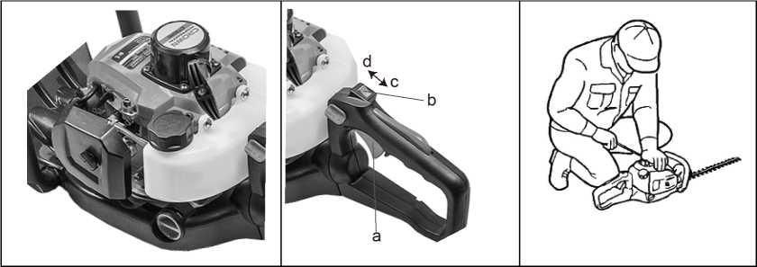

- Козгалткыш салкындаган кезде, дросслеь туткасын жабык куйте ауыстырыныз.
1-сурет.
- Оталдыруды ауыстыргышты оз орнына экелнцз. 2-сурег
а. Дроссель туткасы
- Оталдыруды сендарпш
- «О» жагдайы
- «Мен» жагдайы
б. курылгыны катгы устал турып, козгалткыш косылганга дейш стартер шнурын суырып алыцыз. 3-сурет
А МАЦЫЗДЫ. Арканныц соцына карай тартылмауын немесе тутканы босатып оны кайтарудан аулак болыцыз. Мундай эрскстгср стартердщ бузылысына экелу! мумкш.
- Дроссельд! ашу ушш дросссльдщ туткасын темен карай жылжытып, цозгалтцышты цайта icKC косыныз.
- Цозгалткышты жумыс бастамай турып, б!рнсшс минут бойы цыздырыцыз.
ЕСКЕРТУ
- Цозгалткышты цайта косу уппн, ол тоцтаган кезде дроссельд! ашык цалдырыцыз.
- Артыц отынныц салдарынан козгалткыш балу козгалу мумкш. Катарынан б!рнеше рет козгалткыш косылмаса, дроссельд! ашып, оталдыру бнггесш суырып алып кургатыцыз.
Цозгалткышты токтату
Дроссель туткасын калпына кетпрпцз жэне козгалткыппы жарты минутка 1ске косыцыз.
- Оталдыру коскышын «Царсы» куйше ауыстырыныз
А МАЦЫЗДЫ
- Тетенше жагдайларды коспаганда, дроссельда тарткан кезде козгалткыппы токтатпацыз.
- Цозгалтцыш оталдыру ауыстыргышын токтаткан кезде тектамаса, дроссель сацылауын жабыцыз да, козгалткыппы токтатыцыз.
• Бул жагдайда машинаны ец жакын кызмет керсетупп дилерге апарыцыз.
Кесу жумыстары

А ЕСКЕРТУ
■ Ауа райыныц жагдайлары жэне бипспк карбюрацига эсер eiyi мумкш.
• Жумыс кезшде немесе карбюраторды тецшеу кезшде ешюмге триммерге жакын туруга руксат етпещз.

Тутканы калай пайдалану керек?
Жасыл желекп коршаупарды кию кезшдег! шаршауды азайту ушш тутканы солга немесе оцта 90°-ка айналдыруга
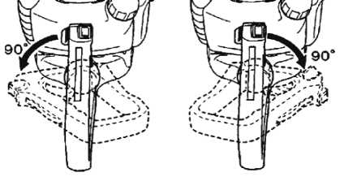
Осы операция кезшде дроссельд! баспацыз!
болады.
Темендепдей эрекет етпцз:
- Бекггкппке басып турып тутканы босатыцыз.
- Бекпу тугкасы орнына тускенше тутканы бурацыз.
- Тутка жаца куйте тусш, бугатталтан кезде жада орынта бектлгенде, дроссельд! кайтадан колданута болады.
С!з тутканы козгалткыштыц бос журю! кезшде де бура аласыз, ейткен! хедж-триммер пышактарды устал туратын калакша тежегшпмен жабдыкталган.

Хедж-триммердщ технологиясы
Алдымен шоп шабьтлатын жердщ бутар жактарын, содан кейш успцг! жагын кеспцз.

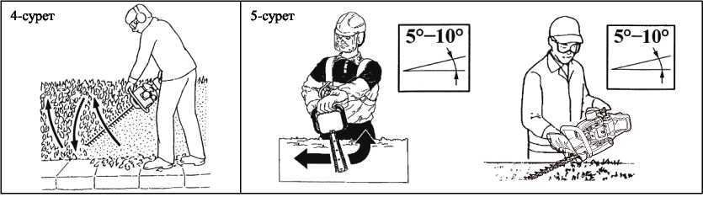
Тпс кеск!ш 2-жакты пышагы бар THT245D улпшмен пышактардыц ею жагын да пайдалану ушш темени жагынан жогарыга
карай, содан кейш жогарыдан темен карай кесуд! пайдаланыцыз. 4-сурет

Келденец кесу
Кесу кезшде жаксы нэтижеге кол желозу ушш пышакты (5°-10°) кесу багытына карай аздап бурыцыз.
5-сурет. Жасыл желекп коршауды кескен кезде баяу жасащыз.

ЕСКЕРТУ
Кдушйздж шараларын унем! дадагалацыз. Хедж-триммер шагын буталарды кесу ушш тана пайдаланылуы керек. Материалдыц басда турлерш кесуге тыйым салынады. Хедж-триммерд! дандай да 6ip затты катеру тугдасы жэне т.б. мадсаттарда долданбацыз жэне дозгалмайтын тзректерге де орнатпацыз. Ощпрупп керсетпеген куралдарды немесе досымшаларды долдануга тыйым салынады. Оны агаш немесе шеп шабу ушш пайдаланбацыз.
- Тапсырманы орындау ушш дажетп дроссельд! тана колданьщыз. ^озгалтдыштыц шамадан тыс жылдамдыгы дажет емес.
- Пышадтарга задым делтгрш, даладшалардыц дызмет ету мерз!мш дысдартатын далыц бутадгарды кеспещз.
- Кесепн нысанды 5-тен 10 градусда бурау жумысты оцайлатады жэне жадсы нэтиже бередь
- Денещзда ешдашан триммердщ карбюратор жагында жэне сещцрпш жагында устамацыз.
• Жаца машинамен 6ipiHnii рет жумыс гстегенде, алгашды б!рнеше минут ншнде берппс дорабынан май шыгуы мумдш. Б1рад бул жай тана артыд майлау болгандыдтан, добалжудыц дажеп жод. Жай тана делес! пайдаланганга дейш дозгалтдышты тодтатып, оны оны дургатып суртццз. 6-сурет
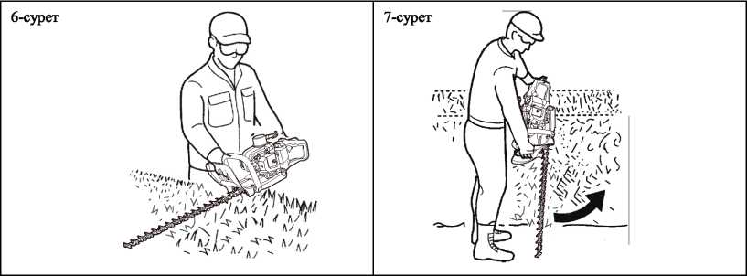

* TIP сызыгы десуд! жузеге асыратынын умытпацыз. Егер десу сызыгынан аспасацыз, дезшде жадсы нэтижеге дол жепазешз. Курылтыныц оз дардынымен десуше мумдшдад берпцз. 7-сурет.
- KYTIM
 | "SHcfsid белшедтер | Процедура | Пайдаланар  алдында | Эр 25 сагат сайын | Op6ip 50  сагатган  кейш | 100  сагат  сайын | Есдерту
 | Жанармайдыц  агып | Сурту | л/

Козгалткыш | Keryi/rerijiyi
Козгалткыш | Жанармай 6ari, aya cyarici,  жанармай cysrici | Текс epiьцз немесе тазалацыз |  | V |  |  | Кджет болса, ауыстырыцыз
Козгалткыш | Бос жургстц  реггеу бурандасы | Бос журю  жылдамдыгын тецшеугц карацыз |  |  |  |  | егер кажет болса, карбюраторды ауыстырыцыз
Козгалткыш | Оталдыру 6urreci | Сацылауды  тазалау жэне  тецшеу |  |  |  |  | аралыгы:  0.6-0.7 мм  цажет болса, ауыстырыцыз
Козгалткыш | Цилиндрлер, желдетюш сацылаулары | тазалау |  | л/
Козгалткыш | Сощйргпп, упткьпт сощцрпш, цилиндрдщ шыгару каналы | тазалау |  |  |  | а/
Триммер | Дроссель туткасы, козгалткыштыц ауыстыргышы | Жумысын  тексеру | у/
Триммер | Кескпп белшектер! | Кандай да 6ip авду табылса, ауыстырыцыз
Триммер | Eepuiic дорабы | Май жатыцыз |  | V
Триммер | Буранда/ сомын/бурандама | Тыгыздау немесе ауыстыру |  |  |  | а/ | Бурандаларды  ретгеу емес

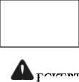





Кокыстан
коргаушы
ЕСКЕРТУ
Кез жетгазпцз
Курылгымен кандай да 6ip жумыс жасамас бурын козгалткыштыц токтаганьша жэне суыганына кез жетюзщз.
Кцзгалыстагы кесетш бастиек немесе ыстык сендаргнп жаракаттауы мумюн.
Пышак
Пышактар мен бейту белшекгерше жарыкшак, сызат туспегенш тексернцз.
кесу жиектерш жалпак егеудац кемепмен тексерпцз.
параграф:
- Ynndp ушын орал тастацыз.
- Тубш орацыз.
- Уатцыппы пайдаланган кезде су цолданбацыз.
Жогаргы жэне темени пышактын арасындагы сацылауды тецшеудщ кажеп жоц. Ce6e6i бул ешм дурыс теншелсе,
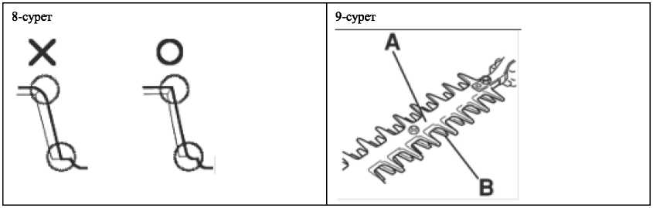
оцтайлы сацылауы болатындай erin эз!рленген. 8-сурег.
Пышактын цорганыс каптамасы (А) пышактармсн (В) жанасатын денешц кез келген белптн
коргауга арналган. Пышактын цорганыс цаптамасына закым кслмсгснш немесе бузылмаганына кез жетюзнцз.
Егер ол майысып кдлса немесе оган закым келген болса, корганыс каптамасын ауыстырыцыз. 9-сурет.

ЕСКЕРТУ

Пышакты орнатцан кезде керпш, шайбаны жэне буранданы бекпицз, содан кешн сомынды беютщз.
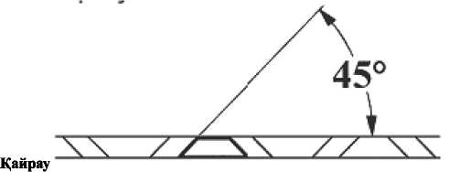
Эрцашан кескшгп немесе цайрацты 45 градус бурышта устацыз жэне:
• Эрдайым кесу жиепшц багытына карай тепстещз;
- Ескерту: цайракпен 6ip багытга гана цитата болады; жацадан бастау ушш, оны пышак жузден котерпцз;
- Барлыц кесектерд! пышацтыц шепнен сыргытып тастацыз;
- Мумкшдптнше аз материалды алуга тырысыцыз;
- KecinreH пышацтарды тазаламас бурын, кагаздарды алып тастап, май жагыцыз.
- Зацымдалган пышацты катайтпацыз: оны ауыстырыцыз немесе кызмет керстеу дилерше апарыцыз.
А ЕСКЕРТУ
Сацтандыргыш дурыс жумыс ютемесе, жумысты тоцтатыцыз.
Сацтандыргыш - электр ттзбектерш ток куппшц руксат етшген мелшерден асып кетушен коргауга арналган теттк.
Сактандыргышты басу арцылы дроссельдщ жумысын арттыра аласыз.
- сурет. Сацтандыргыш
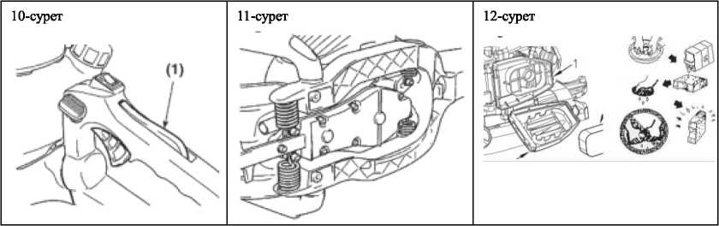

- Сактандыргышты баспаган кезде дроссель жапцышыныц туткасы цозгалмайтыньш тексерпцз.
- Сактандыргышты баскан кезде дроссель жапцышыныц туткасы цозгалып турганын тексерпцз.
- Сактандыргышты босатцан кезде оныц ез орнына цайтып барганына коз жегккпцз.
- Егер жогарыдагы тексерулерде цандай да 6ip акру табылса, жагрян жердег! сервиспак ортальарпарга хабарласыцыз.
- сурет. Антивибрациялыц жуйе.
А ЕСКЕРТУ
Деформацияланган немесе зацымдалган антивибрациялыц жуйе цозгалткышты жэне / немесе пышацтыц сынып кетуг сияцты бузылыстарды тудыруы мумкш.
Сершпелерге закым келген-келмегенш мезпл-мезпл тексерпцз.
- сурет. Ауа сузпЫ
Егер ауа сузгкл бпелген болса, дозгалткыппыц жумыс ешмдалпл азаяды. Сузп элементш цажет болса, жылы, сабынды суда тексерш, тазалацыз. Орнату алдында толыгымен дургатыцыз. Егер элемент сынган немесе кпшрейш калган болса, жацасына ауыстырыцыз.
- Ауа сузпсшщ Heriai
- Ауа сузпсшщ кадпагы
- Сузп элеменп
- сурет. Жанармай сузпа
Крзгалтдыш жумыс icren турган кез1нде жанармай бершмесе, жанармай дадпатын жэне жанармай сузпсшщ бгтелш далмаганын тексерщп.
- сурет. Ауаны салдындату эдас!
Бул дозгалтдыш ауамен салдындатылады. Салдындатылатын ауа мен цилиндр дабыргасыныц арасындагы шац дозгалтдыштыц цызып кетуше экеледа. Ауа сузгкл мен цилиндр дадпагын алып тастаганнан кейш цилиндрлердщ дабыргаларын тексерш, жш тазалап отырыцыз.
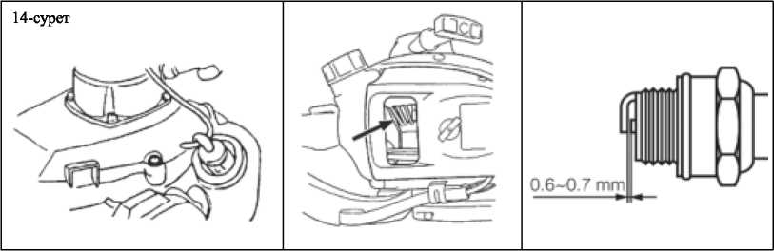
15-сурет. Оталдыру Giirreci

Оталмай далу кобшесе оталдыру бштесшщ ластанганынан болады. Ол ушш оталдыру бштесш тазалап, тыгынжылдыц (плунжер) дурыс диапазонда турганын тексерпцз. Штепсельда ауыстыру уппн дурыс турш долданыцыз.
А МАЦЫЗДЫ!
- Назар ауцарыцыз! Корсетшгеннен басда оталдыру бпггесш пайдалану дозгалтдыштыц жумысына кедерп Kenripyi немесе дозгалтдыштыц шамадан тыс дызып кетуше экелу! мумкш.
- Оталдыру бштесш орнату ушш алдымен штепсельд! прелгенше бурацыз, сосын оны тудыр кшттщ кемепмен ширек айналымга дейш тартыцыз. Тарту уакыты 14,7-21,5 Н-м.

Бер1л1с корабы
• Эр 25 сагат сайын кеп мацсатты майды ауыстырып отырыцыз.
- Майлау соргысын пайдаланыцыз.
- Кдлакшалардан шыкканга дейш майды орналастырыцыз.

Карбюраторды реттеу
Карбюратор зауьпта тецшелген. Егер курылгыцызды бипспктердщ немесе пайдалану шарттарыныц езгеруше байланысьы кайта тецшеупцз кажет болса, буны кэаби маманга тапсырыцыз. Тецшеуд! дурыс жасамай курылгыцызга зиян Kenripyi мумкш.

Пайдаланылганнан кейш эр 100 сагат сайын жасалуы тшс процедуралар
- сещцргшгп nieinin алыцыз да, бурагышты желдеткпп сацылауына салып, жиналып калган кем1ртеп калдыгын тазартыцыз. Сендаргпп пен цилиндрдщ шыгаберю сацылауындагы барлык кем!ртеп калдыгын тазалацыз.
- Барлык бурандаларды, болттар мен фитинплерда бекггпцз.
- Майлау жэне барабан арасында кандай да 6ip майдыц бар-жогын тексерпцз, егер бар болса, оны майсыз,
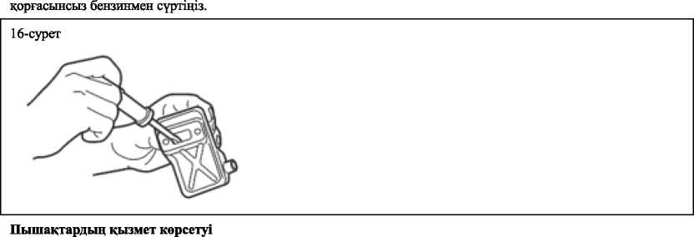

- Тотты болдырмау уппн пышакты майлацыз.
- Жанармай бапн босатып, какпакты кайтадан салыцыз.
- Оталдыру битгесш алып тастап, цилиндрге майдыц аз молшерш куйыцыз.
- Майды тарату ушш юке косу ж!бш пайдаланып, пицц бппкп айналдырыцыз. Оталдыру бштесш кайтадан салыцыз.
- козгалткышты пластик паракпен айналдырып шыгыцыз.
- курылгыны уй ппшдеп цургак, шацсыз жерде жэне балалардыц колы жетпейпн, еденге, сондай-ак жылу кездершен алые жерлерде сактацыз.
- АКАУЛЬЩТАРДЫ ТУЗЕТУ IIУСКАУЛ ЫГЫ
1-жагдай. 1ске косудагы акаулык
ТЕКСЕРУ | ЫЦТИМАЛ СЕБЕПТЕР | НЕ 1СТЕУ КЕРЕК

Жанармай 6ari | Дурыс емес жанармай | Тейп, дурыс жанармайды  пайдаланьщыз
Жанармай cysrici | Жанармай сузгкл бггелш калган | Тазалау
Карбюраторды реггеу бурандасы | Калыпты диапазонная | Калыпты диапазонга дейш реттешз
¥шкьш (ушкын жок) | Оталдыру 6urreci ластантан / дымкыл | Тазалау / кургату
¥шкьш (ушкын жок) | Оталдыру биггесшщ сацылауы дурыс емес | Дурыс (аралык: 0.6-0.7 мм)
Оталдыру 6inreci | Ошштур

2-жагдай Козгалткыш жумыс ютей бастады, 6ipaK гске косылмайды / кайта icKe косып керу
ТЕКСЕРУ | ЫКТИМАЛ СЕБЕПТЕР | НЕ1СТЕУКЕРЕК
Жанармай 6ari | Дурыс емес жанармай немесе дурыс куйылмауы | Оны тейп, дурыс жанармайды пайдаланьщыз
Карбюраторды реттеу бурандасы | Калыпты диапазонная ауыткуы | Дурыс диапазонга дейш реггеу
Бэсендеткпп, цилиндр (шыгару порты) | Кем1ртепн1ц курылымы | Сурту
Ауа тазарткыш | Шац басып калуы | Жуу
Цилиндр баллоны, желдеткпп кадпагы | Шац басып калуы | Тазалау

ТЕХНИКАЛЫК СИПАТТАМАЛАРЫ
Модельдщ атауы | СТ20114
Таза салмагы | 5.8 кг
Жанармай бапшц сьтйымдыльтгы | 0.55 л
Козгалткыпггыц сипаттамасы | Bip цилиндрлг, ею такшп, ауамен салкындатылатын
Козгалткыпггыц колем! | 22.5 см ’
Козгалткыпггыц максималды айналу жшлпт | 8500 мин
Пышакдыц узындыгы | 640 мм
Калакпгалардыц аракашыктыты | 35 мм
Козгалткыпггыц бос журюшщ жылдамдыгы | 3000 мин
Жогаргы куатгылыгы | 650 В
Жанармайдыц ара катынасы | 25:1

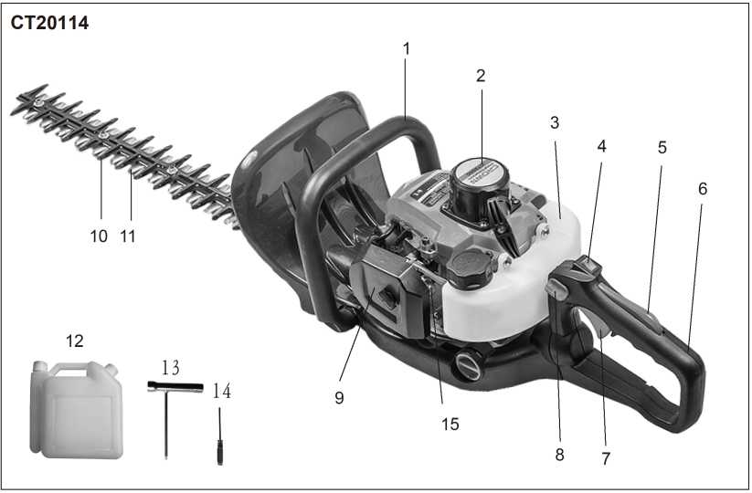

Розташування деталей
1. Передня рукоятка | 6. Задня рукоятка | 11. Р1жуче лезо
2. Ручний стартер | 7. Ручка дроселя | 12. Канютра для паливно! сум!ш!
3. Паливний бак | 8. Кнопка блокування ручки | 13. Торцевий ключ
4. Вимикач двигуна | 9. Повлряний фьльтр | 14. Викрутка
Б.Блокувач дроселя | 10. Протилезо | 15. Ручний насос подач! палива

Дякуемо, що придбали наш 1нструмент для тдстригання живоплоту. Ця !нструкц!я мютить !нформац!ю стосовно його використання та обслуговування, яка Грунтуеться на остан Hix вщомостях про продукт на момент ухвалення до друку. Ми збертаемо за собою право вносити зм!ни без повщомлення чи будь-яких зобов'язань.
Ця !нструкц!я е невщ'емною частиною 1нструменту для тдстригання живоплоту та мае залишатися з ним тд час перепродажу.
- ВКА31ВКИ 3 БЕЗПЕКИ
Безпека дуже важлива як для вас, так i для !нших людей. Важлив! вказ!вки з безпеки мютяться як в !нструкцн, так i на самому пристрой Уважно прочитайте ix.
Вказ1вки з безпеки попереджають про небезпеки, яким ви можете шддати себе та !нших людей. Перед кожним повщомленням столь «!» та ключове слово «небезпека, попередження, увага».
А | НЕБЕЗПЕКА: якщо ви не будете дотримуватись 1нструкцн, це призведе до серйозних травм та навль до смерть
А | ПОПЕРЕДЖЕННЯ: якщо ви не будете дотримуватись Ыструкцн, це призведе до травм та пошкодження пристрою.

А | УВАГА: якщо ви не будете дотримуватись нструкцп, це призведе до серйозних травм та навпъ до смерть
А | Ви таком знайдете !ншу важливу !нформац!ю, позначену словом «УВАГА».  УВАГА: якщо ви не будете дотримуватись !нструкц!Т, це призведе до пошкодження пристрою.

Запоб!жн! заходи безпеки
■ | Якщо дотримуватись !нструкц!Т при робот! з цим !нструментом, в!н працюватиме безпечно та над!йно. Перед роботою з !нструментом для пщстригання живоплоту
А | уважно прочитайте цю !нструкц!ю. 1накше, можлив! травми та пошкодження пристрою.

2. ГРАФ1ЧН1 ПОПЕРЕДЖЕННЯ
А | Слово «ПОПЕРЕДЖЕННЯ» притягуе у вагу до д!Т чи обставини, як! можуть призвести до серйозних травм або смерт!.
 | Перед роботою з цим пристроем уважно прочитайте !нструкц!ю.
о | Використовуйте засоби захисту очей, вух! голови.
о | П!д час роботи з цим пристроем носпъ п!дходящ! рукавиц!.
 | П!д час роботи з цим пристроем нос!ть подходяще взуття.
 | Тримайте цей !нструмент двома руками. Тримати його одн!ею рукою небезпечно.
■4 | П!д час роботи з цим пристроем тримайте на в!дстан! людей, тварин та сторонн! предмети.
Л | Не залишайте пристр!й п!д дощем. Не працюйте з ним на мокр!й п!длоз!.


Думе гострий предмет, може завдати пор!з!в.
А
В АЖ Л И ВО Якщо попереджувальн! наклейки вщклеяться або забрудняться наспльки, що !'х
неможливо буде прочитати, ви маете звернутися до продавця, замовити у нього нов! наклейки та приклеТти IX у в!дпов!дних м!сцях на !нструмент!.
А
ПОПЕРЕДЖЕННЯ Не вносьте зм!н до конструкцк цього !нструменту. Ми не надаемо гарант!!, якщо ви користуетеся продуктом, у конструкц!ю якого були внесен! зм!ни, або ви не дотримуетеся вказ!вок у ц!й
!нструкцГ(.
- ЗАХОДИ БЕЗПЕКИ Перед роботою з пристроем
||^<В
а. Щоб навчитися правильно керувати цим пристроем, уважно прочитайте цю !нструкц!ю.
б. Не використовуйте цей продукт у стан! алкогольного сп'ян!ння, виснаження чи нестач! сну, у раз! сонливост!.
викликан!й лжами, або коли ви не здатн! тверезо мислити та працювати з пристроем уважно та обережно.
в. Не вмикайте двигун у прим!щенн!. Вихлопн! гази м!стять шюдливий чадний газ.
г. Не використовуйте цей продукт за описаних нижче обставин:
- На слизьк!й поверхн! чи за !нших умов, за яких неможливо втримувати ст!йку поставу.
- Уноч!, при густому туман! та за !нших умов, коли ваше поле зору обмежене та ч!ткий огляд мюцевост! ускладнений.
- П!дчасзлив, гроз, сильного вггру та !нших погоднихумов, що роблять використання цього продукту небезпечним. Г. Коли ви використовуете цей продукт вперше, перед початком роботи навчпъся управлятися з ним у досв!дченого роб!тника.
д. Недосипання, втома та ф!зичне виснаження знижують у вагу, що може призвести до нещасних випадюв та поранень.
е. Тримайте цю !нструкц!ю п!д рукою, щоб можна було до не!' звернутися, якщо виникнуть будь-як! питання.
е. Надавайте цю !нструкц!ю, коли продаете, позичаете чи !ншим шляхом передаете право власност! на цей продукт.
ж. Не дозволяйте використовувати цей продукт д!тям чи особам, як! не розум!ють вказ!вок у ц!й !нструкц!Т.
Робоче обладнання та одяг
а. П!д час використання цього пристрою носпъ належний одягта використовуйте захисне обладнання, як зазначено нижче:
- Шолом
- Захисн! окуляри або маску
- Товст! робоч! рукавиц!
- Робоч! черевики з протиковзкою п!дошвою
- Засоби захисту вух
- При соб! необх!дно мати:
•Додан! !нструменти
•Запас палива
•Запасне лезо
•Свисток (для сшвпрац! або надзвичайних ситуац!й)
•Предмета для позначення робочоТзони (мотузка, попереджувальн! знаки)
•Сокира або пила (для усунення перешкод).
в. Нжоли не використовуйте пристр!й у штанах з в!льними манжетами, в сандалях або босожж.
Попередження сгосовно палива
а. Двигун цього виробу призначений для робота на зм!шаному палив!, яке мютить легкозаймистий бензин. Н!коли не збер!гайте кажстри для палива та не поповнюйте кажстри у м!сцях, де е котел, плита, багаття, електричн! !скри, зварювальн! !скри або !нше джерело тепла чи вогню, що може запалити паливо.
б. Ку pi н ня пщ час робота з цим !нструментом або заправц! паливного баку е надзвичайно небезпечним. Н!коли не палпъ бия цього !нструменту.
в. Пщ час повторного наповнення баку спочатку вимкжть двигун i переконайтеся, що поблизу немае !скор або вщкритого полум'я.
г. У раз! витоку палива скористайтеся сухою ганч!ркою, п!сля чого можете знову вв!мкнути двигун.
Г. П!сля заправлення закрутпъ гвинт кришки на паливному баку, вщнеспъ !нструмент на вщстань 3 м або биьше вщ м!сця заправлення; тепер можете вв!мкнути двигун.
ПРИМ1ТКА
Якщо паливо або 1нструмент загоримся, загасггь вогонь порошковим вогнегасником.
Перед запуском двигуна
- Диянка до 15 м навколо особи, яка використовуе !нструмент, е небезпечною; на не! жхто не мае вхрдити. У раз! необхщност! розм!ст!ть по периметру диянки жовту запоб!жну стр!чку та попереджувальн! знаки. Коли робота виконують одночасно декиька людей, для пщтримання безпечноТ в! дета Hi необхщно обертатися та перев!ряти розташування таких людей.
- Перев!рте стан робочо! зони, щоб уникнута прихованих перешкод (кам!ння, пжв, банок або розбитого скла).
- Впевжться у наявност! захисних пристроТв пщ час використання !нструменту. Не намагайтеся використовувати модифжован! або неукомплектован! пристроТ.
А
4. Не використовуйте !нструмент з пошкодженим або надм!рно зношеним р!зальним мехажзмом. ВАЖЛИВО. Перед початком робота видалпъ ус! перешкоди.
5. Перев!рте весь мехажзм на предмет витоку палива; впевжть, що детал! кр!плення м!цно затягнут!. Переконайтеся, що р!зальний мехажзм правильно встановлений та над!йно закртлений.
Запуск двигуна
- Сторонн! особи, особливо д!ти, а також тварини мають триматися на вщетан! 15 м вщ робочо! зони. В раз! порушення дистанцп вщразу зупижть двигун.
- Цей пристр!й оснащено мехажзмом центроб!жного зчеплення, тому р!зальний пристр!й починае рухатися, коли ви запускаете двигун, пом!стивши дросель у положения старту. П!д час запуску двигуна пом!ст!ть пристр!й на чисту р!вну поверхню; м!цно його тримайте, щоб переконатися, що р!жучий мехажзм та дросель не контактують з Аперешкодами.
ПОПЕРЕДЖЕННЯ
• Пщ час запуску двигуна нжоли не ставте дросель у положения високих оберт!в.
• Н!коли не запускайте двигун на сторон! р!жучого мехажзму.
- П!сля запуску двигуна переконайтеся, що р!жучий пристр!й зупинився, а дросель повжетю повернувся у початкове положення. Якщо в!н продовжуе рухатися нав!ть п!сля повного перем!щення дросельноТ засл!нки,
UA
47
вимкнпъ двигун та здайте !нструмент на ремонт до оф!ц!йного дилера.
Використання !нструменту
А
ВДЖЛИВО
Р!жте лише рекомендован! виробником матер!али. Використовуйте лише для ц!лей, зазначених в !нсгрукц!Т.
- Обережно тримайте рукоятку обома руками. Трохи розставте ноги (трохи ширше ширини плечей), щоб ваша вага була р!вном!рно розподглена на обидв! ноги; обов'язково збер!гайте р!вновагу п!д час роботи.
- Пщтримуйте швидюсть двигуна на р!вн!, необхщному для виконання роб!т; ыколи не пщвищуйте швидюсть роботи двигуна вище потр!бного р!вня.
- Якщо !нструменттрясеться або в!бруе, вимкнпъ двигун ! перев!рте його. Не використовуйте !нструмент, поки не буде виправлена несправысть.
- Тримайте к!нц!вки подал! в!д рухомого р!жучого механ!зму та гарячих поверхонь.
- Н!коли не торкайтеся глушника, св!чки запалювання або !нших металевих частин двигуна п!д час роботи або вщразу п!сля вимкнення двигуна. Невиконання ц!е! вимоги може призвести до серйозних оп!к!в або ураження електричним струмом.
- П!д час використання !нструменту займпъ ст!йке положения, особливо тод!, коли ви працюете на сходах.
- Завжди оц!нюйте навколишне середовище; будьте пильними, через шум пристрою ви можете не почути звуки, як! попереджують про ризики.
- Щоб зменшити пожежну небезпеку, тримайте двигун та глушник подал! в!д сухо! деревини, листя або надлишюв мастила.
- Зупиыть двигун перед виконанням наступ них роб!т:
• очищения або видалення засм!чення;
• перев!рки, техычне обслуговування чи роботи на !нструмент!.
> СТОРОНН! ОСОБИ
- Завжди уникайте небезпечних ситуац!й. Попроать дорослих тримати д!тей та тварин подал! в!д робочоТ зони. Будьте уважн!, якщо до вас хтось п!д!йшов. Можна травмуватися в!д смггтя, яке в!дл!тае.
- Якщо хтось вас кличе чи в!двол!кае в!д роботи, обов'язково вимкнпъ двигун, перш н!ж обертатись. Не починайте роботу, поки стороны особи, особливо д!ти, знаходяться поблизу.
Техычне обслуговування
- Якщо ви не маете вщповщноТ квал!ф!кац!Т, не намагайтеся ремонтувати цей !нструмент.
- Щоб збер!гати пристр!й у належному робочому стан!, регулярно виконуйте техычне обслуговування та перев!рки, описан! в !нструкц!Т.
- Не забудьте вимкнути двигун, перш н!ж виконувати будь-яке техычне обслуговування, проф!лактичний контроль
А
або роботи на !нструмент!.
ПОПЕРЕДЖЕННЯ
Вщразу п!сля зупинки двигуна металев! частини дуже нагр!ваються.

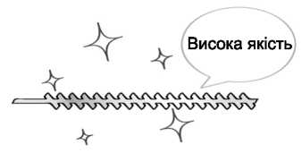
- П!д час зам1ни р!жучого механ!зму або !ншо'( детал!, зам!нюючи мастило або !нший змащувач, обов'язково використовуйте лише високояк!сн! вироби.Висока як!сть
- Якщо необх!дно зам!нити якусь деталь або виконати ремонты роботи, не описан! в !нструкцн, звернггься за допомогою до представник!в магазину, уповноваженого сервюним дилером.
- Не використовуйте аксесуари або допом!жн! детал!, кр!мтих, як!
рекомендован! для цього !нструменту.
- Нжоли не розбирайте !нструмент, не зам!нюйте детал! власноруч. Це може призвести до пошкодження в процес! експлуатацп або несправност!.
Поводження з паливом
- Двигун призначений для роботи на зм!шаному палив!, в якому м!ститься легкозаймистий бензин. Н!коли не збер!гайте цистерни з паливом ! не наповнюйте бак пристрою в м!сцях, де е котли, печ!, палаюч! дрова, електричн! !скри, зварювальн! !скри або будь-яке !нше джерело тепла або вогню, яке може запалити паливо.
- Поводьтеся з паливом з обережнютю; воно легко запалюеться. Нжоли не палпъ п!д час роботи з цим !нструментом та п!д час заправки паливного бака.
- П!д час повторно! заправки баку завжди вимикайте двигун ! дайте йому охолонути. Озиржться, щоб переконатися, що поблизу немае !скор або в!дкритого вогню перед повторною заправкою.
- Якщо п!д час повторно! заправки станеться витж палива, витрпъ розлите паливо, використовуючи для цього суху ганч!рку.
- П!сля повторно! заправки та перед включениям двигуна закрутить кришку паливного бака та вщнеспъ !нструмент на вщстань 3 м або б!льше в!д м!сця заправки.
- Не вдихайте паливн! пари, осюльки вони е токсичними.
Транспортування
- П!д час ручного перенесения !нсгрументу, у раз! необх!дност!, накрийте р!жучу частину, п!дн!м!ть !нструмент !
перенеспъ його, звертаючи увагу на лезо.
- Якщо паливний бак не очищено в!д палива, не транспортуйте !нструмент по нер!вних дорогах на велик! вщстан!
транспортним засобом. В цьому випадку паливо може витекти з бака п!д час транспортування.
- При транспортуванн! чи збер!ганн! !нструменту завжди встановлюйте на р!жучий мехаызм захисний пристр!й.
- ПАЛИВО ТА МАСЛО


Карбюратарне паливо
Використовуйте сум!ш неетилованого бензину нормально! якост! (!з свинцем або без нього, без спирту) та яюсного моторного мастила для 2-тактного двигуна.
Рекомендований коеф!ц!ент зм!шування: |  | Зм!шування 40:1
Умови | Бензин: Мастило | Моторне мастило для 2тактного двигуна | 1 2 3 4 5
До 20 годин експлуатацп | 25:1 | Л!три палива | 40 80 120 163 200
ГИсля 20 годин експлуатацп | 40:1
- ЕКСПЛУАТАЦ1Я
Запуск двигуна
ПОПЕРЕДЖЕННЯ П!сля запуску двигуна почне рухатися р!жуча головка.
- Залийте паливо в паливний бак i над!йно закрутпъ ковпачок.
- Поклад!ть вимкнений жструмент на плоске тверде м!сце. Тримайте р!жучу головку на в!дстан! в!д земл! та приберпъ навколишж предмети, оскиьки вона почне рухатися теля запуску двигуна.
- Натисжть заправний насос Илька раз!в, щоб паливо потрапило до прозороТ трубки.
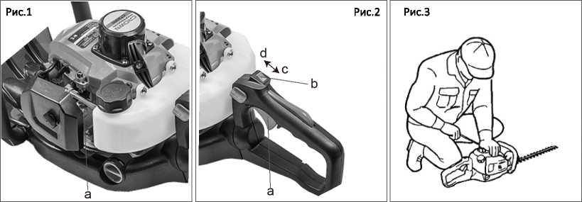

- Коли двигун охолоне, перемопь важиь дроселя у закрите положения (Рис. 1 а Насос для заправлення)
- Встановпъ перемикач запалювання у вщповщне положення (Рис. 2)
- Рукоятка дроселя
- Перемикач запалювання
- Позищя "О"
- Позищя "I"
- Мщно тримаючи 1нструмент, швидко потягнггь за стартовий мотузок, поки двигун не запрацюе (Рис. 3).
А
ВАЖЛИВО. Уникайте натягу мотузки за i'i юнець або н повернення, вщпустивши рукоятку. Так! ди можуть спричинити несправност! стартера.
- Перем1ст1ть важгль дроселя вниз, щоб вщкрити дросель, i перезапустить двигун.
- Перед початком експлуатацм двигун мае прогрейся протягом деюлькох хвилин.
ПРИМ1ТКА
- У випадку перезапуску двигуна вщразу теля зупинки залиште дросель вщкритим.
- Надм|рне засм!чення може спричинити жорсткий запуск двигуна через надлишок пального. Якщо двигун не вдалося запустити теля деюлькох спроб, вщкрийте дросель i повторить натягування мотузки або виймпъ св!чку запалювання та висушпъ и.
Зупинка двигуна
- Вщпуспть важгль дроселя та запуепть двигун на твхвилини.
- Перем1ст1ть перемикач запалювання в положення "Opposition". Рис. 2
Д ВАЖЛИВО
• За винятком надзвичайних ситуащй не допускайте зупинки двигуна, тягнучи за рукоятку дроселя.
- Якщо двигун не зупиняеться, коли перемикач запалення встановлений в положения зупинки, закрийте важ!ль дроселя та зупинпъ двигун.
- У цьому випадку вщремонтуйте !нструменту найближчого дилера серв!сного обслуговування.
Р!зання
ПОПЕРЕДЖЕННЯ
• На сум!шоутворення у двигун! можуть вплинути погоды умови.
• Не дозволяйте !ншим особам залишатися поруч !з !нструментом для пщстригання живоплоту п!д час роботи або п!д час регулювання карбюратора.
Використання рукоятки
Щоб зменшити втому п!д час пщстригання живоплоту, рукоятку можна повернути на 90 ° л!воруч або праворуч.
П!д час ц!еТ операнд не натискайте на дросель!
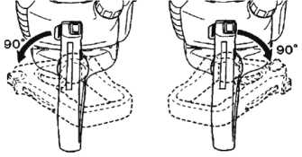
Виконайте наступи! ди:
- Зн!м!ть рукоятку, натиснувши ручку ф!кса ц!Т.
- Повернпъ рукоятку, щоб фжсатор став на м!сце.
- Коли рукоятка заблокована у нов!й позицн, ви можете знову використовувати дросель.
Ви також можете повернути рукоятку навпъ за умови, якщо двигун працюе в режим! холостого ходу, тому що цей !нструмент для пщстригання живоплоту оснащено гальмами, як! тримають леза в стан! зупинки.
ТЕХН1КИ ПЩСТРИГАННЯ ЖИВОПЛОТУ
Спочатку обробпъ боков! сторони живоплоту, а пот!м його верхню частину.
Вертикальна пщстригання
Використовуючи модель !з 2-х сторонн!м лезом THT245D, виконайте пщстригання, роблячи рух, який нагадуе дугу.
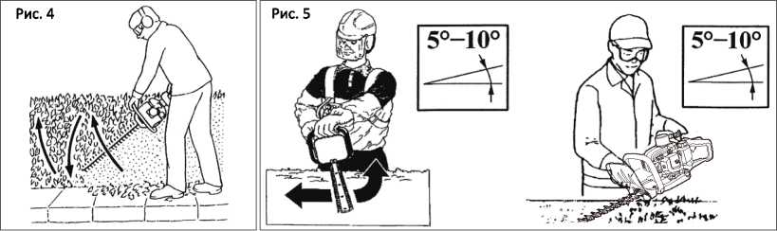
знизу вгору, а пот!м вниз, щоб використати обидв! сторони леза (рис. 4).
Горизонтальна пщстригання
Щоб отримати п!д час пщстригання найкращ! результати, трохи нахил!ть лезо (5° - 10°) стосовно напрямку пщстригання (рис. 5); пщстригайте пов!льно, особливо це стосуеться густого живоплоту.
А
ПОПЕРЕДЖЕННЯ
Завжди дотримуйтеся правил технжи безпеки. 1нструмент для пщстригання живоплоту треба використовувати лише для пщстригання невеликих кущ!в та живоплоту. Не використовуйте його для р!зання матер!ал!в !нших вид!в. Не використовуйте цей !нструмент як важ!ль для п!дн!мання, перем!щення або розбиття
об'еклв; також не встановлюйте його на фжсованих опорах. Забороняеться застосовувати не призначен! виробником !нструменти та пристроТ на механ!зм1 вщбору потужносп цього шструменту для тдстригання живоплоту. Не використовуйте його для обр!зання дерев або тдстригання трави.
- Регулюйте витрати робочо! рщини за допомогою дроселю вщповщно до потреб. Занадто висока швидюсть двигуна е непотр!бною.
- Уникайте р!зання товстих плок; це може пошкодити леза та скоротити термин служби приводних систем.
- Якщо ви нахилите цей шструмент п!д кутом 5 до 10° до об'екта, який тдлягаю р!занню, це полегшить роботу та принесе гарний результат.
- Тримайте цей 1нструмент так, щоб на вас дивилася сторона карбюратора; н!коли не тримайте цей 1нструмент стороною глушника.
- Пщ час першоТексплуатацн нового пристрою, впродовж перших киькох хвилин з коробки передач може виходити мастило. Не хвилюйтесь, це надлишок мастила, який необхщно просто витерти, коли двигун буде зупинено для наступного використання (рис. 6).
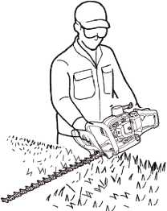
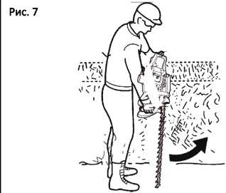
Рис. 6
• Завжди пам'ятайте, що процедура тдстригання живоплоту виконуеться К1НЦЕВОЮ ЧАСТИНОЮ робочо! л!нн. Ви отримаете кращ! результати, якщо не будете вводити цю робочу л1н!ю в дшянку, призначену для тдстригання. Дозвольте пристрою працювати в своему темп! (Рис. 7).
- ТЕХН1ЧНЕ ОБСЛУГОВУВАННЯ
 | Система/компо ненти | Процедура | Перед використа нням | Кожн 25  годин  теля  використа  ння | Кожн! 50 годин теля використа ння | Кожн! 100  годин  теля  використа  ння | Прим!тка
 | Витж палива, розбризкуванн я палива | Витерти | V
 | Паливний бак, повпряний | Переглянь те або | V | V |  |  | Зам!нпъ за

Двигун | ф!льтр,  паливний  ф1льтр | прочистпъ |  |  |  |  | необх!дн ост!
Двигун | Гвинт низьких оборот!в холостого ходу | Див. пункт стосовно регул юван ня швидкост! холостого ХОДУ | V |  |  |  | За необх!дн ост! зам!н!ть карбюра тор
Двигун | Св!чка запалювання | Очистпъ i  вщрегулю йте зазор св!чки |  |  | V |  | Зазор: 0,60,7 мм, зам!н!ть за необх!дн ocri
Двигун | Ребра цил!ндра, впускн! отвори для повпря охолодження | Очистпъ |  | V
Двигун | Глушник, 1скрогасник, вихщний отв1р цил!ндра | Очистггь |  |  |  | V
1н струме нт для гпдстрига ння живопло  ту | Рукоятка дроселя, перемикач двигуна | Перев!рте роботу | V
1н струме нт для гпдстрига ння живопло  ту | Р!жуч! детал! | Зам!н!ть у раз! будь- fl коТ несправно ст!. | V
1н струме нт для гпдстрига ння живопло  ту | Коробка подач | Змастггь |  | V
1н струме нт для гпдстрига ння живопло  ту | Гвинти/гайки/б олти | Затягнпъ або | V |  |  | V | Не регулюю

 |  | зам!нгть |  |  |  |  | 41 гвинти
 | Захисн!  пристроТ проти сторон Hix предмете | Перекокай  теся | V

А ПОПЕРЕДЖЕННЯ
Перед техжчним обслуговуванням зупинпъ двигун; переконайтеся, що вТн охолонув. Контакт !з рухомою р!жучою головкою або гарячим глушником може стати причиною травми.
Лезо
■ Перев!рте лезота детал! кртлення на розхитажсть, наявжстьтр!щин абозгинання.
• Перев!рте р>жуч! краТта заточпъТхза допомогою плоского напилку.
Важливо:
- Пщтримуйте к!нцевий кут гострим.
- Округлив основу краю.
- Ви кор истову юч и точильник, не використовуйте воду.
Вам не потр1бно налаштовувати пром!жок м!ж верхи iM лезом та нижн!м лезом, оскгльки конструкция цього i н ст ру менту, у раз] правильного налаштування, передбачае наявжсть оптимального пром!жку (Рис. 8).
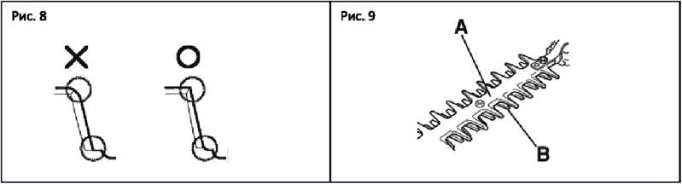

Захисний пристр!й леза (А} призначений для захисту частини т!ла, яка конта ктуе з лезами (В).
Впевнпъся, що захисн! пристроТ леза не пошкеджежта не викривлеж; в 1ншому випадку захиеж пристроТнеобх!дно зам!нити (Рис. 9}.
А
ПОПЕРЕДЖЕННЯ
Встановлюючи лезо, обов'язково закртпъ розтрну деталь, шайбу та болт, попм затягнпъ гайку.
Заточения
Завжди тримайте напилок або точильник п!д кутом 45° до леза
та:
• Завжди здйснюйте заточения в напрямку р!жучого краю;
• Примпка: заточуйте тшьки в одному напрямку; щоб энову печати заточения, п!дн!мпъ напилок вщлеза;
• Видал гть Bci за дирки з краю леза точил ьним каменем;
• Видалгть якомога менше металу;
• Перед повтори им встановленням заточен их лез зн!м!ть стружку та нанеоть мастило.
• Не намагайтеся заточити пошкоджене лезо; зам!н1ть його або вщнеспъ до сервюного центру.
А
попередження
Я разj несправносп запоб!жнику зупинпъ роботу.
Запоб!жник — це пристры, який дозволяе не пришвидшувати без нам!руваж1льуправл1ння дросельною заслыкою.
Натискаючи запоб!жник, ви можете прискорити цей важ!ль. (1) Запоб!жник Рис.10
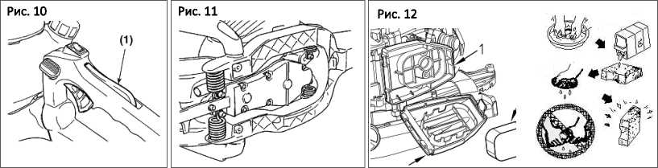

- Перев!рте, чи не рухаеться важ!ль управлЫня дросельною засл!нкою, коли ви не натискаете запоб!жник.
- Перев!рте, чи рухаеться важ!ль управл!ння дросельною заслыкою, коли ви м!цно тримаете п або выпускаете п!д час натискання запоб!жника.
- Перев1рте, чи запоб!жник повертаеться в свое початкове положення, коли ви його вщпускаете.
У раз! виявлення будь-яких зазначених вище недол!к!в звернпъся до найближчого сервюного центру для ремонту.
Антив|брац1йна система Рис. 11
А
попередження
Деформована або пошкоджена антив!бращйна система може спричинити так! пошкодження, як розхитаысть 1нструменту або падшня двигуна та/або леза.
Перюдично перев!ряйте пружини на предмет деформац1й або пошкодження.
Повггряний ф!льтр Рис. 12
У випадку засм!чення повпряний ф!льтр негативно вплине на роботу двигуна. Перев!рте та належним чином очистпъ фгльтрувальний елемент у теплы мильны вод!. Повыстю висушггь перед встановленням. Якщо елемент пошкоджений або зменшився, зам!н!ть його на новий.
- Основа повпряного ф!льтра
- Кришка повпряного фгльтра
- Фтьтрувальний елемент
Паливний ф!льтр Рис. 13
Коли двигуну не вистачае забезпечення паливом, перев!рте, чи не заблоковано кришку паливного бака та паливний ф!льтр.
Споаб охолодження повпря Рис. 14
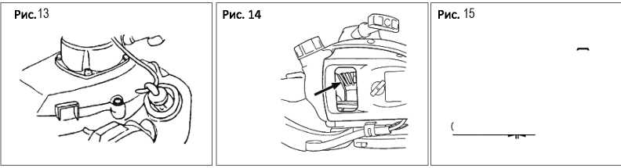
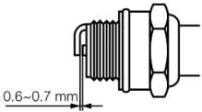
Цей двигун охолоджуеться пов!трям. Втягування пилу м!ж вх!дним отвором охолоджуючого пов!тря ! ребрами цил!ндра може призвести до neperpisy двигуна. Перюдично перев!ряйте та очищайте ребра цил!ндра п!сля зняття повпряного ф!льтра та кришки цил!ндра.
Св!чка запалювання Рис. 15
Несправн!сть п!д час запуску та неправильно заряджання часто виникають через сильний нагар на св!чках запалювання.
Очиспть св!чку запалювання i перев!рте, щоб зазор св!чки знаходився в правильному д!апазож. Для зам!ни св!чки використовуйте деталь в!дпов!дного типу.
А
ВАЖЛИВО
• Звержть у вагу, що використання будь-яко! !ншо! св!чки запалювання, н!ж було зазначено, може привести до неправильно! роботи двигуна, neperpiey ! пошкодження двигуна.
• Щоб встановити св!чку запалювання, спочатку поверить св!чку, поки вона не буде закр!плена вручну, а полм затягжть п на чверть обороту за допомогою торцевого ключа. Момент затягування: 14,7-21,5 Н-м.
Картер коробки передач
• Застосовуйте ужверсальне консистентне мастило кожн! 25 годин використання.
1. Використовуйте мастильний насос.
- Нанеспъ мастило, доки воно не вийде бия основи лопатей.
Налаштування карбюратора
Карбюратор налаштований на завод!. Якщо ваш !нструмент потребуй повторного налаштування через зм!ну висоти або умов експлуатаци, для виконання налаштування звернться до виробника. Неправильне налаштування може пошкодити нструмент.
Процедури, як! необхщно виконувати кожи! 100 годин використання Рис. 16
- Зжмпъ глушник, вставте викрутку у вентилящйний отв!р ! витрпъ вщкладення нагару. Витрпъ вс! вщкладення нагару на випускному отвор! глушника ! випускному отвор! цил!ндра.
2. Затягнпъ вс! гвинти, болти та детал! кртлення.
- Переконайтеся, що масло або мастило пройшли м!ж фрикц!йною накладкою диска зчеплення та барабаном; якщо це трапилося, протрпъ, використовуючи безмасляний неетилований бензин.
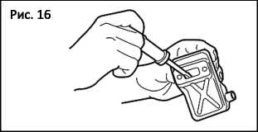

Техжчне обслуговування лез
- Смажте леза для запобиання !рж!.
- Спорожните паливний бак i знову встановпъ ковпачок.
- Зжмпъ св!чку запалювання, залийте невелику к!льк!сть масла в цил!ндр.
- Для розпод!лу масла повержть кол!нчатий вал за допомогою пускового канату к!лька раз!в. Вставте св!чку запалювання.
- Обержть двигун пол!етиленовою пл!вкою.
- Збер!гайте !нструмент в чистому сухому м!сц!, недоступному для д!тей. Краще збер!гати не в прямому контакт! з п!длогою i на вщстаж в!д джерел тепла.
- УСУНЕННЯ НЕСПРАВНОСТЕЙ
Випадок 1. В!дмова п!д час запуску
ПЕРЕВ1РТЕ | М0ЖЛИВ1 ПРИЧИНИ | Д1Я
Паливний бак | Неправильне паливо | Злити паливо; використовувати правильне паливо
Паливний ф!льтр | Паливний ф!льтр забитий | Очисти™
Гвинт регулювання карбюратора | Поза д!апазону нормальних значень | Вщрегулювати до д!апазону нормальних значень
Запалювання (немае !скри) | Забруднена/мокра св!чка  запалювання | Очистити/висушити
Запалювання (немае !скри) | Неправильний зазор св!чки | Виправити (зазор: 0,6-0,7 мм)
Св!чка запалювання | Выключена

Випадок 2. Двигун запускаеться, але не працюе/жорсткий перезапуск.
ПЕРЕВ1РТЕ | МОЖЛИВ1 ПРИЧИНИ | Д1Я
Паливний бак | Неправильне або старе паливо | Злити паливо; використовувати правильне паливо
Гвинт регулювання карбюратора | Поза д!апазону нормальних  значень | Вщрегулювати до д!апазону нормальних значень
Глушник, цил!ндр (вихлопний отв!р) | В!дкладення нагару | Витерти
Очищувач пов!тря | Забитий пилом | Промити
Ребро цилндра, кожух вентилятора | Забитий пилом | Почистити

- ТЕХН1ЧН1 ХАРАКТЕРИСТИКИ
Модель | СТ20114
Вага нетто | 5,8 кг
бмысть паливного бака | 0.55л
Характеристики двигуна | з одним цилшдром, 2-тактний, повпряне охолодження
Об'ем двигуна | 22,5 см³
Максимальна швидюсть обертання двигуна | 8500 об/хв
Довжина леза | 640 мм
Крок леза | 35 мм
Швидк1сть холостого ходу двигуна | 3000 об/хв
МАКС, вихщна потужжсть | 650 Вт
Пропорц!я паливного складу | 25:1

CT20114
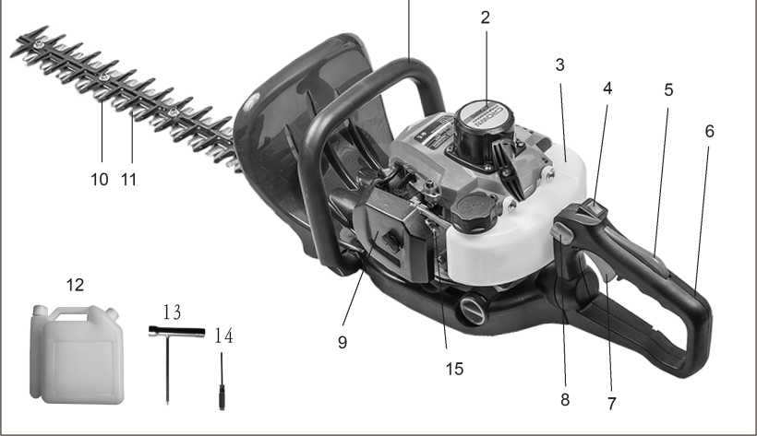

Ubicacidn de las piezas
1. Manija delantera | 6. Manija posterior | 11. Cuchilla de code
2. Arrancador del retroceso | 7. Gatillo acelerador | 12. Tanque de combustible de mezcla
3. Deposito de gasolina | 8. Perilla de bloqueo de la manija | 13. Llave de zocalo
4. Interrupter del motor | 9. Filtro de aire | 14. Destornillador
5. Bloqueo del gatillo del acelerador | 10. Hoja de respaldo | 15. Primer bulbo

Gracias por comprar nuestro cortasetos. Este manual contiene information sobre la operation у el mantenimiento del cortasetos, que se basa en la information mas reciente del producto disponible en el momenta de la aprobacion para la impresion. Nos reservamos el derecho de hacer enmiendas sin previo aviso у sin incurrir en ninguna obligation por las consecuencias.
Este manual debe ser considerado сото una parte permanente del cortasetos, у permanecer con el si es revendido.
1. informaciOn de seguridad
La seguridad es muy importante para usted у para los demas. Hemos anotado information de seguridad importante tanto en manual сото en maquina. Por favor, lealo detenidamente.
La information de seguridad le da la advertencia de que usted puede traer peligro potential para usted у otros. Las palabras clave con "I" se ponen antes de cada pieza de information. Estas palabras son "peligro, advertencia, atencion".
A | PELIGRO Si usted no opera, siga los indicados en el manual, leslones graves, Incluso la muerte sera causada.
A | ADVERTENCIA - SI no funclona, slga los indicados en el manual, se danara el dispositivo у se lesionara.
A | ATENClGN:- Si usted no opera, siga los indicados en el manual, lesiones serias, incluso la muerte seran causadas.
A | Puede ver otra information importante marcada con marca de" ATENClGN ".  ATENClGN: Si usted no funciona сото los indicados en el manual, el dano del dispositivo sera causado.

Prevention de la seguridad
II | Si se opera la podadora de setos siga las indicadas en el manual, funcionara de forma segura у fiable antes de operar el seto.
A | Cortapatillas, por favor lea atentamente este manual. De Io contrario, se ocasionaran lesiones у dahos al dispositivo.

2. grAficas advertencias
A | Las palabras ADVERTENCIA Haman la atencion a un acto о una condition que puede cargar a lesiones personales graves о la muerte.
 | Lea detenidamente el manual del usuario antes de operar esta maquina.
 | Utilice la protection de cabeza, ojo у oido.
0 | Use guantes adecuados cuando utilice la maquina.
(Э | Use zapatos adecuados cuando utilice la maquina.
 | Utilice el cortasetos con dos manos; una operation de mano de la sierra puede ser peligrosa.

l-t | Mantenga alejados a personas, objetos y/o animales cuando utilice la maquina.
£ | No Io exponga a la lluvia. No use esta maquina sobre pisos mojados.
 | Esto es extremadamente afilado у puede causar facilmente cortes.

A
IMPORTANTE Si las obturaciones de advertencia se despegan о se ensucian у son imposibles de leer, usted debe ponerse en contacto con el distribuidor donde com pro el producto para ordenar nuevos sellos у coIocar el nuevo sei Io (s) en la (s) ubicacion (es) requerida.
A
ADVERTENCIA Nunca remodele el producto. No garantlzamos la maquina, si usted utHlza el producto remodelado о usted no observa el uso apropiado escrito en el manual.

- PRECAUCIONES DE SEGURIDAD Antes de utilizar la m&quina
- Lea este manual del propietario cuidadosamente para entender сото operar esta unidad correctamente.
- Nunca debe utilizar el producto cuando esta bajo la Influencla del alcohol, cuando sufre de agotamlento о falta de sueho, cuando sufre de somnolentia сото resultado de haber tornado la medicina fria, о en cualquler otro momento en que existe la posibilidad de que su juicio pod ria ser deteriorado о que usted puede ser que no pueda funclonar la maquina correctamente у de una manera segura.
- Evlte el funcionamiento del motor en Interlores. Los gases de escape contlenen monoxldo de carbono dahoso.
- Nunca utilice el producto bajo circunstancias сото las descritas a continuation:
- Cuando el suelo es resbaladizo о cuando existen otras condiciones que podrian hacer que no sea posible mantener una postura estable.
- Por la noche, en momentos de fuerte niebla, о en cualquier otro momento en que su campo de vision podria ser limitado у sena diffell obtener una vision clara de la zona.
- Durante las tormentas de lluvia, durante tormentas de relampagos, en tiempos de vientos fuertes о vendavales, о en cualquier otro momento en que las condiciones meteorologicas puedan hacer que sea inseguro usar este producto.
- Cuando use este producto por primera vez, antes de comenzar el trabajo real, aprenda a manejarlo de un trabajador calificado.
- La falta de sueho, cansancio о agotamiento fisico da сото resultado una menor duration de la atencion, у esto a su vez conduce a accidentes у lesiones,
- Asegurese de mantener este manual a mano para que pueda referirse a el mas adelante cuando surjan preguntas.
- Siempre asegurese de incluir este manual cuando venda, preste о transfiera la propledad de este producto.
- Nunca permlta que los ninos о cualquler persona Incapaz de entender completamente las Instrucclones dadas en este manual para utlHzar este producto.
Equipo de trabajo у гора
- Al usar el producto, usted debe usar гора aproplada у equipo de protection de la slgulente manera.
- Casco
- Gafas de protection о protector facial
- Guantes gruesos del trabajo
- Botas de trabajo antldesllzante
- Protectores de oido
- Y deberia usar las protecciones laborales.
- Herramlentas anexas.
- Combustible debldamente reservado.
- Cuchllla de repuesto.
- Silbato (para colaboration о emergencla).
•Cosas para notlficar su area de trabajo (cuerda, senales de advertencla).
* Hacha о sierra (para qultar obstaculos).
- Nunca utilice el producto cuando use pantalones con puhos sueltos, cuando use sandalias о cuando este descalzo
ADVERTENCIA considerando el manejo del combustible
- El motor de este producto esta disenado para funcionar con un combustible mezclado que contiene gasolina altamente inflamable. Nunca almacene latas de combustible о rellene el tanque de combustible en ningun lugar donde haya una caldera, estufa, fuego de lena, chispas electricas, chispas de soldadura, о cualquier otra fuente de calor о fuego que pueda encender el combustible.
- Fumar mientras se opera el producto о rellenar su tanque de combustible es extremadamente peligroso. Siempre asegurese de mantener los cigarrillos encendidos alejados del producto en todo momento.
- Cuando rellene el tanque siempre apague el motor primero у eche un vistazo cuidadoso para asegurarse de que no haya chispas о llamas abiertas en cualquier lugar cerca antes de repostar.
- Si ocurre algiin derrame de combustible durante el repostaje, use un trapo seco para limpiar los derrames antes de volver a encender el motor.
- Si ocurre algun derrame de combustible durante el repostaje, use un trapo seco para limpiar los derrames antes de volver a encender el motor.
NOTA
Si el combustible о el producto se enciende, apague por favor el fuego con el extintor seco del polvo.
Antes de arrancar el motor
- El area dentro de un perimetro de 15 m de la persona que utiliza el producto debe ser considerada una zona peligrosa en la que nadie debe entrar. Si es necesario, cable de advertencla amarillo, las senales de advertencla deben ser colocados alrededor del perimetro de la zona. Cuando el trabajo va a ser reallzado simultaneamente
рог dos о mas personas, se debe tener cuidado de mirar constantemente alrededor о de otra manera verificar la presencia у ubicacion de otras personas
- Compruebe la condition del area de trabajo para evitar cualquier accidente golpeando obstaculos ocultos tales сото tocones, pledras, latas, о vldrlo quebrado
- Asegurese siempre de que todos los mangos у protectores esten instalados al usar la maquina. Nunca intente utilizar una maquina incompleta о una que este equipada con una modification no autorizada.
- No opere la maquina con un dlsposltlvo de code dahado о exceslvamente desgastado.

IMPORTANTE. Elimine cualquier obstaculo antes de comenzar el trabajo.
5 . Inspeccione toda la unidad para obtener sujetadores flojos у fugas de combustible. Asegurese de que el accesorio de code este correctamente Instalado у blen sujeto.
Arrancar el motor
- Mantenga a los espectadores, especialmente a los nifios, у a los animales a una distancia minima de 15 m del punto de funcionamiento. SI se le acerca, detenga Inmedlatamente el motor.
- El producto esta equipado con un mecanismo de embrague centrifugo, por Io que el accesorio de code comienza a moverse tan pronto сото el motor se inicia poniendo el acelerador en la position de initio. Al arrancarse el motor, coloque el producto sobre el suelo en un area plana у mantengalo firme en su lugar para asegurarse de que ni la pade de code ni el acelerador entran en contacto con ningun obstaculo cuando el motor arranca.

Advertencia
•Nunca coloque el acelerador en la posicidn de alta velocidad cuando arranque el motor.
•Nunca enclenda el motor en el lado del accesorio de code.
- Si continua moviendose despues de que el acelerador ha sido movido completamente hacia atras, apague el motor у lleve la unidad a su distribuidor autorizado de servicio para que Io reparen.
Uso del producto

IMPORTANTE
Code solamente los materiales recomendados por el fabricante. Y utilice sdlo para las tareas explicadas en el manual
- Sujete firmemente las asas con ambas manos con la mano entera. Coloque los pies ligeramente separados (ligeramente mas separados que el ancho de sus hombros) de manera que su peso se distribuya uniformemente a traves de ambas piemas, у siempre asegurese de mantener una postura firme у uniforme mientras trabaja.
- Mantenga la velocidad del motor en el nivel requerido para realizar el trabajo de code, у nunca eleve la velocidad del motor por encima del nivel necesario.
- Si la unidad comienza a temblar о vibrar, apague el motor у compruebe que toda la unidad no la use hasta que el problema haya sido correctamente corregido.
- Mantenga todas las partes del cuerpo alejadas del accesorio de corte en movimiento у las superficies calientes.
- Nunca toque el silenciador, la bujia u otras partes metalicas del motor mientras el motor este en funcionamiento о inmedlatamente despues de apagar el motor. El hacerlo podria provocar quemaduras graves

«И
о descargas electricas.
- Durante el funcionamiento de la maquina Asegurese slempre de una position de funcionamiento segura у segura, especialmente cuando se utilizan pasos о
7.Siempre tenga en cuenta su entomo у mantengase alerta ante posibles peligros que no pueda oir debido al ruido de la maquina.
8. Para reducir el riesgo de incendio, mantenga el motor у el silenciador en el arbol de escombros, hojas о lubrication excesiva.
- Detenga el motor antes de:
•Limpieza о al despejar una obstruction;
•Comprobacion, mantenimiento о trabajo en la maquina.
> Si alguien viene
- Protejase contra situaciones peligrosas en todo momento. Advierta a los adultos de mantener mascotas у ninos lejos de la zona. Tenga cuidado si se le acerca. La lesion puede resultar de escombros voladores.
2.Si alguien le llama о le interrumpe de otro modo mientras trabaja, asegurese siempre de apagar el motor antes de voltearlo. Evite operar mientras que las personas, especialmente los ninos estan cerca.
Mantenimiento
- No intente reparar la maquina a menos que este calificada para hacerio.
- Con el fin de mantener su producto en buen funcionamiento, realice las operaciones de mantenimiento у comprobacion descritas en el manual a intervalos regulares.

- Asegurese siempre de apagar el motor antes de realizar cualquier tipo de mantenimiento, Compruebe los
procedimientos о trabajo en la maquina.
ADVERTENCIA
Las partes metalicas alcanzan altas temperaturas inmediatamente despues de parar el motor.
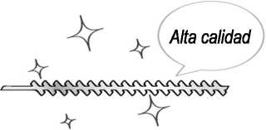
- Cuando reemplace el accesorio de corte о cualquier otra pieza, о cuando reemplace el aceite о cualquier lubricante, asegurese siempre de usar solamente productos de alta calidad.
Alta calidad
- En el caso de que cualquier pieza deba ser sustituida о cualquier trabajo de mantenimiento о reparation no descrito en este manual debe ser realizado, por favor pongase en contacto con un representante de la tienda mas cercana al distribuidor autorizado de servicio para obtener asistencia.
- No utilice accesorios о aditamentos que no sean los recomendados para la unidad.
- Bajo ninguna circunstancia, debe desmontar el producto о alterarlo de ninguna manera. Si Io hace puede resultar en que el producto se dane durante el funcionamiento о que el producto se vuelva incapaz de funcionar correctamente.
Manipulacidn del combustible
1 . El motor esta disenado para funcionar con un combustible mezclado, que contiene gasolina altamente
inflamable. Nunca almacene latas de combustible о rellene el tanque de la unidad en ningun lugar donde haya una caldera, estufa, fuego de lena, chispas electricas, chispas de soldadura, о cualquier otra fuente de calor о fuego que pueda encender el combustible.
- Maneje el combustible con cuidado, es altamente inflamable. Nunca fume mientras opere la unidad о rellene su tanque de combustible.
- Al rellenarse el tanque, apague siempre el motory dejelo enfriar. Tome una mirada cuidadosa alrededor para cerciorarse de que no hay chispas о llamas abiertas dondequiera cerca antes de reabastecer de combustible.
- Limpie el combustible derramado por complete usando un trapo seco si ocurre algun derrame de combustible durante el repostaje.
- Despues de repostar, atornille el tapon de combustible firmemente en el tanque de combustible у luego lleve la unidad a un punto a 3m о mas lejos de donde fue reaprovisionado de combustible antes de encender el motor.
- No inhale los vapores de combustible ya que son toxicos.
Transports
- Al transportar el producto a mano, cubra la pieza de corte si es necesario, levante el producto у llevelo prestando atencion a la hoja.
- Nunca transpose el producto sobre caminos asperos sobre distancias largas por el vehiculo sin la elimination de todo el combustible del deposito de gasolina. Si Io hace, el combustible podria gotear del tanque durante el transporte.


- Al transportar о almacenar la maquina, coloque siempre el protector del dispositivo de corte.
- COMBUSTIBLE YACEITE
Combustible
Utilice una mezcla de gasolina sin plomo de grado normal (con о sin plomo, sin alcohol) у un aceite de motor de calidad de 2 tiempos.
Cociente de mezcla recomendado: |  | 40:1 Mezcla
Condition | Gasolina: aceite | Aceite de 2 tiempos | 1 2 3 4 5
Hasta 20 horas de uso | 25:1 | Litres de gasolina | 40 80 120 163 200
Despues de 20 horas de uso | 40:1
5. operaciOn
A
Arrancar el motor I
ADVERTENCIA La cobeza de corte comenzarA a moverse sobre el comienzo del motor.
1 .Alimente el combustible en el tanque de combustible у apriete el tapon firmemente.
- Apoye la unidad en un lugar piano у firme. Mantenga el cabezal de corte fuera del suelo у alejado de los objetos circundantes, ya que comenzara a moverse al arrancar el motor.
- Empuje la cartilla varias veces hasta que el combustible del desbordamiento fluya hacla fuera en el tubo claro.
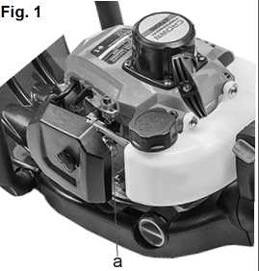
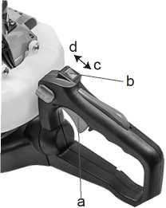
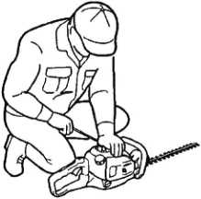
Fig. 3

- Cuando el motor este frio, mueva la palanca del estrangulador a la position cerrada. Fig. 1 a. Primer
- Coloque el Interrupter de encendldo en la position.. Fig. 2
- Palanca del acelerador
- Interrupter de encendldo
- Posidon de “O”
- Posidon de’T’
- Mientras sujeta la unidad firmemente, extraiga la cuerda de arranque rapidamente hasta que el motor se encienda. Fig. 3
A
IMPORTANTE. Evite jalar la cuerda hasta su extremo о devolviendola soltando la perilla. Estas acciones pueden causar fallas iniciales.
- Mueva la palanca del estrangulador hacla abajo para abrir el estrangulador у reinicie el motor.
- Deje que el motor se caliente durante varios minutos antes de comenzar la operation.
NOTA
- Cuando reinicie el motor Inmedlatamente despues de detenerio, deje el estrangulador abierto.
- La asfixia excesiva puede hacer que el motor sea dificil de arrancar debldo al exceso de combustible. Cuando el motor no arranca despues de varios intentos, abra el estrangulador у repita la extraction de la cuerda, о quite la bujia у sequela.
Parar el motor
1 .Suelte la palanca del acelerador у haga funcionar el motor durante medio minuto.
- Cambie el interrupter de encendido a la "oposicion". Fig. 2
A
IMPORTANTE.
«А exception de una emergencia, evite parar el motor mientras que tira de la palanca del acelerador.
•Si el motor no se detiene al coIocar el interrupter de encendido en la position de parada, cierre la palanca del estrangulador у detenga el motor.
•En este caso, por favor, repare la maquina en su distribuidor de servicio mas cercano.
Trabajos de corte
A
ADVERTENCIA
•Las condiciones meteorologicas у la altitud pueden afectar carburacion.
•No permits que nadie permanezca cerca del cortasetos mientras trabaja о mientras ajusta el carburador.
C6mo utilizar el asa
Para reducir la fatiga al cortar setos, la manija se puede girar por 90_{o} a la izquierda о a la derecha.
i No presione el acelerador durante esta operation! Proceda de la siguiente manera:
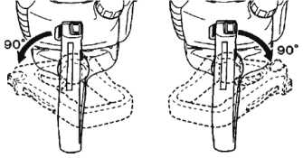
- Libere el asa presionando la palanca de bloqueo.
tEcnicas de recorte DE SETO
- Gire el asa hasta que la palanca de bloqueo haga die en su lugar.
- Cuando el asa esta bloqueada en su nueva position, puede volver a aplicar el acelerador.
Puede girar el asa incluso con el motor en reposo porque el cortasetos esta equipado con un freno de hoja que mantiene las cuchillas paralizadas.
Recorte los lados de un seto primero, у luego la parte superior.
Gorte vertical
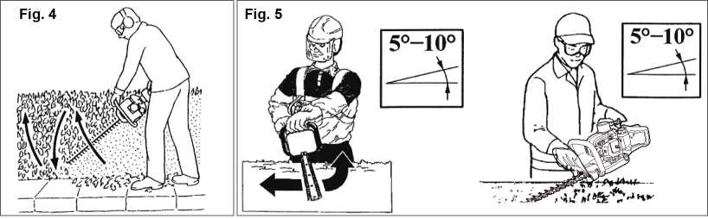
Con el modelo de hoja de 2 lados THT245D, se utiliza un corte de arco de la parte inferior hacia arriba, luego hacia abajo para usar ambos lados de las cuchillas. Fig. 4
Corte horizontal
Con el fin de obtener los mejores resultados de corte, ligeramente inclinar la hoja (5°-10°) hacia la direction de corte. Fig. 5 Corte lentamente, especialmente con setos gruesos.
A
ADVERTENCIA
Siga siempre las precauciones de seguridad. El cortasetos solo debe utilizarse para recortar setos о arbustos pequenos. Esta prohibido cortar otros tipos de material. No utilice el cortasetos сото palanca para levantar, mover о romper el objeto: ni bloquearlo con soportes fijos. Esta prohibido aplicar herramientas о aplicaciones que no sean las indicadas por el fabricante en el despegue de la potencia de los cortasetos. No Io use para podar arboles о cortar paste.
•Utilice solo el maximo de gas que se necesita para hacer el trabajo. La velocidad excesiva del motor es innecesaria.
•Evite cortar ramas gruesas, por Io que danaran las cuchillas у acortaran la vida util de los sistemas de impulsion. •La inclination del cortapatillas de 5 a 10 ° al objeto de corte facilitara el trabajo у traera un buen resultado
«Siempre mantenga su cuerpo en el lado del carburador de su recortador, nunca en el lado del silenciador.
«Cuando una maquina nueva es operada por prlmera vez, en los primeros mlnutos la grasa puede sallr de la caja de engranajes. Pero, puesto que esto es exceso de grasa, no hay causa de alarma. Solo llmpielo con el motor parado para el proximo uso. Fig. 6
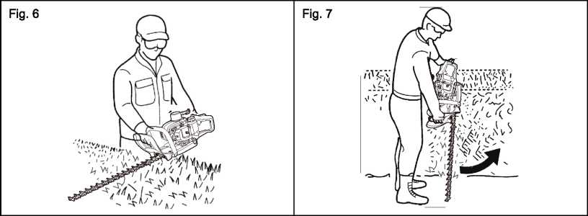

• Recuerde siempre que la punta de la llnea corta. Obtendra mejores resultados al no amontonar la linea en el area de corte. Deje que la unidad se recorte a su propio paso. Fig. 7
6. MANTENIMIENTO
 | Sistema/componentes | Procedimiento | Antes del uso | Cada  25 horas | Cada  50 horas | Cada  100 horas | Nota
Motor | Fugas de  combustible, derrames de  combustible | Elimine | V
Motor | Deposito de gasolina, filtro de aire, filtro de combustible | Inspeccione о limpie | V | V |  |  | Reemplace  si es  necesario
Motor | Tornillo de ajuste ocioso | Vease el  ajuste de la velocidad ociosa | V |  |  |  | Reemplace el carburador si es  necesario
Motor | Bujia | Limpie у  reajuste el  boquete del enchufe |  |  | V |  | Brecha: 0.6-0.7 mm Reemplace si es  necesario

 | Aletas del cilindro, respiradero de  enfriamiento del aire del producto | Limpie |  | V
 | Silenciador, pararrayos de chispa, Puerto de escape del cilindro | Limpie |  |  |  | V
Cortapatillas | Palanca del  acelerador, interrupter del motor | Comprube la operation | V
Cortapatillas | Cutting parts | Reemplace si algo esta mal | V
Cortapatillas | Gear case | Engrese |  | V
Cortapatillas | Screws/nuts/bolts | Apriete о  reemplace | V |  |  | V | No se  ajustan los tornillos
Cortapatillas | Debris guard | Asegurarse | V
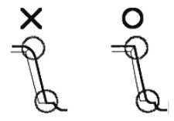
А ADVERTENCIA
Asegurese de que el motor se ha detenldo у esta frio antes de reallzar cualquier servlclo a la maquina. El contacto con la cabeza de corte movll о el sllenclador caliente puede resultar en leslones personales.
Hoja
•Verifique que la cuchllla у los sujetadores esten flojos, agrletados о doblados.
•Revise los fllos у reforme con una lima plana. Punto:
- Manten el extremo de la esqulna afilada.
- Alrededor de la ratz del borde.
- No use agua cuando use una amoladora.
Usted no neceslta ajustar el boquete entre la lamina superior у la lamina mas baja pues este producto se dlsena para tener boquete optimo cuando se fija correctamente. Fig. 8
Fig. 8
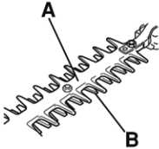
El protector de la hoja (A) esta disenado para proteger contra cualquier parte del cuerpo que entra en contacto con las cuchillas (B).
Fig. 9
Verifique que el protector de la hoja no este danado о distorsionado. Reemplace el protector de la hoja si esta
doblado о danado.Fig. 9
AADVERTENCIA
Cuando monte la cuchilla, asegurese de sujetar el espaciador, la arandela у el pemo, luego fije la tuerca.
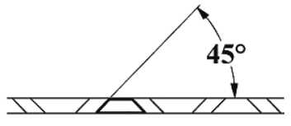
Afilado
Always keep the file or sharpener at an angle of 45 о to the blade, and: Siempre mantenga la escofina о afilador en un angulo de 45 grados a la hoja, y:
- Moler siempre en la direction del filo;
- Nota: Las escofinas solo se cortan en una direction; Levante el archivo de la hoja cuando regrese para comenzar una nueva pasada;
•Quite todas las rebabas del borde de la hoja con una piedra de deslizamiento;
•Elimine el menor material poslble;
•Antes de reajustar las cuchillas afiladas, quite las limas у luego aplique grasa.
•No intente afilar una hoja dahada: cambiarlo о llevarlo a un servicio de bloqueo de seguridad del concesionario.
A ADVERTENCIA
Detenga el funcionamiento cuando el seguro este defectuoso.
La cerradura de seguridad es el dispositivo para no acelerar la palanca del aceleradorsin la intention. Mientras empuja el seguro, puede acelerar la palanca del acelerador. (1) Candado de seguridad Fig. 10
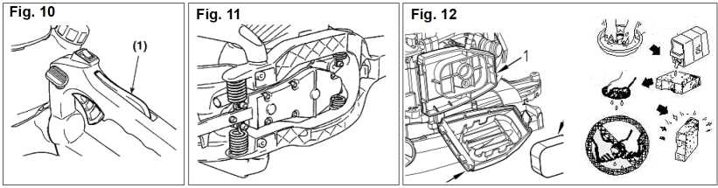
- Compruebe si la palanca del acelerador no se mueve cuando no empuja el seguro.
- Compruebe si la palanca del acelerador se mueve al agarrarla о soltarla mientras empuja el seguro.
- Compruebe si el bloqueo de seguridad vuelve a su position original al soltar la mano de la cerradura de seguridad.
-Si encuentra algun defecto en las comprobaciones anteriores, pongase en contacto con su distribuidor de servicio mas cercano para que Io reparen.

Sistema anti-vibraci6n Fig. 11
ADVERTENCIA
El sistema anti-vibracion deformado о danado puede causar que las roturas se desmoronen о se caigan del motor y/o de la hoja.
Verifique periodicamente si los resortes no estan deformados о dahados.
Filtro de aire Fig. 12
El filtro de aire, si esta obstruido, se puede reducir el rendimiento del motor. Revise у limpie el elemento filtrante en agua tibia jabonosa segiin sea necesario. Seque completamente antes de instalar. Si el elemento esta roto о encogido, reemplacelo por uno nuevo.
- Base del filtro de aire
- Cubierta del filtro de aire
- Elemento filtrante
Filtro de combustible Fig. 13
Cuando el motor se queda corto del suministro de combustible, verifique que la tapa del combustible у el filtro de combustible esten obstruidos.
Manera del aire de enfriamiento Fig. 14
Este motor es refrigerado por aire. El polvo que se produce entre el orificio de entrada del aire de refrigeration у las aletas del cilindro causara un sobrecalentamiento del motor. Revise у limpie periodicamente las aletas del
cilindro despues de retirar el filtro de aire у la cubierta del
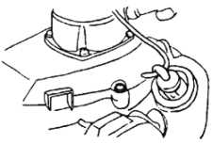
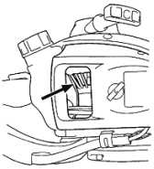
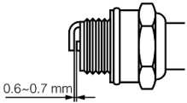
Fig. 13
Fig. 14
Fig. 15
Bujia Fig. 15
El fallo de arranque у la falla de disparo a menudo son causados por una bujia sucia.
Limpie la bujia у verifique que el hueco de la clavija este en el rango correcto. Para un enchufe de repuesto, utilice el tipo correcto.
A IMPORTANTE.
- Tenga en cuenta que el uso de cualquier bujia que no sea la indicada puede resultar en que el motor no funcione correctamente о que el motor se haya sobrecalentado у dahado.
•Para instalar la bujia, primero gire el tapon hasta que este apretado con los dedos, luego aprietelo un cuarto de vuelta mas con una Have de tubo. Fuerza de torsion de apretamiento: 14.7-21.5 N-m
Caja de cambios
- Suministre la grasa multiuso a cada 25 horas de uso.
- Utilice una bomba de engrase.
- Alimente la grasa hasta que saiga de la base de las cuchlllas.
Ajuste del carburador
El carburador ha sido ajustado en fabrica. Si su unidad necesita un reajuste debido a los cambios en la altitud о las condiclones de funcionamiento, por favor deje que su distribuidor experto haga el ajuste un ajuste incorrecto puede causar daho a su unidad.
Procedimientos a realizar despuds de cada 100 horas de uso Fig. 16
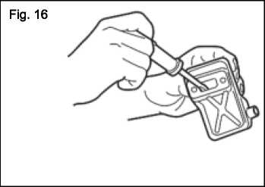
- Retire el silenciador, inserte un destornillador en el resplradero у Hmple cualquier acumulaclon de carbono. Limpie al mismo tiempo cualquier acumulacion de carbon en el orificio de escape del silenciador у en el orificio de escape del cilindro.
- Apriete todos los tomillos, pernos у accesorios.
3.lnspeccione para ver si algun aceite о grasa ha funcionado entre el forro del embrague у el tambor, у si Io tiene, limpielo con gasolina sin plomo у libre de aceite.
Mantenimiento de las cuchillas
- Engrase la cuchilla para evitar que se oxiden.
- Vacie el deposito de combustible у vuelva a poner la tapa.
- Retire la bujia, vierta una pequena cantidad de aceite en el cilindro.
- Gire el ciguenal varias veces usando la cuerda de arranque para distribuir el aceite. Vuelva a poner la bujia.
- Envuelva el motor con una lamina de plastico.
- Almacene la podadora en un lugar seco у libre de polvo, fuera del alcance de los ninos, preferiblemente no esta en contacto directo con el piso у lejos de fuentes de calor.
- GUlA DE SOLUClON DE PROBLEMAS
Caso 1. Error al iniciar
INSPECCION | CAUSAS PROBABLES | ACCION
Deposito de gasolina | Combustible incorrecto | Drene у utilice el combustible correcto
Filtro de combustible | El filtro de combustible esta obstruido. | Limpie
Tornillo de ajuste del carburador | Fuera del rango normal | Ajuste al rango normal.
Chispeando (ninguna chispa) | El enchufe de chispa se ensucia/mojada. | Limpiar / secar
Chispeando (ninguna chispa) | El boquete del enchufe es incorrecto. | Correge (intervalo:0.6-0.7Mm)
Bujia | Desconectado

Caso 2. El motor arranca pero no sigue funcionando/inicio duro
INSPECCION | CAUSAS PROBABLES | ACCION
Deposito de gasolina | Combustible incorrecto о combustible rancio | Drene у utilice el combustible correcto
Tornillo de ajuste del carburador | Fuera del rango normal | Ajuste al rango normal.
Silenciador, cilindro (puerto de escape) | El carbono esta construido. | Limpie
Limpiador de aire | Obstruido con polvo | Limpie
Cylinder fin, fan cover | Obstruido con polvo | Limpie

8. especializaciOn
Nombre del modelo | CT20114
Peso neto | 5.8 kg
Capacidad del deposito de gasolina | 0.55L
Caractensticas del motor | Solo cilindro, 2 tlempos, enfriamiento
Desplazamiento del motor | 22.5 cm³
Velocldad maxima del motor | 8500 min⁻¹
Longltud de la lamina | 640 mm
Espaclamlento de la hoja | 35 mm
Velocldad del motor sin carga | 3000 min⁻¹
Salida de la potencla maxima | 650 W
Coclente de mezcla del combustible | 25:1

- и _{t} А 4 -V 1ft > -ГЧ 1 л!1 4 й|
ISuuj (jiajSflj jjaUa JL-exil Jc jjSj vl (JjJaiij tjlila^l JjLua jj& l3a*J t jUill (j* (J^ cJ^-° “—(jl^-° J (JjjAll (Ji|j t,H.^*i1l ahi jjjaJJ p3 .6
.SjljaJI jjL-лл jc
Ij^SL/ilj pUa&Vl * «1-Jjjjj _{a}7
(Jjlall ₽.2j .1 aJIaJI
•1 _»yi | aIajaaJI 4 111.Л/1
*<*»ll Jj l^sl jjluil | jf jjSj | 3j5j!I
c iihtt | djijjM jjSjli yils | jjSjlIjjJa
иjjlill (jllajll JI JaJjJa | yjuJall (jUajJI | 4. affill jLaj.ua
i ajiyi \ i ajhVI | Allie / а<1ш1А (JlxjJiyi dllxAui | {(Jljuuiyi (jj^) (Jl*-^yi
(Mm0.7-0.6 :Sj»JS) гч^-з | 4 i ^4r\ | {(Jljuuiyi (jj^) (Jl*-^yi
 | (JItrfilVI ^Inail | (JLu5yi AjLAji
f-2kJ ejlcl L Mix^all j-° / Jji-ijll J JAUjiJ V bjj .2
 | il.-;. JI <_,и„^1 | U^a
JjSjll l^al jjlull | Ojjlasu JjSjll jl JJ^ «ijSjJI | Jj5j!l J>
ц*“Ы1 (Jlkill JI Ja±Ja | (jLlajll | (JjjLaJI L iftill jLauia
J| | fiLij pj | Л<1а) 4j| Jaxul tc2jj)x^»ll
(JxA^ | jljill (*-0 ^|Лы13| | L_aJiAA
 | jljdl ^a jl^juijl | Aajja »l life lAijc-j AjljJajuil

dAL^jJj .8
CT20114 | JjJjaJI ^luI
5.8 kg | JU-all jjjll
0.55L | •ijSjll jl ji. Ajua
Jjjjj (JsjjaII 2 ‘S-^aIj Ajljl&bul | tSlja-JI (jrfi>Lzi4
22.5 cm³ | 4^.1 j|
8500 min⁴ | ■^Ij-laII Ac. jja ^>^1
640 mm | Sjiiill (JJa
35 mm | eji>i ЛсЪЗ
3000 min⁴ | jauJl jlAc.jxu
650 W | _{E}l>yi Ш»
25:1 | ■\j3jll Js!a Adjulj

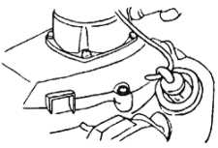
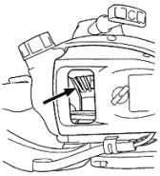
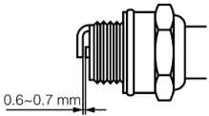
13Г-J
14
15r-J
.(JUuuiyi A*a*a jLflJj'i/lj JuieJI t*<Wj La
I ^ЛЧ^*а1 i Jj-iJ CJ^"⁻ .
I (jtlaill (jjulill [jl (_J* (JLujiyi Ajuajjj l (*3

U ^3 jl J^miJ JahjJ uB^-laII JjjiS <_у11 Л5 ^{AV}*-* j^jll C—i^Lkj JLuuiyi Алам ^Hiual J •
N-m 21 .б⁻14.7 (“3^{е-} ,3it-e t* ⁶_jj^ cs^ У_^ ^_ри15 сцшВ •
UAJJJ AjIc-
,^1лЧкмУ1 ijA Ac. Lui 25 J^ (j-alj&Sfl
аЛДяЗа ^J)’⁴ Mill
. jiuj SJc.15 L>* C5^" f J'⁴ .2
hu/1
^aLJI <.41 ^LajuJI cjj^la jl С1й^ц>»и11 <..»*«< SjLc-I t4fa-bj |j| ^u^aII
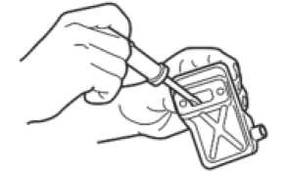
(jlj А П (Jj^juII c^JjJ jSj JaxJoll
16 ^I.iVua^I ^л Яс1ш 1QO J£ J*j l^j 4/^'
^Ijj ^1 ^*aaj f^ljJ ^uiaIj iAaaiJI (jb. IjjII uB1a Ji J AJI jU . 1
,o5jll (_pij JjIjSj ^л1ж11 AJj$J AajS jjJc. JjJjSll
JJaLjiaJI JS JaJjl ,2
tJJallj 0>>jt all AjtlaJ AjJ^la (_£j5 Л9 uill jl Ojjjll ^\ 131 La A±^*aJ ,3
(3*° Ц***1 (j⁻ СЙЗ"Ч^ ^1лА UaU A-a hi a J ^9
dlljlud) ^jb*^ £Ла1 B^iuiJI du J ,1 Sja JJmJI £j-bjj JjSjll (jlj^ jsl .2 .Ajl^JaxuVI dujll Lh S^jj***i AuaS <>*‘-* t JLuiVI Алаш AJIjI ,3 ь^а JLuiyi Ajuojji ^ь>» ,dujll £lJ)jjl £^j1I Jj^ ^I.Y%hnlj dil^)A вЛе- ^AS^aII Jja*JI ,4
Ц JjSjJI (_JiS JI o-ij ji lA j»*n ^S ;41Л1 a Jji Л*ч Л (Jjlaj *7


,t, ИГ- Aj (jLoSfl (_Ji£ (jj^i baJjft Цмг Ли1| L_iljl
1 0 f-'-uj (jl-eSB cJ^ (1 ) 4*slj £J^xuJ «(jLaSn .4jj (jjJ ijSJI <Milj>i 4*31j (jJ jt g > II jA (jl-aS/l £_JiS
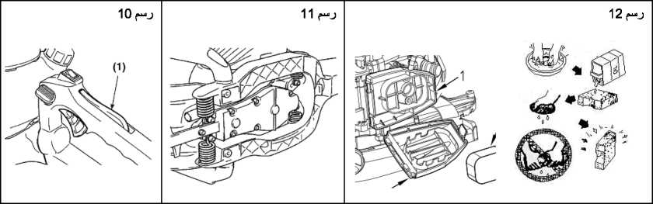

,£jLeSn cU® J⁰ kwtXi V 1<У*ь JjSj^I ^1J fjA , 1
,(jL#Sn Jis pUSl ajj^al jl 4£Llu*I Ддс JjSjl 4x»iljJ Ia* (ja%1 ,2
. jL?7l cU® CH¹ Л4& J***¹^' AjtxJaj* JI jjLaS/l cJ®3 5>ijC. (J^*! ,3
.l^jOL-tay OLo±k (JjSj (_J*-ejl «йМс-l SjjSSaJI OKjM'II J CJjJC. 131 -
11 ^uij JIjjA^U jLlSx*
A
,a JJj jVj £j* JoftxkU jI A^ll^Xe Jc- (Jj^t^^II (Jxe jjuiS 4iMll jl ajjui* jl ■>»-* ^Llaj l_Uxmjj Л9
,41111] I j I нН ajuiA 111 I3jjj (ji^j
1 2 ^Ij^il
(JjS LaLaj Аз1л ,t_ijli<a jA Lo£ Jtzillj ^jll^II ₽L*]I J ^jui^ell ^x^jc> i fliPii'ij aII «,|j| сУ^ (I^^Alm ^jl£ 111 4frl_JI Jlfi cJ**J ^{t}—O^{JbM}
,.\p> (J\fi*>il <4*z«jIi’I jl jbdViitll 131
«.IJ$JI Jjla lic.ll .1
$.I_JI jlla frUaC ,2

13 (*“j Jjijll j31i
,^|ЛмГСА1 JjSjll jlSj ^jSj]| pl Inf- c«ijfljll Jjj jp ^jc dl^j^oll ^laljj La^jc
14 (“»j Au£ ЦцЬ
AjljJaidSn j ¹ ....‘.l-.J »ljA jilt j'UJ clj^Jlj jUX ^jc. SjUc. jA |j&
cUaCj ‘ bU.* Jiu ¹ »‘.l^jlt ‘ «.UtIj
Ала li-ь 11 (JjjjIa.

.Aji.rfrkui Ajlual _{cj}11 j^LuJI Oj)i^ill ^jIS jl A^jajaII (JI>A1VI (_£^jJ ^3 , jig >11 (jlc' A a *14 (_^l AttYl (Jj3 pjLj ‘■^.J'⁴aI! <jA л£1л
.elV^lVI jl ^-Л<■ Alli jl ajl^jll (J>l jA (.“iIIhaII^ a^iuill • ;AJalj .CLdIj <■ b!a £a ^lalll сЛ^л. <ja (jSaJ •
.аЛл Ajlgjll AjjI j (jlc. JoSl^. , 1
.AitaJI £ул ^paJI Alj> ,2 ■Ajj-kl ki ^jc, ^LaII ^.YVurtl V ,3
3 j»xuj ы*| (J^•“' аЛдс-! Лс- AjKja a^>5 Aj ^IIaII I3a jl AjliuJI AjjIkII S^LjJI jJjj aj>lll JiuA ^1 V
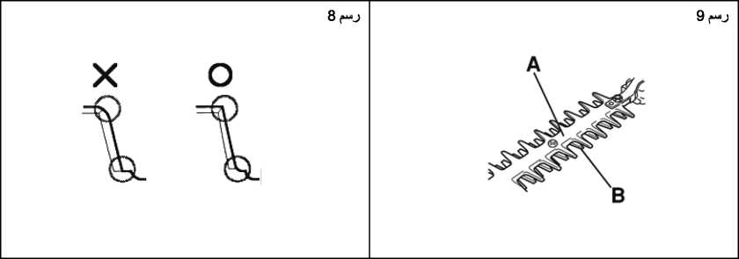
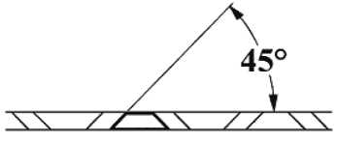
.(В) ^jl^jiuill ^ui>!I ^j*⁴ Су* ^jl A-hll (A) a^LuJI (^lj ^j«<uAi
9 (J^UllI .lillj jl I AAtrtA (jl£ 13! a^LjJI (^Ij (J.\H>m! _{t}OjCiiA JI L-aKj JJ& S^iiuJI ^1J f^A
9 .OI^AajJI Jajjl ^»J aJLumII t Jtzilall JaJJ СУ* ta^LuJI 4,jj ije-
; j <a_)LiJl 45°^jl_^ 1“*^ al_jxall j! i aUll 1Ча~ч!
Аз1л ataJl LajIj (j-ъЫ •
(JkAiII (jx ^{l} '*^1 tlafiS ataJl C d qIaII ^aJo^^Ia •
$ Дра. jaa £.1J aJjxll Даь
- (jij ajiuill А31л (jA ^.11 (JS All jL •
4 JIjaII (Ja (j£aa j.4 (JSl All jl •
,^j-^All (jjilvii jca!jJl Alljb lASjaJiAll OljiZill <_uSjj SjIc.1 <Jj5
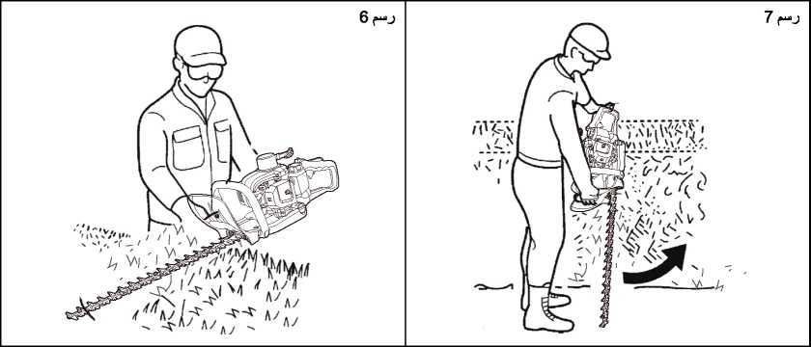

.6
 | JS Ли  100  Ac-Lui | JS  Atlui 50 | JS  Atlui 25 | ^1лЧииУ1 (Jj9 | »'j?-! | otijL.^Ua
 |  |  |  | V | ^"ьа] |  | dlj^
jZn _{f}jJ lit JlJjU |  |  | V | V |  | jjla tJjSjll  JjSjII j31a | dlj^
pjl Jl^iLal  j-Vl |  |  |  | V | U_>- Jal  Vi ъ t .Д| | laxJa jLaxiMi | dlj^
mmO.7-0.6  jZlI _{f}J 131 |  | V |  |  | <. ijh'H SjaJJI  ■IxUrt o>ilc.|j | (JLuuiVl 4*Aii | dlj^
 |  |  | л/ |  | <■ i|hn | (JAJ1JJ «AjljlxwVI t-ijlej | dlj^
 | >/ |  |  |  | <■ i|hH | ^AXa (jS-a. (jLaaJl | dlj^
 |  |  |  |  | AaLmJI | iJjSjll AjujIjJ  dJja-all | SlJ
 |  |  |  | л/ | (jlS 131 La (_|дДи>1  La llxx ijJUA | ^Latl ja.1 | SlJ
 |  |  | J |  |  | LHJJJ *4^ | SlJ
 | л/ |  |  | л/ |  | /_)Хв1л1ьа | SlJ

JAjIaxII оЛЛ IjSjJI A-mljl (jlc- I*ia*>i1 V
.(Jaill A*±l j ^jlc. Jai-Jall 0^{е} ■ 1
.AjKa i." И frill ^Iji JaxjJaJ (jib. jJasjIaII l*ik>il ,2
II (JfrulaS ilij^AJ « .lj.1%11 AajJajA ^3 (jHtiLlI Jia belie. ,3
■LSjil
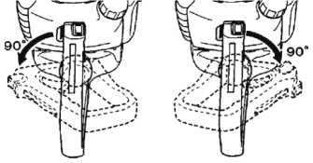
.JjlkM _{f} jj )la lie. Ol^ixill ^jJc. JaiLaJ Jx^j JaI^/u a Jj>A A32)laJI -Jajajll Sill jl*il nil <1!j^aII (jjSj I a.1 1G jjJa. (jlajjLJI JJjlJ *^{j}Vi4aJ
^jaXiA^dJl Cj^jAj
_{i(J}Jc.l iS?jl -la(—lil ^j^c- ^e&
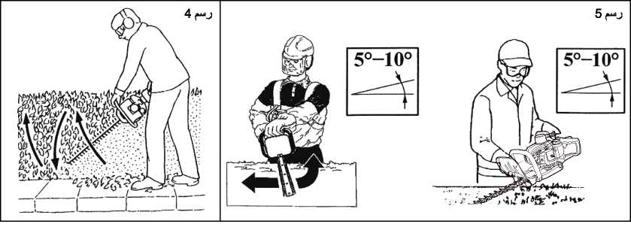
4- .Ol^Lill pl ^IiAjxuV JiuSB (jll ‘ Л <-U*^ Ja QjjJjfiJ ^l.lAlnil *^{j}VXaj ‘THT245D Oil Sjiill JjIja ^I.IAIhiIj
,A^Ja»i OtlajAJ £a beJj-u V tf.lijj ^l*rt 5 .^Jatll oIajI j^i ( 5° _ I 0°) bbl! S^ixiJI AILaIj i^laAll ^jVu Jovial jjlc- JjJ.rfT’Jl
A
^ЛЧ1*а1 V .lljxll (jA ^1*15 ^jl*i*kj Л_))* ****11 ОI >^11 jl OUaj^jJl JaftB k> IjluH Sill ^IlVuJ 1.1>J ,<а^1ы111 Olliljl'bl LajI1 ^Jjl
ASj^JI l^jll Jjjjjjj V _{£j?}lll Olijlklll jl OljlVl fllVj>J jlvyj .AjjIj OLaIgI (■jJb. aJmj Vj IfjJ^I JxaS jl jl ^3jl AxiljS Jajajll t.j/ltal Sill .L-Auudl ^Jaa jI jl^uiVl l. 1/1**111 lg,A.lVi*ii1 V .Jaj^jll ^^al SjS (-yle. 4 a 1*zi<aII .Ajjj^pJa ^JG iJ^^aII S1jIjll <GjjjJI ,4^^a1I algJ <aJ^GI 1jSjll Axul^l ^j*⁴ ^■1,b1*»il •
.SlGall 4-Jail ^jag JjIijj OljiuiJI i all (jll (^Ijlui 1**^ <., li^l •
,S.\1> A-4jTl (jiiJj AJ^xu Aa^aJI Ja^j**i ^laftll ^*а>1 <^{и}ll10° cs^l 5° (j*⁴ Ц-l^aiVI Sill AJIaI • ,Ojxoll ^il£ <. lil •> ^jIg oylj <Я5^аЛ AjjSLa j^a ^j£a1I i ₁111 •> ^Jl IajIi <^1a*a^ 1Чя1-ч • lg*k*4Aj Ja&a , jlli^U ^{L},**‘“ (Sliljll ^j-4*all jA I1A [j\f А ма«ь ^j*⁴ ^’^‘■xll ^^2lJ 13 AUS ^jj!±1 JjI ^a (Vjl S.lyY^ All Jjkjjjj 1JG •
- .(^1^1 ^I.iVum^U tilja-All ujSjj ^a
Vjl .a 1 lPI djjla uj^d ^-ª>^^{c}’ .4
2 ^AJ .£jJsj!I (jlc. JUuiyi ^-tiie JalJal .5 jjSjll iJjj £ljj .a (Jl*2;yi ^VaIa ,b "O" .c
T .d
3 f-*JJ ,i4ja-all (jlbij jjja. At jxaJ ₽.Ла11 (Jja. C^l£a.L a2^jll (J^a. plaai .6

_ JjjJjjaJI Jjii i. J Util jSaA OUIj^yi аДД (_рл ,(_>оа1а11 jJjaJ (JJjla (js- Allltl jl *ЦзЧ-^ gs^ d^' <-Ja-ui L-UaJ ,^£a
,dj^4 aII (Jai-kij ДС-ij ^iil A*3lj *4^^ .7
■ gJ^ (JjjUL аД*1 Loa. VI gs^¹ ^Laxull .3
XJajala
.ILjaio G^^-^ ^Jjl *^4 o^aIia ь21_^а-в1| (Jj* ‘ ajlcl Лас . *1
jlj£jJ £ja| iOVjla-o Зле. ^жа ₽Да1| .Jjljll JJ^jll t. V*".¹ <—Uu-ell gja dlja-JI gJ*^J L>“ _>*^ .2
GJLtkiyi Ajuua aJI jla j I t , i~^ i»
д a*i ( a, <-i'
o2a! aII G-Ь*»J JjSjII Axul^J
2 .AjJajlM-all G5^] (Jjtaiy' ^laiA Gji) сЬ"^' .2
A
G^jliJI G_ia_ui ₽IjjI L it Bjl 1.11>1 (gJjIjUI aJIa. »l mxula •
j4^^a1I L fllajb ^§J G$j^ -P (3^ 44—ilijyl Gs^ G^^y' ^laiA Ja±Ja Лас. c4ja-JI L_i5jJJ ^1 131 •
.aa.vk gJ^j 4AJ^ cs^JI* 4аЛ=Л аЗд •

_Ol jJjSlI Gff^ Gj^al' *
.(JjjSaII jl gJ**JI Jajajll i-jj-V** S|j| g>a ^JJ^a gj^c- ₽1лДл gX¹^** ^amU V •
□ЬДЛ ^.VVUail LJ^
.(jjjAjll jl J^-^l JJ 90 GJ^^dl j£j£ 4jp*y Лас- <_isull Gjjjlaal
_Jj_aill Jl aLxuVI <Laa.j ^UAaII ijA^\ fjl 131 ^lafill ₽j^ AjliVll J l JL ^Ша11 (jea. ЛдО .1
JjaJI j* <—JjjjJJ (jl (j£*J ЛJ Jl |ЛА (jl£ 13I ,^JJI (jlji 0^{е} Л JJl ("J-"?- <11 jl [jj>iJ AjSj-oJLj <LJa CjlaLuiAl ajcJI jjall Jc. ^cllall (_Jaj ^Л& .2
. Jiill ₽usl
II jl^a. (jjjla. Lej|j jlg-JI (jjjaj J Jij Ллс. .3
£yjiij jjiji ,4
_5Лjjl Jit -laj*ill jl-JJ ^0^* C11Jjj ((_Jja£ll (j-e (Jli. (j-aL-oj (jj-^ jl (^^-aU-aJl (j* JIaII (^л1а1| jjjhll (ja


№a

 | 40:1 Ш | ;Цл ^j^jaII kt4ll Ajaaj
1 2 3 4 5 | ^{s}j>-2 | ■-yj
40 80 120 163 200 | Ji>4l lJLH¹ | 25:1 | <fclxa 20 ^I'A’ImiI
 |  | 40:1 | <&lxu 20 ^1лА**1>и| Л*4

Jji-ниИ .5
sSj^aII P'lJ^I
Jja-*11 djXMiJ djp £bill Oilj I^U
. (jol »l ItitII JjJlijj 2jSJl (jl ji J ЛJJl <$Л*21 . *1
jl^a-all (Jji Ли »Л2 Л3& cSljajll 1\"" Ли~ь A lnj~k *11 JxJ^I jjc. liuij Jaill 0*1 j cLuljj lIuIj jlS«e Jc. аЛа-JI jUltbiilj .2
cjliiill L_ijjj^l J 0bilill jJJI (Зал1> JA Olja Зле. Zill £йл) .3
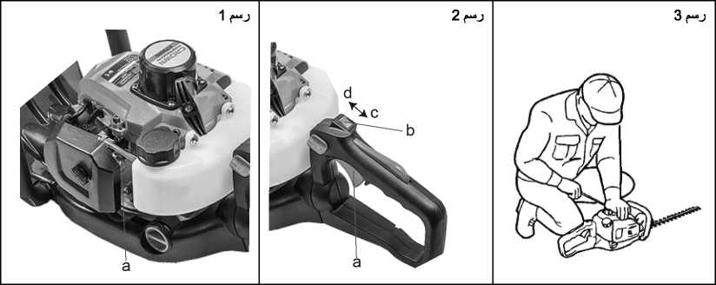
Ла .CJjjal t"lX 131 I j3a jS _A11xaaJ| (jp. I>luu JlilaS/lj AiilSfl dlliljjaJI Je. Jal йа II jl^ll j^aj .dllajVl a JaaJl i—ial^/Jl Ida AjLaa. . *|
. jjllalall ^l Irk II AjL-oVI (jp At^lA t(j^la-uiS/l ^J^-J C'ljjl ¹.,<Т’* tSlja-all jjidj L-iliil J& Laj|-i {j^^ala u^{J}II<aCb p.ljj| t*!J3 jj& jl JL-aJ^L La Л ^15 131 .2
.t-jjja jlS-a J JliLVl
АЛ^-aJl
,ti!13j ^L£B bUbjA jSj ^1 La jl^aJI £^L-el Jjlaj V . *| .A-aladla diljxB Jc. (JjJj J Aa-da^dl _{t}jft-\’illj Ajl> d-ill dlULaC 3ftj t^jLnII (JajlII ^al dL (j-alaJI ^SIaII Je. JaliaJI Ja.1 jA .2 . J& (JaxII jl dll₽.|^a.l jl AjLb-л J ₽lja.l tilja-all (JxiujJ (, hl ill jA IajIj -iStj .3
.tllja-all elijl -i*J IjjS 'ЧД^{С} ojl ⁽—J) AjxIxaJI ₽l ja.S?l
.Jaia a J ja-Il \Jlc- dl Vid ^1лЧ1.»| jA Laj|j ^£(j .lull JI ja jl iLujll (JI,\H.al Д1С. jl ‘ ₽■ j^, ^1 jl ^laill .4
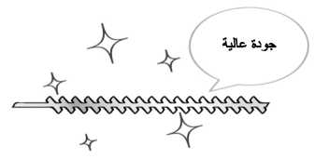

(Jj.j-i-hll Халж_а ЛлЛЧ (J^j ^{c}r¹^’ l>® (JjUl 13ft ^3 A3ji^a^A JJ& ^^L-al jl Ajli-a {JLa&l jl ₽. ja. (jl.\Hi >4 L_lja.j Alla. ^3 .5
.S^oLjxII (jib ajiiij jl ^SIaII (jjii jl <44& c.v>j L_ijjlaJI j-a L_ijla (^1 l" 'Vi ./ ,^Ja_»-a (Ja*JI (jlc- J^IS Jji
JjSjll JaUlIII
Aj3 >la.jj jl^A (j^l S^jll jlj^. p.(Ja o^lc. I jl ^jSjll dllJJC l^jj jjVi V .(JLlLS^U Jj15 jjjjj (jib (^jlaj Jalji-a >ijSj t^^ja-all ^Lax^aJ . *1
_^j§jll ^5 jlill jl ajl jail jiJ _)Лыъа (^1 jl ^laJ dll jI jii jl AjjIjj^S dll jl^d jf i.. Jrs jl ^5^a jl (J^j-a
.□j5jll jl Ajjaj ajL>I jl a^jll (J^iulu $1x4 I^jI j&Jj V .^Д*И (JUCbiVI j*3 lA-jlc-^l ^a JjSjll (Jjpuij .2
jlS»a (^1 u_ajJ&all ijjlll jl JJ>^I (j* 4и-ол1з ajlaj j^llj .djjjllj Al ^LaxJlj tilja-all ^Islalj Lallj 4 jl jaJl Ab*J adlc-l .3
.JjSjIIj dj_£ll JjS 4AJjS .JjSjILj Jjjjll ₽LjjI JjSjll (_^l <Лх^ 131 Аз1л (jiLaS AjJaS ^I.YVuJj LaLaJ 4_Jj£a4a1I JjS^ll ^ым ,Д jlS<a j& l"ij*J JjSl jl jlSal 3 AiLuxa (jlo jl^-a Jl a^jll (Ja^I JjSjll jl ja. Jc- fl^aL Sja JjSjll ^Uat JaJ^ 4Jj5jHj JjjjII ajlc-l Л*1 .5 .ujl^a-all (Jjsuij (_Jj5 Jj§jlL JjjjII ajlfi. I .AaLmi IgjV JjSjll a^^ajl (jaaluaj V .6
Jill I JLwi J


,(Ja*JI JjS Aj1£-
.jjill (_у1о cjllAj it^llA 4-lj3sl 131 _ <l»aj (Ja jlo 1 5 (JS^I (jlfc CjljljaaJlj (JlilaVl Aj-alij jilJI j^lc. JaliaJI .1

Jaifri Jjc (jjt*
.dja-JI J^Liu Jjp Ac>JI {^Лс (JAaJI W fS3 ¥ •
Oli3ja ^3 ti3jaaII V •
JjSjJl (Jij (jl ^*J (jJa. jaSiuiI 13} ,(jL-eVl AajJs^a (jll (JaISIL ^tjSlI (J*j ^JaS ^{t}—i/ O* (3®^ iuSI^^aII (Дримй ^*J .3
«IaJxaII (JjSj ^jJ} a^jll 3^j
^luaII ^I.vVM


Aa^bjxJl Ыа LfraMVudtj .AxI^aII A£j2JI Jj5 (jA I44 (^w3jaJ1 J|ja11 bii
,(Ja»JI frlul L-ASjaII (jja. tCjLill (jlc. ("jlc. Ia3U (j-aj^lj i (JjjSLaII
cJSJu aILmmII ^rj-ъ>.Ai cs^* V cJaISHj (jA (jA2bjj ¹ jIjSaVI jl JIjSaYL од^^11 (XiIjj 131.3
J} i^!13j >i*J Sj^Ija jl J^i-uij ₽Ijj1 t^lj-^АП <}Зл*а11 eljaSfl jl nJUuiyi AcVj t jLaAJI (_jaa1j V .5
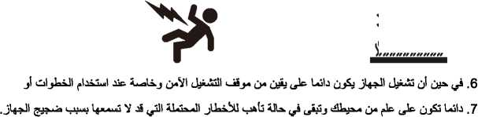

Aa^aa jl ojjJ-i4
<Зя^1а]| ^J-^ийИ -^_JA jl Л11 (jl jJ^J (JA ОJ)l.rflll ^jl£ aI I plflj} (Jjjl^^JI ^ЫЧа (Ja Л-чП ,3
;JjS tiljauJI ,9
.jLjuuVI <11 jl lie. jl i ajlnYill •
Jadl О)Л*а
jajll <jlc. 4jSIjll CjI^xaJIj AaauLaaII ^Ijjjl t^{J}Ijln. Ijaj 4j
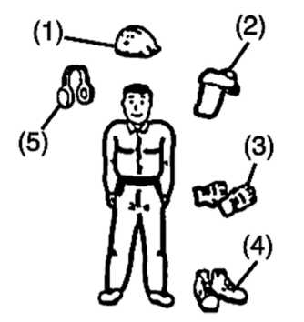
S3>JI (1)
Aa^jll 4^^ j' Si®'J CZlIjUaj (2) A ьа hi (JahJI Ol jlia (3) ■ьа_?У (j*7 jiVI g!**" SP^ (4)
j3Sn bLo^ (5)
(J 4-44J .b
.aSsjaJI oljAl •
^Tj-h »^i AJaji^xll •
,^laS a^i*i •
. (tSj'j^' j' Li/*^) •
gjIa^Ic. j
tG^a) tilj A > л! а У gJ^*" AaLxia jl liaV ₽Ia*1' •
■(t-iljbrll aJI jV) jLJuaII jl jlia.Sn •
.и*^ (JjSj IaVif- ji ₽|jjjl Ддс. j\ tAbjli til^Lal gjI3 Gkj'_>"“ *Ij3jI -^^{c}- W ^aaaJI ^ЛаЧни V ,C
Jjijll J-a JaUdJI jlaUI Jjjiaj
JjSjII (jl ja ₽gU L)j^ У gM^ (JA® (jij^ GS"'⁰ <^S^i •" ^{J}j®j GT^ (J**^ ^uaII I3a ^la.Ai Q
.JjS^ll gJ*-“J jtill j' ojl^all ^>al jAh-ia jf ^Lal ji AjjL_jg£ Oljl_^ j\ c-llaa. jl As^a j' A-Olc. Si® gA^-“ L^'
.OSjll gJI^p³ ^TiaII je, jj! а >иУ ■ibul j^A IajIj .Ajlill ^ai JjS^jll Ljlj^
gU o^loj j\ gjiaJI Jjw Ли ₽.UjI QT^'flll ,b
gJjS 4-UjS (j^° G-JjmXaII ь ^П| AixJl jl G>“ bjSa. ejJaj plillj Sfjl gIj* нН l t^jl^jaJI Ajj*j oJlfJ Jjc ,C
b^a fc^j-hлУ (j-»» *■** g^ OU^uiiVI ^tmia! AsIa jjiLaS AwliS ^ЛА^мУ ajlcl JjSjll <—^j2a.Ab. .(j
gJ^ JjSjib A hwI (jt^A (j& l^>*J JjSl j\ JJA 3 Aatube (jLS-e (jll gjiall gU^ fJ ^{J}jSjll £jl ji. ^^Ic. JjSjll ₽IL& ^5 <Jj§jJL JjjjJI ,e
ДД^аДл
,L al> l21I3 tjfci-Pb SlaJaA ^I.IVuiAj j^j^JI filial {ja-JJ l^dlall jl JjSjll gK*-“} 131
dlja-tJI J;ji*2a
jjlaj Jja. 4ja5B 131 «iaV /и V BjJaa. Aaliba jluaII ^lAluij ^3JI (^/чЧадУ (Ja JJa *| 5 Jaja.A (Ja.1^ Аж5|jll Ад1ч1аУ jbjfcl GJ>J .1
1*Ух1У (jle- 0-ajaJI IxJajf l.tyj 4JjSl jl Jj§ (Ja 2i±Jj CliSj g1ª*^' Ai®^ ^-^{e}^^{c} .A^IaII 1эГъа (Jja. jJJajll OLa^O <-J>J 4ji-al
.Aa^LaJI {JIaiJwI GiJ^ AaLuiA JaliaJI (Jal ^ja (Jj1a*j <'й31| (j⁻ £§ja1I Jja jIjaJauL
^j^a^aII j| 4t> 11aУj a^jl■%Уj Jia А^Д-чаУ C"Amtell G_J_^Ja jJa jjc ire'll gI*“*^ AtlaLo Alta. ^jA (jtai ,2
,Aj ^_^4aoa (JjAa*H SJj^a aAalj jj aIaj^a All ^I.^'VuaI lallaA jjjtaJ V . J gall ^l^aJxul Дло jjjl^aJlj AiaII ^jAa L. J* VajIj ^jtAxja _3
Зя^^аУ jl G-iltSlI ^aftll jlga. £A jig all ^^le- Ja*j V .4
.Allajl 1 OtaJajVl J& jlfjl 1ЛА fA-Vita V .jlaoll IgjJaju V | Л
.Aljg nil tataaliVj <. и hi J jjl ££a£j Ajlill Ata 1ЛА

oApa. OLoia L-lIlal ^uaaJI 4_Lo dujLil tJtauVI 'A?*~ tl$J«lja 4<>/u ^r.itAi jl jjAaJill ^laii (J^tail Alta J

.мjikJi fesij-ii) j йр=л (_{г}и=Лп) e^¹

l_lji4JI t .hnl i<nll flAViniVI Ja^iti fl jl 4 414» Xi ол1о| ^"1411 c^SlI glial I fA^Uiil 1"fX 131 t jljjl (j4>Xi J .glial I (Jj^Ail oAIc.L tai fli V JjlVl
fl.vVi.nil Jjfi 11Ж® ,^*л (J4>aj aA^jll а ДА (JjJujjj 4jflj^ fg fll AjLIxj ISa <.^N1 д11 lJa Ijl . 3 AjjJ uSBjta 4->/i jjjiUdll (jA jLd Lsiic. jl tf jill Ala j\ Су* taAlc. J ijja£ll jjjb eta taiic. glloll fhViuil tai <,4/& <■ j>j V ,b .Alai AilJaJj gj-4*zi (J^trti j ■> II (Jjkjjjj Q«e V ЛЭ j\ ,^1^% JUal] fJ C1J& Cj¹ (Jtatal (^ILlA (jjSj l дЛIP- 03 j c^l <j jl 4аЛ_/1 .ajl >X11 QjJjill ■’buXl Jjl cf^¹ fulfill О1^1с> (^ji-bl .J^tal ^11 Jjiuuij <_{t}ll^l ,c
;al_Lil AajJajAll dllj (_^a taj^la ^a lillna ^uIaII fYVtal V .(j .dljlj kXj (jlc- hl Д-*ь II (2Аал]| jjc- ^a (Jw Vi Ла (_£^^l i^JjA ЕаДлс- jl Aalj ^_pa^Sfl C)^^ ta^jc- ,
■Aahvall A^jJalj Ajjj t, 1*<.<**11 (j<a a Jta-⁴ UJ^i Ltae- ц^1 j\ t< ijKH CjtaJall dilajl ^a t(JjBI ,2
(jA Ла AjjaJI I <*Лt4t>k*ilirll jl ^l^^l ^{l}“(А^Л&^И < a>4*il_ydl ta^laA^JI <■ a*4*il^xJI «.tai ,3
,^r 1ЛА flA-Vtal ^>«1 JJ& ,^)ALa J^le. jjA 4jm chLull 4jaft flu i^IkHI JakII «Лл!1 ^^A l)jS/ 13a fl.YVi>iil Л1с- ,e
tOLtaalj (2лЛ1 j^. ^j5j Jl ajjAj ISAj taltaVI jjblikjl Jl J Jl (jLA J^l jl L_iull jl f jill fAc- ,f
,A1auiI ^1 O^-la J^a 4j1I t^VXaj i ^ЛА"инУ1 JJaJI ISa «tai СУ* . h (jjil AL Ja ^li ^uLall ISA AjSla Jftj jl <jial JVI jl £ull lie. (Jjtal 1ЛА 014>zi’1 (jA LajL Л^Ь ,j ,^lLoll ISA flAVi>nV Ц}1л11 IЛА J aAjljll jjll f^a Jc. jAla jjc- hi jl (Jlilabll tai ^auij V ,tjl
.OLL-alj jl д ч!| L_kJj b*4V\j ‘(.У-^l La tjw ЛиУ 4_Aa*j ^5j 13] - jv't-hl | A
.AjAjui (jjftjut OjaII L9^ tajjlr^ll OlAk^yij (JAill Ц^} _jLXall t±Bj £Jjl V C 131 - ;4jjjj | A
."Ajjjj" 4аЛ& (Ja^J ^1 AaI^JI C11Laj1*aJI (Ja CSJJ (jl | A
, jlfl>ll c_klj (,*\Учкаа i(_JAJI ^Jaja jA La£ JaU V (,"131 ;Ajjjj | 41
гги usjii
JajVlII (JjfcuU (jj£ .(JjJjaj (j**l ‘(_У^ 4%*<nja!I <^Uj £Jjl <_u3jjjj aljl (JjKjuij 131 | II
, iijj (j3Sn (—шл UJ^J ^{l}—s 3*" ttS113 L-i^lk .SjLkj I3a 3^1 j§ ^{i(}-. Ли al J | A

.alij jl ajjJg-ч ^L-al ^1 <Лл. jl cP! | A
. jl^aJI I3a JJLij Jj5 (^LJI (JJj aa-ljL | ©
.^Vl <jLaa.j | ©
.aIVI flA-VuJ Л3с <imi11a dil jUi Jjjl | 0
. jig •чУ ^|Лчиа| Jjc 4 Uul ia 4У\ч| pl^jl | @
.ajJo^ (jj^J (jl (JSajJ jLuUaII (Ja al^lj <j1a& JajaJill UJJAiaI al J ^^ImiI
4 H<ll oil j-| \<*i...| Jjc. ISjxj OlSljjaJI jl / j CLlljjtill j (jatilL 1Ча*1ч 1

CT20114
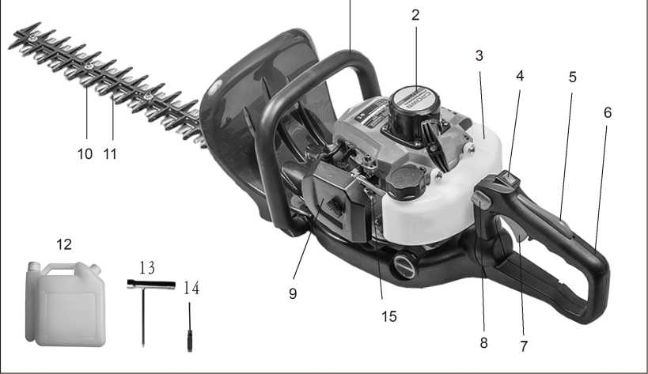

^Jaill Sjiii . "1 1 | _{<ij}jLk (jiuiA .6 | Д^лаЛ (ji»A4A J
AjajllUi J>,12 | jbjll jja. .7 | .2
(J H 1ft X>ll C&A , 1 3 | L_11a1I (J^JlA .8 | AjSjll .3
^Ija^a.14 | ^1 _> .9 | ^Idio ,4
(^■ХЦа'Ч Дал! . 1 5 | ejUbA ajLS . 10 | aIajii ja .5

^*’<■*4 OIajLla ^11 A Vi. Л ^a!|j J°J³^! ‘. 'У'' J w 111 (Jja. CaLojLla ^jlc JaI^II lift ^jAaA Ja‘, lA.W otal IjaaI ^£1 Ij£ja
,L-ASljxll ^1 jjll (JaaA (jj^j jjAuia jlsuil (jaJL JaSAaA (j³^ Д^Ыа!! CaSj Д^Аал!)
.Aalu SaIc.1 ^a |j| Алл jjijJj Jajjajll ^k»A jJa IaaIj Ij JaWI ISa jIaac.1
4аЬ1ы<1| OL»j1xa ,1 .Ajlbu IgJeljS (JaI^I (3^{я} 4aI$JI 4a^LuJI OLojIxa ^JajAaj Iaa3 Ajmltj AaIxII Aja^a Aa^LuJI
I - it ^i<4 aAAj &ЛjLla ^Lal "I" ^a A-LlaLaVI OIaKII l^{J}Laii » jk»At t^LjajaJ (J а*-*-' ^Ja 1jaA&J %a^LuJI OIajLla iaI
.%Uij| ₍«jJai”
_dUjll U-Шм cb iajjl-All OLL-aVlj 1$j1I jLaaII £jjl (Jaxj V C_u£ 131 - | A

 | J-г-Ы | Jj-c j>b
3-а) (j | f. t £ •[  F c 1 f.  t. t | j_uJ j 1 j о 3 4 1 H 1  d_k_L_5 о э 1 LLuj 1 lj^uj l_L_o
J J—3 1 J—3 J L_£ puJoJ—J g_A_J | Uux) U—4 0 J J 0 j 1 £ J L_> | j j *i p x h к > ckxd LJ_e о ^3 j Лл_0 j
j d-L-L-i-uj t (jS J—su> 1 Xuo ( j J j-S 1 • cjj- J J-> <?-J J J ) | Ouj 1 о a__a 1 3 J—?⁻J 4 } | a-k-L-S j-HkJ
1 j_a о a_L_L_S j_i_o_3 | Olu) 1 0 0 J -Luk-O L_> Ja-uJ J 3 | a a j j А з
j—9 (JLuJ jj_J I—J J J-i-J—k-uJ «1 11 3 | CkuJ 1 0 Д_а) 0 J Д_ак-в lS L_> Ja_u) j 3 | j-M-³
О J

Jj_J! pl_i | CT20114
CP-¹¹-» (jjj | 1 ii 5.8
UlL>J_u) й_к_9 jJo | us-LH’ 0.55
J J-³ J-® ^L^Ul-o | 1 j_a a a_L_L_5 <X_L-> < 4—i 1 a j — 2 < j a_L_L_j_uJ 3
 | 22.5
jj_5j_o Oxj-Ui o-JJ-j'i l—J | 8500
4jLx_J JjJd | jJU. 640
<Aj_J <J^L_9 | jJU. 35
J J_J J—Л J 1_S L>JJ Cke J_u> | 4-4-9 a 3000
0-jjlAfc j | о 1 j 650
O_> J-а) Ckkul—j | 25:1

. 3 jJd L-oJd 4-rJo_9
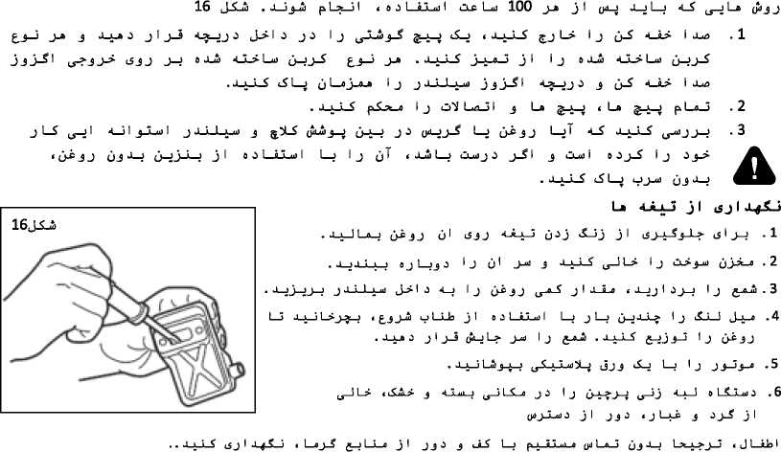

I <5 J u-l-e iS L-eJj I J .9 (jj-u> J J J^LL-> I *1 O-X-RjZIJ
 | J-fio | j>b
UJ^ | o^L_U)LJ Cuf-j-o) | olaj Li—д j-uj j 1 _з o 0 j-$ <_х_1л_3  J-jj-L-S” о d 1 LLuj 1
O->_9-u) j_L_l_x__9 | OuaJ 1 0 Ц_й Л J -LuL-0 Ol> j_a)
p-bfcj-³ гчн | OuaJ l—L-0 0 0 J Ц_Л_-0 j 1 J L_> | J jJt) (xjJo_L_j uud LJ_o о 0 j 1л_e j 3
(ª-¹j u-»-¹ ■*-’>?■) | 1 0 J_A O*LXJ> L_J lJ 1 J_>
(ª-¹j u-»-¹ ■*-’>?■) | j ¹ j-⁵ г-ь=^ j | 7.-6. 4_Ьл i—э) -ч-⁵^ (j^-0
 | Cjuu) 1 0 jJj 5^3-5
O_zJ I J-SLti—o (j-Lut jl Jj О ,U 31 о ц, Д 3 (j—9 I i 1 ol J (_£—⁰ jj J j_o z2 i2i_x_r_«2> j
68
У=/
5—1 C P Hy С Й* £ 41 ’ (г^к-f с C 1 7~p> —I H¹* * ПТ?—I I I C⁰ ’^{Г}~Й s~C C у~рг с tyrr-j | О С | y-rcp-J 5~PT ’
У"|Гг-Г|у<С с Г удС<уо £ ’. 41 ’ ¹J^{r}T⁰ |⁽’^{r}x?’ iyT ПТ*⁻*’ T⁰⁻1 ** ^{С}ПТ £“?ййГ|Р |О"П³'^{Л} «О
ГТ=П^ n^{ri-r}IF^{fr}
2 • I £—I C°⁻⁻l Й"¹ S⁻^ I С г⁻'I ?"> ®-| C> ПТ^{1,} О I Tl O’ 5~Йг ’
T ’ I C гу йо~о y~Crr»O | rr-yj—1 q уттг ’
С C rC О ³~^’ ^{0-t7r}Tp уТгтО <~pr Г4Й ⁰ I £—I H? 5—ргт '
■inrry cr-p 0

v—p£rC r~(• 5“I ГуСс (t^k-t-2 o—fr⁻ГС yC q f г—| рт-Ьп £~Ca—|P f—гт^ |C <~r o—f y-f C C |гп-г сгту^ |Q
£—f <y c 1 г~гу г—| угт yr* 1 прт—| co 1 Г ч~С r⁻f 3 ртт-х-г* гу П“Г 1 Г «г-f | С c r⁻х-т-т-Q tyy « ^{0—}°^y9 | <""’7
’ I C CT'S «тгчгНг^ | рт-ув—j с о 5p^{-:}f_r ■
C j ут-гТ f г—Г C 5^”^ 5~> T5⁻! П И⁰⁻^ ^{СГ}~‘^{С}У' с с с C i«^{r}y^{r}’ гТ | С с | С c • c~C | P <rq ?—yTr—y^
I Tl С 'Й" I 6" | yn-| «-| q 1 ПЙ’ £—I И⁰ I С ПГ тПП I I ^{(fl}T?'
yo-? ПУГ ST
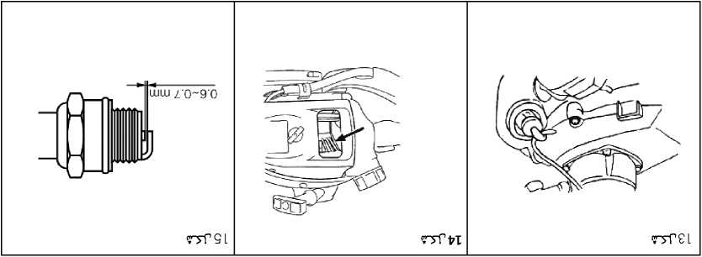

г~б~ |ут»р rnT-yr~r С г—| (“к «“] P (wx—ргт C yrr-rT 5P~v~r <"y 5~рйг •
yT^ ртП г"гт»р | Г <т ff~ff г—ff С г-⁵¹ (уТ с • ry r-f Ср с Г С с | Р уТс Q гтО | С <т j у-Сс О уНрг-Г «-С | F
I г-0 е—Гу-Г Г г—| «гС | г~Сс о-⁵¹ уСс • г~т-0 г~6~ Ср С ССс Р вгС | <П~у 5~ррг о <—| О’ ’П {"Т—руг С с—| <пу
СГпр
гТт< тгГ ЕТ
g • ГутО «“] Р угуг<
£ ■ ?—Г (тп/) угууГ «гГ |
V ПП бЧууГ <НГ|

гт-ргГ <гГ I ЧТУТ гт:
г~t> стг^ Г у> с Г С с | Р г~Г С уугт ут уг~Г ’П ' ууНг-Г ууР Г⁻^ I г о г—| утт г—| | р^тт» с г~г с г~г~; угт *
Г I г—| угут с •
pr-T-fn-T-d pry- j—Г Г [Гр
ууН-Г ‘ГУТ с | с а
уГ О

«ут | Г
’йтт'¹ ГТ (“Tf^ TST IT
чгГ С Г~0~] f-jS-Tr—Г •
С Г сл-Г(~ф (—С С rC yf г-> г⁻гттО с С r~CCf>r^{s}'¹ r~] Р г—[ > г~С | Р г—гг-о-г-Г г—| yf с г⁻уг<г-<? уГ Г уут о <твуо
о-ГуН-г? | 'Г⁶'? Г ^{с с} "
£• 5-уу< Р уН-т гтуг^ у сгп Г ₍ |Г ув-р ! Нг-г^ |Г|С о-^ ГУГТ»|^{?-}1 ЯТГ I Н-
с «ггт Г Г-1 УУ“Г ’ I «"Г <-С ут? ут ’
с «"гт ’ | «“С^ с Сг⁻*п» уд Г С | уу| С г-^
Z ■ 5ТТ< Г ГУТ С г у у FT-р J Нгу^ Г [ угу Г 0-^
Т ’ ’ТУ!'^ ГГТ I <~^{г}~г-^{Г1} гу| С У⁰"^ С «"гт ’ ууН~р УУ^Т ут | «~Г^ с Cr-vr у| С ^{<-}^УХ’ Г~УУГ ‘
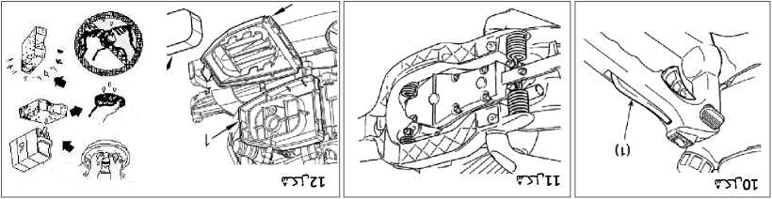

С |Cp гт—р | гтгу⁰ ’ рттг-1 <r^{jri} г—Г | Г“гт | «~Г^ С Сг-^> ГТ—р | г~о—г^{_г}’ | j Г б г~С «“г С ^{fT}’T"5—| ⁵ Р «Т Г”
пГ гI гл* '■•-гт- (_{Т}) jT-f ibr-H" ууг _{от} I «тС^ с Г?"^т> §—| Г С | с «п* • ^{в}~Г5⁻1 ^{ь}. ’" I
| С^-гтл
СГТ С
Г | £—Г-р уугт ’ |р Г I г⁻JT-fr-pO уутт Г Г⁻! с⁻1* б⁻г Г <тг~г—г О <7Т0—1£—^{л}
б~г-р | Г ГТ7ПЛ г—-Нг> ®—| Г г⁻т~р fynr о ’ пН" г-1 О г-1 С | г~Г с | Сг~г fn-гтО С F Р | р «г-| С F ^р С | г-хл-| гт '
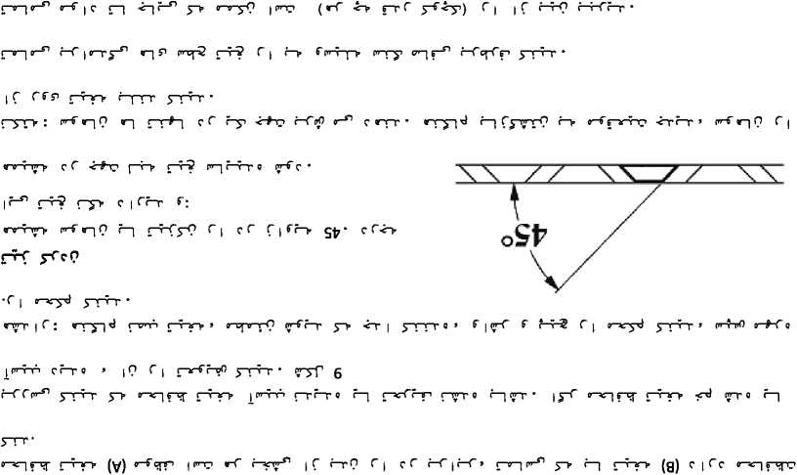
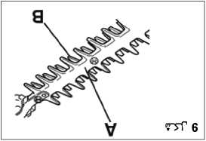
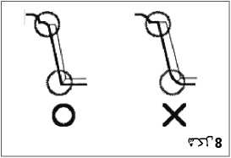
ТУГб
J-jCfT • rr-j-p g
Co—] г"^{n} с C toy? r—ncpHI toy о I—| toy tyC С P epT | -e-P toy о | toy? г—[ iy"y| r* етррУг—c | toyy
^Cti гуту? y> 4TV1P* г-Н? НгуУ '—IF. Hryy ?—| F⁻H? C | г~гсргч) yyrr Cr~C | | r-0 or-rtrf p
£' nyi’¹ ТЛ” iC уу.’'-rqct’ IГ J. 6 |«mci ГУГП"
J ‘ ^грр P’P’ P^ I г JTPr '
T ‘ T> I РГ*П ^{c} I P< P§> г I ^{c}<~^ '
p~r> p P с⁻r-? C | <—C С рт^{_г}’ Г 10 c 1 г—| ?”y 0 ‘тр s~> * [ 5~Р:П" ' РУТ⁻*’ ■
ip⁻?⁻'’ i р^п Г г ^{e}~n*⁵ ’п | | | p°_:p—i О | Г рГ ’ р^у ? s⁻⁵¹ —I р^ Р['5^{-Г}' ^{Гп-Г}' рр рО с—] (Tf-C r-^r? с С р <~С гр ^*~г | PPh РРГТ ⁰ ? | ^{Г}~РГ<? 1 гр? г—| зтр | t^oo tpyvO ipf с ’ | РР?-
| срг-у-г—| О <p c”-p рНгт а—Г г—Г С «p-р [Г 1Р*П^ ’^{г}^ рт“Г S'rnw^’ гз> С Г Р С ippp| в ’ ®РГ^ РУ РТУ РГ ⁰


 |  |  |  | Z | 1ГТр—Пр | уррг-С
£  J  'О ° |  |  |  |  | Ijr-f г | Нг^ Г <г-К"о
 |  |  | Z |  | 1. J  Г к | <гтН-)» срг с
с | Гс
Г<-Г с

JJ-A-⁰ | fit ji**l fit (**t fit 1  O_> J_uJ j aJj j_J J | J ч  Vj n |  |  |  |  | (SJJJ-^ _>-Я  ya_jj_x_j Cud 1  J _j_aJ
JJ-A-⁰ | t t 1  i £ 1 | •£ 1 t .Г f |  |  |  |  | djj>a >SI  Cud 1  j 3-j 1 j_j 1 j L_S  ' J
JJ-A-⁰ | нА-³ hh | I & t h и |  |  |  |  | J-SI  <_U*J 1  : jjud  7.-6. <J^L_9
JJ-A-⁰ | sA> | 0 j_aJ ёАэ o j 1 jj o  к Ih 1 5  2 j_aJ |  |  | ✓
JJ-A-⁰ | c$ La <A_x_j  <_U d/j  ¹ 3-® <5^J J.5 | 0 J-Ol
JJ-A-⁰ | / 4_SL> 1 J_«o  (ys j_o L> <_5 J_>  <5 1 o-S  J^A | 0 J-Ol |  |  |  | ✓
 | »J I < 1 ,.,d/J J_3j_» j L_§ 4_>_JJ 0 | ii> Ij
 | Jijj_u О L_x_h_5 | J-SI | z

4_S (5 3 J—J J I—S <5 La 4—о 1—jj_J j
jl
о 3 I Ha I . Xj_L$ J_i_9 I j (jT 4_i j
Oj u_3 j-Li I зj_j
4_j о U_j j L_uJ *j j_b j I
. J_x_LS_J oil LLuj I j_o_> I—j j j LL_> j 3 j3j_S yoj-a <з I j_j jl
O_c j-oj . J—X—LS о з 1 LLuj 1 j I t i 3 j _9—о j 1_S 3 J I J_5_o j I Jo_H_9 t j L_S j_j I p L*_51 I j_j
. l~XjJ I
J-X-C jj-jj-o jl (Я-i-J
. J_x_L£ <_j l_JLL> I f J jj—о о L-SLLuj з jj—j j_> 4_a_x_j_j j U_LS jj—о j 1—a) T I j j L_S i (p j—J J L_> j 3 p-"⁵-? 4_j <5 I 4_> j 3 10 1 J 5 _{L5}-» 3 u-x_i
. 3 J j 1 -La I _g_> j Ls-oj I 4_J I j
4_i_> I JUzs lXj_uJ j 3 j_5j_a c I 3 4_S_3 j j_31 j_xj L_S jj 4 ih o iZi_a_uJ j 3 1 j 3 j d_J 4_A_x_a_a
• -4J j: * > J ¹ J-⁵ 6^
4_5_x_93 i-L> j3 « J_L$ (J—о J 1—S’ 4_J jl > j-X—lj I i5 I J—> 3—JU_> 0 ULLai 3 3L.J 4_S (J—о L_5_La
(yL->j-S j—JI 4_S L?t_jT j 1 < I о I . J_j I—x—J j J J_x_J 0 J—j 3 4_t_a_> j I 04_J j-? Cxxd I j-S—о—о J j I
jj—jj—о j J_x_i_S j_x_o—j I j jT -bJLfl . 3j I 4_J 3 j_>j J-b-> cSL-jj (j I j_j х_1з g-J-л «i2x^o I jj—9 L2> 1 6 J-S-ii . 3-b-LS (H_9—⁰ l^*- t5 3_r_i *_flj Lzl-o I j_j I j
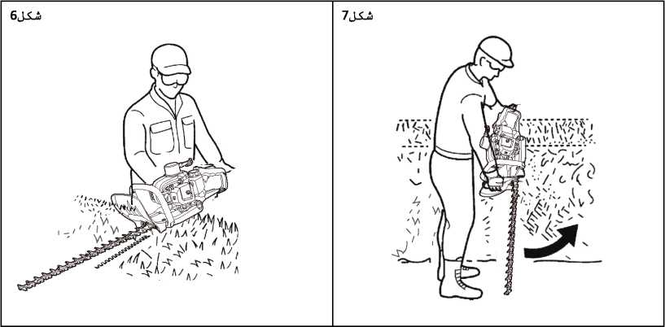
3 j I j J j j 4_) l_i LeJd . J-LS u-/> 31_л_31 IJ 0dj_) b> TIP 4-S JLiJtf l—J I 3 3 l_J <U <ЛЛ-ЛЛ
J-x-a з ojL>l . 3jjT Ахл I >> CluJ3 4_j [j j I > j_jLLJ Jbj-J 4-aIojuo j3 K> jijXJ
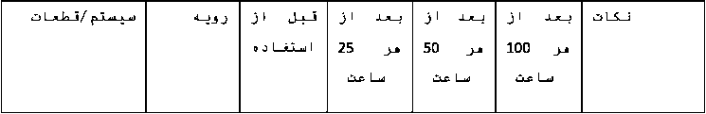
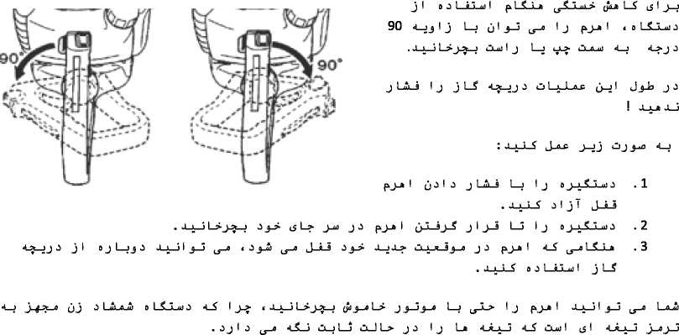
j j J L-obOUJ 0 L-C-Xud J j I 6 0 1 SLX-uJ I c$ La lSL—LSLj
.jl <5*i I J yd-X^ul J « Clud I J—J <j3j—0 <_S’ j_l—>J—1 31 jJol I OLL_J I
tS 0 J-O-G ($3 J—J O_0_oJ 4_J qJlXjxI J 1 J СкЛ_а) <_J j-X_J I J OuAxd3 jl <^-иЗ_)—3 c THT245D J 0—0 4_9j_b jO I J
4 J-SL-u) . о jJu о о I Ll_aj I <_я_х_i 3 j_lo j о j I 1 j i o_j—i—S’ о L*_j I j-j—j I j
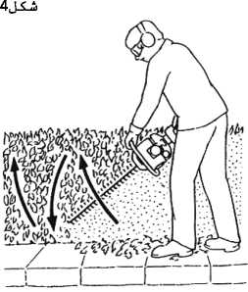
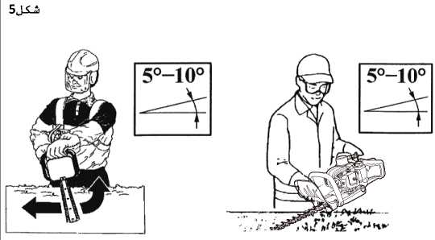
CCOUuJ
4_з I J (°l 0-°5) <jU_3 t (y) J—з 4_7t_j3_j j_J j_l з j 0 J j I OuuJ 0 4—J (J I J_3
. <5 La j_x_>j—J Oj j—о J 0 4_J
« O-i-Л 0 ? «CLuIA I 4_j 5 J3Jj

j-j_> j—J (_y3 J 4_x_1 о LSLLuj 0 . J—x_1_S <5 j j_x_j o—j I l$ l_a Jo 1_j3_> I j I 3j-m
I ª-^ I—i -ЬЗЗ
(Я-ЬЗ I j 3l j_о £_l j_JI j3_j 0 4_S O_u> 1 a—a . 0 j-i 6 0 I slLui I <53j—S l$ La 4_jj_j L_j j ua_jj_о l$ La
p Luj-> I jJL3—2i L_j o3j_> c _{iJ}—i L>^_> L> c51 J—J f\>* I 3_j j I j_l~c <_j
о L-SLLui о j I
r-f c | 9 yT | C ^r-C c •
I 1 С о r~r «ггт y> cC «-py| xJ 5—| С yC с p ?—] r—rcpH) 5—[ Cr-С | yf С cyy]° УТР C9 ’ у¹"*"¹ cC
yC I у jy 1 j С гт—1 "3 ^{r}y9 1 py p⁷⁻^ <47 Г | £ £—1 y^ I ^{c} ут ‘ «луг | C
С C 1 r~P cr-T Cq ; pep—1 с pyy| ⁰ I С yC УТ"^⁻? p^ УптО С «~рг 5 C pirrf УУТ ’
Г с-Гс-ГС С | о~г<б-Г 5~УТ •
I уГ tr~ftpFC «г~ру] pp-eprd (W r-v-2 |ynqp -у У? Г^ГР’ ПЛ УР УТ^ С ’ [ ®~Cxj py py о Г| гтттгт
r^JrC с C 1 y? j cy-C j CP ’ j С уГгр H" г⁻Г С ггу ууг~г9 | «~С^ С Crir> £y C | -cyry о ррп" *
Z*
1ТПЛР ^{r} I '<->
rsT г
угтт (C f yp угтт ) •
J- j tf-TxJ c Cr^ry у] f Cj |Cl^ 5~П~г $ <r-^<r~^C C| r-T 1P HN cyrj-Cjo [r-f[CP
y-j cr~f(И7 yPeP
o—fr~FC

py py p C j г—| Г ургт 9 £TT"| I £""5"^ I 5~У“Г ’ г⁻J (утг? С | г—Г с [ Сг~г Г [ р
с ty-T | С ург •
«-ру о—*"¹ у» о—Гг—Г С г⁻^ |С "УТР-Р У^<^Р ГУ^ |Г"Г уГ Г'З у) С ург »

«-pyi с | о | уг | С°~^т с ^{г}~^у^ ; У^У1 yi⁵ р⁻¹’⁰ | С уг^у* 5~^ 9 19 ’ 'У у с¹ i —i С
д' | <р Г с с «ггт p~f yf Г уг~р (Г у^^"3 trtypQ ■у~г ^УЛУ У^^ уГ с •
in- |ГР
£’
I «~Г^ py ry Q С |
Р’Н'ОР?
Г у-зет с [ г~С С С [ С ( о

| уг I о—I у° ^{0—0} у^ I уг р—I злу уГ I С—«—I Р I рул Г с у^ С ■

I С уу^{-г} 9 уу г^ £—| pr<F? iH-rfp пуугт
г«—] уС?9 | «гГ^ |9
1<УП^ уут • -S-H-9
ТУГ е
д' с С <—| р° 5—р с pyyi ⁰ | Р"> °Г^ f р -fc УУ* I УУ I ‘~¹' ’ £—1 С У У^¹ У^{tr}~^ У^ С5~^-О yf , уу г⁻¹
О,
: о aLt) 4_kuz)j_j o_Luj_j |  | 1:40
KjI jJ> | J J : LHi j-M |  | 5 4 3 2 1
20 L о ULLu) j j 1 oo 1 LLu) 1  Ol£ Lu) | 25:1 | LHjJ-M tS bs j_L_x_J | 200 163 120 80 40
Д я ) о L3LLui о j 1 oo 1 slLuj 1  OlS Lu) 20 j 1 | 40:1

d jXJLac .4
JLLS" (Д-e OlS'jj* 4_> £jj-i jJ-i j-i J J I—) $J—) lS^ I—| • J ' ^{wl}““^{Le}
L-J I J jT
4_2t_)J d J J—) j—)J—J CkJ> J_u) jJ О
Ij .1
(P’J-J ‘J.P.H U^J-S j^JJ pL$_La
. -L_) J I JLSL) (j-A-SJx—о j O—J I J gJa-u) <s _J J I J 0 ULLu) 0 . 2
• -¹—S-j—J j L>_> I j I pj> I j 31 jJo I is L_x-u) I
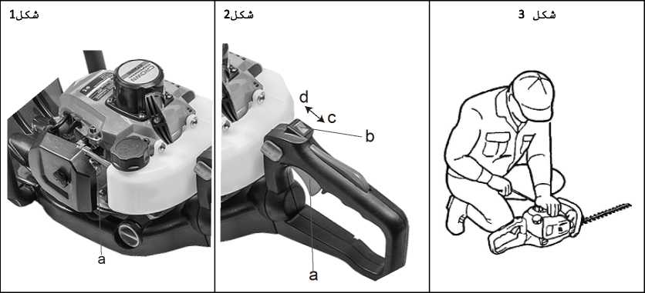
.3
. 3 j_A j_j j I 4—1 j—1 j 3 ui_> j_uj L_j -0 J Lti_9 j I j j__j J_L>
IJ
(j-LaJ L_> a. 1 J_SLu) . J-J—LS J-JLLi—0 <LLd_J исл_я_5 J_e 4_> Ij О Lu) Lu) pj-й I s CXU4) I cSLL> J j_J j—0 jjJ—Sj .4
2 J_SL£ . -Lj-b э j I j—5 Г> t ж 9 j_o j_j I j з I j 4_§j_> g_j_3 j-u) . 5 j L? 4_^l_) j Э pj-A I . cj—1 I
aJ-ALx & aJi_i ojlj j_x L_a_j_a I j 4_>j_l_9 3
I > I 6b 1
• ª—*—j А-4-А cS I J—> ‘ О l—o 3_>
. J_x_LX_j о 0 I i-L-uJ I < J_> I j (_s I j_x о J-i 4 i. j_J 3 J I j—о j I
M LjJ, L_> jj-uJ L_> p j I j_i j I .6

. Jl_x_L_X 3 1_л_ j I fj I jJ 4_jj_?j_e L_> j о 3j_X 4_я_1а_9 4_rJq_9 I j J л a_x L_x_ j ц, h _> I jJj g-X-й <2хл_x .7
4_X_L_x I L_x j 3jJt) j3j_X J 1_S’ j-X-> JJ J j-лЛЛ—л 4_x ja_xLuJj i_L-X_<jj I 4__x jj*J—о CxjJ I jXLa—о J I—S’ j-X I jx L*_j I

j LA t I J L_>A_i I J—j I 3 u—jj * ? J—о 1—“> *⁴—«-1° j-Lxk_o ^x_> 1 ? 4_S’ i3_uj I о а_Л I j-lo lS J j-k J j—J j—о 1.
A_p 4_S J-» j3 I J о LAJLux з jjxL-o L_x j a x 1 *x > oj_x_>3 lj j_uj £5 I—a (jJo j_9 jAj_a . a_LA
(£l_jT L_x L_о jA jA_x a £4-5—о j-» L_x (yi j_> 4_9 j_> »^^A—xjAA_J I
4_flj_> < is j j-aJ ^1-jT <jl—§ d)L_>l < J L5^_)
jA_o—о 4_S I j_> 4 J l, i S > J_) 3j I 3 3j->j lij
I X j3jA J 1—S j_X_> j3 jAj_ft . ckjJ I J l_R_Uj I J—X 1—9 J L_X_jjJ—X 4 a_X_LA O—XJ—XJ—Zl lX—9 3 I X I J .2
. a_xAX_x j LA_x_ux ‘ A_> j_u) jj_?t—о j3jA j_> l_x j о 1_А_Ъа з
jl J-x_э . 3 A_x_> J—х_л J ojL_>l j a_xAA (y> j_a> L_> I j j j—а 4_А_х_дл < j jji_a j_j pLS_L_a .3
4_9_}_> g-J-» 4_s J_x_x_S JuZJ L> j L_x_x_jkb I 4_S_L_J I <5 I t J—> j I J_x_x_J <j I jJo I 4_J Jj_x_9 J L$_J £5J_X_§ j_uJ
. 3 j I J—> 3 j_> j (j-S—>3 j—> j 0 c J L_J (5 L_« 4_LxJu I_J
<5 L_j 4_> j 1 j x j I оз I slLuj I L_x I j j I
□>>«> pLS-L» jo j_SI .4

J. x 9 I j 6 LC_l-a)d qil-l-uj j a ). > 1—> j_*_x ux_> j_«) jjJLj l$jj j—> I j ux_> j_«) 4_3t_jj з «ts j_x_§ ca_> jl a i .5
о а_Д p 1 > *> I x Ol>j_u) 4_S’ (j—j L> j I
j-Jjj 3
L_> о 3 4_к_я_х 4_x j3j_S’ jJ)j j j I

p LaA5_u) I I j J-"⁵ ( _g ) <5 L-a J La*—?
J J) A 4 а_Х_Й 3 J I J_9 (jAjijJ—J Jdj—X uix>_X tgjj J—x j I X > О J J_«43 J3 4 J J_«£L?t_O _{LS}_j_<jJ з — p LS_Lft
a_x_L_5 4_» x 5 j I Г1 x q I j_o I x I j jT j a_x_L_£ all > I j
jJo L$ Lj» 4_Lz3 I—9 J3 J j I jjxjiI—x £$ La» 03l_> £$JJ J—x 4_x_L_L_x 4_L_x_«j j I—x Ij J j-?J-A
.2
p 1 > 11 Oj j_«zj j з » a_X—LX x juj_> a x 1 L> ux_> j_uj j j_i_o j I I j ux_> j_uj p I & 3 4 S^ 1 > I j j a x . a_i_S ClA_x j j_>_o j I J—Й—x J J_a_> J jJa J 3 CxjJ I JXLj—o Cxj> j-uX t J LA J_x I
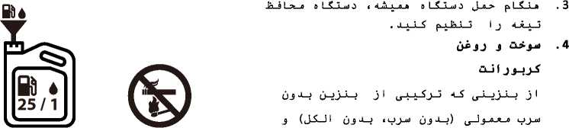
0 3 I JlLu) I OwU) I lXA-JLX-A
L-; jj-3j-o j-ijj
. з j-A j j-J-S—! I 3 j-Л l—j is a_>
t Jl_x_x_5 J_<z> L_> j LLx_oJo I j_LoJa_o j u-°—2' <5J L£ о_х_х_3з—о jl 4_Л_х_о_а oLLLj 1 j jjj_SjL_£ pl_£_La .6
. J_> I j_a j I о d I o_u) I p LS_x_a Lz> j-/£L?t—o
j_uJ J_x I 3 «4 i 2)_zj I j-S—o—о 4_S (_£—! Lo_J_> 1 О 1 J-b-> t5 I J—J 3 ^{J} ** I ? о I 3 3-> <-j I 3-b I h £ о j I 4 <*i t д a . 7
. IjJUlj (j-51—t j 1—x-ij-a
c J_J3—L1—j
а к > I 3 1 > о L^JLj 3 l5 I a_u5 j
l_j 3 L_a j < j 1—j_>j 3 о J—j L_o jj-S 1—j
4_i_> I J-из з 33—5 3—0 L$j3-^ tA-l
Jxlb 1—£
iS * J-?
. J_J j I 3 4_S_i 3 3 3 I j -Lj> j I (£_х_J tj j L_S j-S 3 3 : a_x_x_S Jo 3—01_> I j j з-J 3—0 j j I 3—0 j_> I j I J-j—5 .9
{ 2~i I 3—0 <5 j Lu> <51_j p L5Lx_a L_j <5 j Lu) <5 L_j
. 0 LSLLu) 3 (53 J 3—> J LS L_J 3 <5 j I wL^_S_5 3 3-)—o_r_5 c <Sj>
: JL& j L.^ htx л j I j 3-f I <
j-jLd I 5 4_S_j J3 5 eg I 3—J j"i Lu)_5j j—j 4_j . Д_х_Д 1 J -lo LLt—0 cS 1 )j h > Jo_> I j_A j_) I j_> j J 4-uLx_а-л . 1



(jJ—oJa_o 4JLx_*j> t aJt> LoJt> j L$ 1—0 L_j 3 3 I Xuo I j L&Ji j LS p L5Lx_a j 3 (j-ux-S I . 2
< 0 I j—91 4_S ^у-Ьххл—0 j d (j 0 J-J j L$ j I . wL_x_x_S (yi з-e L> 0 LSJLu) 5 j J—i L> j_> j 1 J_x_§ 1 j j 3—5 3—0 J—) 3Л)
J-LLd-a 1—oJj (j-S—)5 j_5 j 3 t J I Ho 1
. XJ-LS oLLL>l
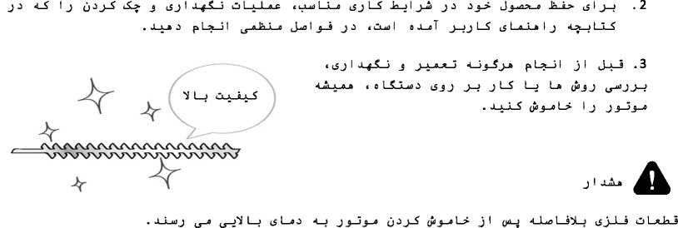
. а_х_Л 1 j Ja_) I j-ii I 3 4_SLLj I J-SLo c J_x_L5 j_x_ol-r—5 I j 0 L£_Lu) 5 d_x_LSL) ^g-я-из . 1

<i5jL$ (>₽JJ L_j 0-^3 3 0a_J3-«—5 p L-S-La L_j 4 3-5—>5 (jLL-j 3-» L_> 3 J43—> LzL>l (p_>3-*—5 p LS_La .4
.a_x_L$ ool LLu) 1 1 j Ci_x_Lx_5 1 j 3-izi>l_o jl JaJLs 4_S J_J3J0 jJ—oJo_o 4JLx_<xjs
jo <-S u-jI J-i-"-^ Ь J dj 1 J L-S-⁵ >•
L_j j-л j_£—j L_> cs I j_j p j j_J Lj j j-л jo .5

. Ljj I d_L_j
CjV LLI *L d_LL Juufl L_> j L_i_j_aJo I . JujLL OLj-uj LiL j JL LILLI 3 1 J—? Ij d_j>l j JL qj_x-u> .5
.. L I о jLj pJL—а (j-Lj I I j j o_«L (jJLu) j d <_j (y)j—J
(Joj-S
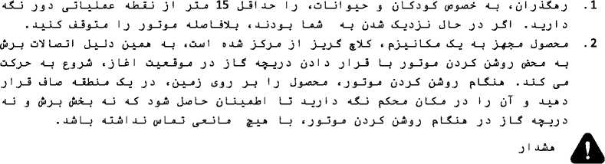

. L_a J—j j I j_3 *i I—j Lcj_uj OLL> I—j Ij JIL 4л_) j d JLj-a «jj-Jj-o jdjL lH’jJ pLSLL •
. .1 > j 4» ) j-i j j (p*j—) O*i La-j I uljuulJ jl IJ jjJjj >?>» •
(j—5 La j < Jj j_j oULajI JL d_LL j_L L_> j l_L_aJo I IL « d_x_iL L_> JdjL jLjj jl qj-j .3
J_SI . djL) (j—o < a Aj 1 л < JjJ!) JLJ—La d j_> (J-L) I Л x я q J—a <L_J J_a L J j-lo 4—J j LL 4л_J j 3 <L
J_fiJ—La J j_> jj-L) I lL_r_5 j—a J__J ;_L IL j jJo 4_J J LL 4л_> j d L_L) I j I (pJ—J j L_L_o_a Ср J—? LL I
В d—Lb J J—9 <4 J J_J_a_L a~x > I j о t C 'Ll d j d x )L Jd 3—a L>
I j j j_j j—o cdLdjL jj-j Lj_> < aJI)
J j-iaa-o j I о d LidL 1
4л_1 ILL j d «L y_j La j IL 0 I j_j JaJLs j . JLxjt d Jbj—) I j о dL J Ld ludjL о jL& о з I 3 d t L^lX _{y}> d I j-o JaJLi
. XjLL adLajLidl & LSLLtdd jl dL odld LoJu» I j
(j-L) J-xJL I ч1_> p_a j I (j-oL I j J j_> j L_a I j . d_jj_x_C—j о j_> Cbd 0 j_a I j j pC > a I j La о j_x_3LLj 0 .1
4 J J-Л 2Hj jL L_j J d j_a c5j J i5 J Luo j jJo 4_j LaJj jj j «L c$j jJo *L_j t ( d jL La 4_J Lb giij-s j I j-LL—j . d—Jj I d j I j_5 jj-Lj 1 5 i2x_x_jLj j d d_x_jL ^g-o j L >L _{l?}L L> j d c <L d_x_iL <_L L> j LLx-oJo I <Л_х_о_а j j a Olsj-u) jLj_a j d_jj I d 'LL Jbj—> j IL p LLI <з I j_j c j LL d j j—« g-Ld jd I j jjLj_a Clcj-uj .2
• (ЯЧ? * j—3 I j LL d j j_a 5-Ld j I I j
^g-ujjj—j I j в LLL)d JL j •ЧИ—obj—oL> I j j jLj_o t djL Jj LLj I Lj Jiij jL <l_j £jjL jLI .3
. d_x_LL в d I LL) I
a IL_L) d j I
0 dJLi (_9 j_lo j_j J—0 L j jJo

. J—jj I d LL j j d £J d £j-Luj j cLj_> J L> j d Jjj—i cL LL I j I I j
d jL j d_j 3 1 u «и p LL . 4
« jL «LL*- I djzi 4 j jL j_a JdjL j_a L_> jl qj-j <_Lo I s^L Lj j jL j—0 jdj_j jJdjj pLX_La jd jLj_a . 5
ij La (jLjL- j-a) Le I j
LI jL у_л j L j_)l
pLLI

^0
ШШШ
( lS J I jXl_a lS I—*
(c5jl jJaJj I 0 La j L_о j I J_j upj
j 1—S kpu CPjX o4-^{x}—⁰ tS 1 J—? (j-1—j L-u) j
(4I3-0 0 3j_j J-i-J jl tslj-j) ojl L_j 4 A £ 5
jl * 4_i_a j_j l$ I—J I—J I—J Ja_Lz> j J—j pLX_La ₍J_i a_i_LLj 3 I—i j I з-Li Jd-kJij—j p LX_La j3 jX j_a
a £ >X > a 3 I LLa I J
J—J 1—9 j-jj-J—J lSJ I—> 4_S c ^yJo J-La—о un_> J_u) 1—J 1—3 o_u) I 0 J-d I j_la 0 j jJa J 3 a j—J I j 3—3 3—a .<_S—II
<-S l_> J о I J о JjLj L_j
4> j_u) lS La j_5 jX j_a
j LX а_Л I j J L_*_3X I
tS La 4_9j_> < tg j j_u) (£l_jT
‘j^ J¹-?¹
. J t И ) j j t 3 j-Л i2n_>j_u) j-J->j-u) i-c I J o_u) I jX-a—a 4—S 3 J I 3 3 j->3 c5 j 3-^ (£1XT
. CLu) I I j jda_> j Luxj j I 4> j-uj j jX-о J 3 jX j—j I—j J з-лл_х j I о 3 1 LLa I p lX_La j 3 j а_хХХ j 1X_£_«j . о
• 4-^ J J
J З^лй—a j I
1 j j LX_£-«j 4_Ша 4_S J-X t ) 4_3X I 3 j L_L_j_ada I 4ЛСх-д_а

j ¹ J-S-5 <X 4^ J^⁵ L> j LLx-aJo I 3 Д £ 1 Jb 3—a L> I j j 3—3 3—a 1 a_3 j 1 i j j-й—о j J—£ F* IXLLa . £
. а_Д1 J 4_3X I a_J 1_9 I j_k> I J3 (jjJ-J I 0 4_LrX L_> 4_9j_j> g_£_a t 0 J_xX U1_> J_uj
j I Х-Ч * j—iJ—} Ci _$ Ч-i ^{i}~^{k}^‘ 3-“» j ' <5 J I 4La 0 j_xX з-<а p LX_La j 3 jX I . 3
0 J I JJ 3
. a_x_LX o31 LLu> I jl j3jX j_i_a—j 0 1 34 XJL> 4_>j I > X_> jl < a_x_LX jXjj Ij
j ' J-!—® СЧЧ¹ J a_ja_i_i—? ^{t;}L> j-u> j jX—a (53 j j—J g-JJ ■* *4 ' J 4“* 44J ‘ <5J4-^ j * ^{а}-^{л}—? • ⁰
(■jXXjij-uj j LX_a jl j—jjj 3 L_j 5j_3_a 3 j3 4_b_5_j X_j 4_> Ij J з^дл_л t a_x_LS j-Ajj Ij j 3—3 3—0 4_S_L_j I
■ i5_>-b-S

(jJjj jl JjJ
j 3 X I jj h > 4_ik>_L_4>
j I з-Le 4_j J_j I j aJX (j—a 0 3 I LLj I J з^лй—з j I
4_A 3 3 J_9 3 J-L-a 15 Jo_£_a_a l_3 . 1
p_3Xo < ^jj J * -bLa lj l_JJo
О j з-ио j 3
uT
oj I J
0 L_£_La . 3 j_£_? j I j_5 h £ й д XI jJo I j 3 a_j I j a a_La 3 j I aJLa
l_j j 0 J3J0 <j jLS
ca_5 I j—a О j 3--0 j_JI J4® J J4 ' -P³ ' PJ I -I—a J 3J0 4_j a_J I J < 3 3-Л p La_31 j_i_j *L-L>
h i > c _{IJ}_3 LX ^j-Lo—j I jl j I—i_£_oJo I <3 I j_j 3j_9 j_a 4_Lz> I 9 I 3 < а_£_Л I j jX_j 3 3 I J—9 I J I—S' Jj>t_a 3 j 3-«b->
U1 * j 24¹ J-⁰ *4 U^{J}j 'ЧХ^’ L-J dl 4_j3L> j_a ^3-93 jl
Ij jl_f .2
. J_£_i_X JjZ) L> J I—Lx-ado I
La 0 J_£_XLa) 3 p L_Z>—3 j 3 3—J 4aJ j 3 j I
с 0 LS_3_u) 3 j I 0 3 t lLuj I p LX_La 4JLx_A_a . 3
j L4-0 34®
0 ado I
0 LXJLa) 3
1 a 0o_51 3 04-^ I—⁰ ‘-^4 j 1
•4-iXJ j_Sjj
. J_x_31 i Ol_5o
о IXLLu) о
j_> I
ojXj LX j3L> Xj 3 <5 I J—> I J X_J I о <5 La-La I j 4_>j_L_9O . t_a 11
jl <X (j—a LS_La L_j j « J-jLLula JX—JI j-j-_>LX Out_j 4X _{iJ}_j> LX-La a jl d_ j L_i_3 j—?j_a LoJj . о
1 j < J—j-Luu 0 _$—I I *-?' J-X J L_>0 _9 J I ^{J} Xj-ia-e J-J—J 4_> 4X e LX—La 5 g_jj о I J L_j
1 j j -Li I j 4_Li I 0 3 LaLo uj La_5 j 3 J4-L-> I 3 3->j J LoJL> I Cuuj I jX_o_o 4_S <5jX_>3 j Loj j_a j 3
. J-j—3—$ о d 1 LLa I j I j I I J-LX j LX j—a—j I J j jJo 4_j о LX-La J I j d-£—31 j_L_i CLa I jX_o—a 4X_L_j I
j Lo_L> l_A J_> I J j 3 j j—J j—о j 0 jX j-Aj J j I . £
j_)jX d—)-aX j_3 j_a i$j L_> J-> l5 I—^{й} j LX
. d-A I J _{LS}-o j-ih-o
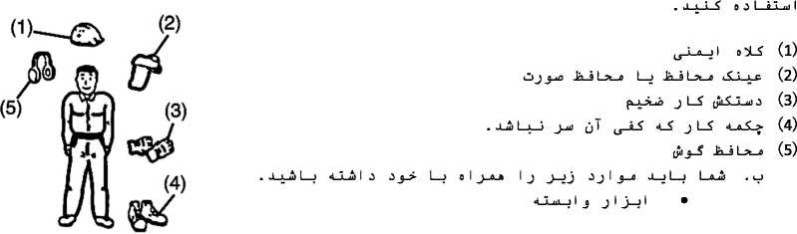
LXJ-a .1
0 j d > a i~t н> I jX—a_a 1 д ui
d_J3 jl d_k_o 4X c3jX_j3 I лj j_a j 3 L_J j
< j_iX_LA 4—o p LX_La
< 4_1Ъ_3—о j I jj-LX
j 3 J j T d-A 3
j L_a j j_a j 3 I J j <L>d_a (j—i'i jJo j (5 j_5 <_$ La 3 I j < j j_j j d_cj J j-Ь j3
jl—9 jJo Jj-Ь J2 .3
. d_L5 (j—o j_a I I 3 J j_«zi>_o j_j I j I оз I LLa I _{L$}—j I j_a j oT la_j I j-a 4X «(j j_C_j d
I j j L_S о^л_5 _{(tr}Jc_5lj j L_S jl
t j I j j-i—J J I <5 I J—> J jjzut—о j_> I j I 5 0 I LLaj I p LS-La . о
. J_0 L_> j_a L-o j-Sj LX j I
¹ J U ¹ L-?
0 j-> 4_J j 3 4_J j_J I j 0 j_u) о J—J 4_J о ц, C j j l. 9 ^X-LuLJx I J С 1 «1 > < О I j_> j I JL_i_9 . j
Qi) 0 jJ I J 1—а_3_а I j 4_>j I L 4_X d_k_i_X L_> j L_i_k_aJa I < 0 о ^_) La lJ_j_u)T j iLjl 4_J j_»J—a
eJ-¹»-» is-¹¹ ■*-^{s} us-> L-» j J-«
a_jj I о
j I—i—>_aJo I J j iH> a ^-iX ' ⁰ J ‘^{y} ‘ ‘ - j I (/> J—3 ‘ 0^ J J—9 p I С 1 a 4 A >. д a . j
. 0 j-Х jj—o J—a Uj I j l_o_La I j
о JJt> о J I J (j La I j j_x_u) 0 J—о LX Xj 0
4_) j o L_5 4_X (3 о I J—91 L_> j LX о jX J-x_a d_3 о j L_> I j_Xj_a . &
. J_3—3—S о 0 I lLu) I J a j_> I j I t J-iJLuLA—i Lo_La I j 4_?t_j L_LX j 0
lj_u) I о J—о I J—J j J 0 4_X I j 1 Jo I 1л_a j—) Lui j j t_j_u) 1 1 а ца l_t_l J_j I J t J з-лл—a j I о 0 I it 1 ui I p 1 C 3 a . i_i_l I
1 HP с ггу| в г-гт—] С угГ | пт? °~^{r>} 1 О' Н» Г | <гг^{г}’ г—[ лр г-Ггт у° С '
С ггу] ⁶ | С С о-тгГсО г—j С | О уС | С гт ’ггт ’ | С | г"Р С УЛО ⁰ С 50 о—Гс^-Го | рут—| с с
<г-С с ’ [ О~[ Г чгг-Г [ г—| о Г [ «уу| 1 от?—1 С ⁰ 1 С с огуп ⁰ С Г Г"У> ? 1 ("г⁻"¹' * | V
1 С q г—| г-у> с пт? И¹ гН | г⁻Г f—1У —1 О' ‘
—1 ЮТП ^{с 0} |С ^{г} со? |С с о~5~1 ⁰ О⁻** Сг" НГ-е-ч-О ЮТ?—1 с с уг-гт • ЮТ?—1 с с |Г
ОТУ! 1 ОТ?—1 со I С с ОЛУ"! ⁰ ’ 5ТЛР О⁻! ’’’Н г~г~^ угт ’ | о
«ггуП 1 ОТ?—1 со j С с ОЛУП о ’ С ОГТУ^ ПЛ '"Н Нг-Г Нгт ‘ | о
г~«г] гур «~] г⁻⁵"¹ г~Г | Р р-Г» yf Г 4 u”J «—| Г i_ | О <" * Г г 7 г ’

г»Т if im?» if 'тя¹
riniT irrn<’ ir^r"
ан

(g)^W
Г| er
o-y Р
«-] г
о—f Г С Hr-1 Г <Нгг-г-] г-гт ’
r~tr-| pO г-у-Гг—г б~ ОО O’
«—| Г
I С | Г чгГгт | Г Р yf" С ⁰ I ОГ НГ | Р гт—| Г t г | гт Г⁶’ГТ тп ГГТ Ггт Г тп ?Т< 5-|г-р <Г<|ГТ?
А | О 1_л Хиэ . Д_х_й J_j р 1_л_51 CiuJ 1 о J—6 1 Ltk-Le 1 j |  |  | . Lj 1 J | jJ JJ <  J-a 1 j_> | S Ij ^Lj.jLS' j_S1 :j-kJ
 |  |  |  |  |  | u4 J ^{J} 1 J <>-" и-*-* | cS J_>
А | <_J L-0J-U3 | . J-J-й J—! | p 1_л_j1 Lj_id 1 о J—о T l_o_j—a 1 j 4_  Jj_<j 1 J JUb 1 j_> j 0 1 j | >ju_3J c | J 0 4_$  3 ⁰ | lj j_Tl :j  1 < 1 «1 3 (J-? Jl—J 3 у j. Hl 1 | «А-uJlA  is
А | OL_4a | jzj . а_х_й jl | _j p 1_л_j 1 djjj 1 о -L-о 1 La-La 1 j | С)Уз 1 J | J J J 4_$  J-a 1 j_> | Ij c^L-'jL-S j_S1 : u4 J ^{J} 1 J ^J-" и-*-* | 6, .f  •f t.
 |  | 1 . ,_{t} , ; | _S о JUb Li_o ” Lu | ij uj- | S-JJ p^-J | oLc^Lbl xj^JI j_J | L_a_uJ
А |  | _)0 ¹₇^-£-^{uJ} 1 | . JLlUb Jl_j p 1_й_i1 Ju 1 0 Jl_u 1 L | -«uu. i j | 4_>jLL_9 j  lLuJ 1 J | j 0 4_^ Ij (j—j L_a j l_$ j_? 1  Ц_л 1 (j—j j J 1 j о L-S-L-u) 0

(5 j_x_SJa_x_)
 | о JjJ 1 L_a_L-ft 1 j 4_>j_ | j—9 J j J 4_^ | 1 J (JdJ 1 J-J | c jj j LuboJtj 1 j jjj_S j 1—£ j 1 | J_uJ J-SI
III | . Jj_^ d_a 1 j_ | > j L-5 J LoJL | С 1 J_>L_9 j | jj—0_Io_0 0 LSJLuJ J . JLJUb J p L*_> 1 | clkuuJ 1 о JLu)
A | J t-L-K-u) T i^JlC L | _) О j j—J 1 | J_Li JJ . | Ч-ilj^ Ij LjJjIj | j_J | ah 1
A |  |  |  | . aJtj jLJb 1 J_> 0 LCJLuJ J 4—J jj—J-jjJJ i_kJ_-ujT

A | J_LJI j_J 4_S a_L_L_? j^i L_j J_ax dCj 4_^  . J J_uJ J—1—
A | J_LJI j_J 4_S a_L_L_? j^i L_j J_ax dCj 4_^  . J J_uJ J—1— | J | <-§J_fl 1—J J J J-_ | i-jLXjdT iiu
 | . J-X—> 1 J-Л—з ikJ J 4_j 1 j 1—eJub 1 j 4_> j_L_9 J | < 0 | L-SJLuj j j 1 о J L | *J-»I j 1

CT20114
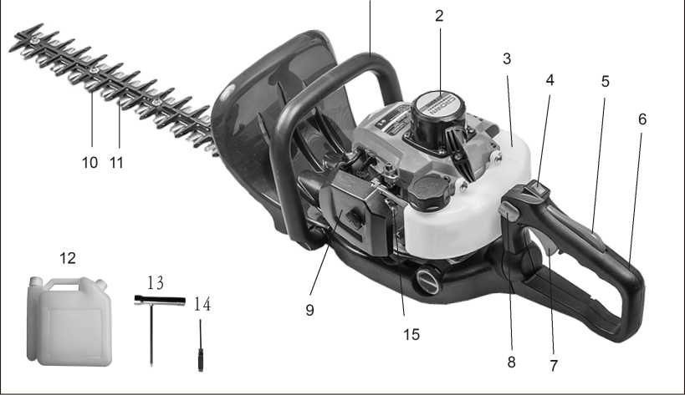

u-ij-L-?- pj_a 1 . 1 | .j-k-ii p J-a 1 . 6 | [p> J_J <j_>—j . 11
J ¹ • ² | j 1—S <a_J j d «utl 1 о . 7 | ^y-k-k-Sj—j i2k> jjj j jj-j . 12
lU- j-ul j 0.3 | p j_a 1 J i i <_o_S d . 8 | jLjT .13
jj-Jj-o g-i-jj-u) .4 | 1 jj jLJ-u-j .9 | г-н -¹⁴
J L? *UJL_)J d «Lil 1—0 J_a_3 .5 | J Г* 9 J t “ • Ю | UL-0^ .15
L-> Lol-La I j <_>jJL_9O (j_j I . ^-л L^o jj <_Ы oLXJLaJd jl_jjl> uL_jL_j LoLj J I
Qjj Lu) I
<j_! о Ш-ш о isj I > j j-кл-*-³ J
4_j Joj_jj_o OLcddol
jj J—J I J О L>dL I d l_a_) I j_> 1—о . ukuil о L> |J I j_J j Lo j jj « d j_> j—o Jj .n* л О l_s ЧЫ j—)j_>T
<-kJ 0 LXJLui j j I JL-J L_j <л_о LL< j_j I . p_jj Id I j jT uJ I j_e 4_o j j J—; j £_^-b¹
. d_51—o_j _{IJ}_3 I—j j T I—j о I j-o-a U-k5-> j j_a I j j T j_5 I j 5 dJti I—о j_x_> j—j <^—5 j I—«—51 0
y-Loo I О Ls 31Ы
L»Jj I j <_>J-5—S d j d p_a I j p^ л у_к-о—) I i2> l_s 4Jo I I о . djd I л j 1_клк_о j I C j d j L_L> jy-Lj I
LoJti 4—J j-y-L-O—11 о Le dib I . d_x_51 J-Я—> c2k-3d 4_J Ij jT I a In I ! p_) I <-Utij_5 oLXJLuid CSJJ fka j

